CHETTINAD VIDYASHRAM

COMPUTER SCIENCE

PROJECT

(2020-2021)



(AN INTEGRATED TRAVEL BOOKING SYSTEM)

DONE BY:

K.SRIJITH

SYED AMEEN

K .DEVADARSHAN



INDEX

|  |  |  |
| --- | --- | --- |
| S.NO | TOPICS | PAGE NO. |
| 1 | ACKNOWLEDGEMENT | 4 |
| 2 | OVERVIEW | 5 |
| 3 | FUNCTIONS USED | 6 |
| 4 | FILED USED | 8 |
| 5 | SOURCE CODE | 9 |
| 6 | SAMPLE OUTPUT | 95 |
| 7 | CONCLUSION | 99 |
| 8 | BIBLIOGRAPHY | 100 |

ACKNOWLEDGEMENT

I would like to express my sincere thanks to our senior correspondent beloved Meena Muthiah Aunty, Principal Dr. S. Amudhalakshmi for their encouragement and support to work on this Project. I am grateful to my computer science teacher Mr. Thomas Sathiaraj and to the computer science department teachers, lab teachers for the constant guidance and support to complete the project.

Also I would like to thank my parents, family members and friends who helped me to complete this project successfully.

OVERVIEW ABOUT OUR PROJECT

Our project is a Booking reservation online website, which allows users to book tickets for buses, trains and flights, to travel to any place within India. The booking site is named MRF, which stands for “MOVE RUN FLY”. There are mainly three main parts of this website – The admin portal, the user portal, apart from other attributes such as help window, know about Indian transport window and about us window. The Admin window allows the admin to add and delete a vehicle from the chart, put the chart and update the chart, view the passenger list, and to add and delete an admin. While the user portal allows a user to view the available vehicles and book tickets, the guest portal helps the user to see the available vehicles, but doesn’t allow him to book a ticket, as only registered users can book tickets. It asks him to sign up, and asks the user to enter the required credentials such as name, age, phone number, e-mail id, and gets a Username and password from the user, given upon which he’s allowed to enter the user portal.

When a user confirms the vehicle he wants to book a ticket in, the website re-directs him to the payment window, and when the user gives the “Proceed” button, the bank website opens and asks him for a choice between Debit Card payment and Net Banking. The bill amount is calculated according to the ages of passengers entered by the user and service tax is accordingly added. Finally the bill containing each and every detail is printed. If the user decides to cancel his/her ticket, the user portal provides an option to do that. It asks for the PNR number which is available in the bill. If given correctly, the ticket is cancelled with 50% deduction.

Basic concepts used in this project are Functions, Database Management System(DBMS), Graphical User Interface (GUI) viz. Tkinter module, File concept, lists, and Sequence and Selection Control Structure viz. while, for, if and nested if statements.

FUNCTIONS USED

* start() : To close the current window and open the main window (outer loop)
* start1() : To close the current window and open the previous window (inner loops)
* start2() : To close the current window and open the previous window (intended inner loops)
* cav() : To enter the required chart to cancel all scheduled vehicles
* cancelloop() : To check the scheduled chart and cancel all vehicles
* update_chart() : The main function to update the scheduled chart

1. check() : To get the required chart from user
2. stillcheck() : To ask the name of the vehicle to be updated
3. appendit() : To enter the file containing the required vehicle and update the chart

* put_chart() : To put the fresh chart

1. puttingchart() : To get the required chart from user
2. appendit() : To accept details from admin and put the chart
3. morea() : Asks whether the admin wants to add more vehicles

* add_a_Vehicle() : To add a vehicle in the chart

1. addingvehicle() : To get the required details from the admin
2. addda() : It adds the vehicle to the respective file

* cancel_a_vehicle() : It is used to cancel a vehicle from the chart

1. cancelvehicle() : To get the required vehicle name from user
2. c_v_n() : To remove the vehicle from the respective file

* Table : A class used to get the required lists to display the table in matrix form
* showpaslist() : Used to show the required passenger list

1. showchart(): Gets the name of the vehicle
2. _init_ (): used to display table in matrix form

* deladmin() : Used to delete an admin’s account from the server

1. deladinput() : Gets the name of the admin to delete the account

* addadmin() : Used to add an admin’s account to the server

1. addidpass(): Asks for user id and password of the new admin

* Admin_portal() :

1. Airways_portal() : To enter the airways portal and execute actions
2. Railways_portal() : To enter the airways portal and execute actions
3. Roadways_portal() : To enter the airways portal and execute actions

* Admin_id() : It asks the admin the required Username and Password to enter the portal

1. adminidpassword() : Checks whether the user’s input is correct or not

* About_us() : A function to display a textbox about us.
* destroy_text() : It closes a textbox
* ITSHOW() : It shows details about the Indian Transport.

1. itroadways() : Displays a text box with information about Indian roadways.
2. itairways() : Displays a text box with information about Indian airways.
3. itrailways() : Displays a text box with information about Indian railways.

* HELP() :Displays solutions to common helps needed for the user.
* Exit() : Terminates the program
* cantic() : Used to cancel the ticket booked by the user

1. can() : checks whether the given PNR number is available in the file of existing PNR numbers.

* user_login() : Used to enter the user portal by providing essential details.

1. useridpassword() : Checks whether the username and password entered by the user exist in the server.

* user_portal() : Asks the user the mode of transport he wants to book a ticket in. According to the user’s choice, redirects to the respective portals.

The user portal leads us to the following pages and following function does the job respectively:

* Railways_portal () : Asks for details to search for searching for a train according to user’s choice
* Roadways_portal () : Asks for details to search for searching for a bus according to user’s choice
* Airways_portal (): Asks for details to search for searching for a flight according to user’s choice

The following functions are common for all the above mentioned portals:

* comsearchit() : It searches for a vehicle according to user’s choice and the availability and displays a table of the available trains.

1. namecheck(): The user is asked to enter the name of the vehicle he wants to book a seat in, from the available trains. It checks whether the given name is there in the table.

* Input_information () : It asks the user to enter details about the name, age, gender and preferences of the user.
* banking() : It calculates and displays the total amount, and asks user to proceed for the payment.

1. payment_mode() : It gives two choices to the user to pay money online viz. Net banking and Debit Card/

* bank_login() : Payment via net banking. User is asked to enter user id and password.

1. bankidpassword() : If the username and password are valid, the money is automatically transferred and the bill is shown

* debit_card() : It asks for two of the numbers available in the grid behind the debit card.

1. debit_check() :If both the numbers are valid, the money is automatically transferred and the bill is shown.

* bill() : It displays the final bill of the customer.
* Registration() : It helps a new user to register to our website, so that he is able to book tickets.

1. searchuserlist() : It searches if the given username is already in the server, and also checks whether the password and confirm password are the same.

* Guest_login() : It allows a guest to enter the guest portal and to check for availabilities of vehicles, without allowing him to book.

The Guest portal leads us to the following pages and following function does the job respectively:

* Guest_Railways () : Asks for details to search for searching for a train according to user’s choice
* Guest_Roadways () : Asks for details to search for searching for a bus according to user’s choice
* Guest_Airways (): Asks for details to search for searching for a flight according to user’s choice

FILES USED

* AIRWAYS: A CSV file used to store the details of flights such as flight number, arrival, departure, date and status.
* RAILWAYS: A CSV file used to store the details of trains.
* ROADWAYS: A CSV file used to store the details of buses.

NOTE : There are files which are created during the execution of the program. For example, while a user books a train in a train named “Chennai Express”, a file named Chennai express is created, and if already existing, the files is opened and the user’s name and other details are added into the file, thereby creating a passenger list

This is one of the csv files, in which the data is stored.

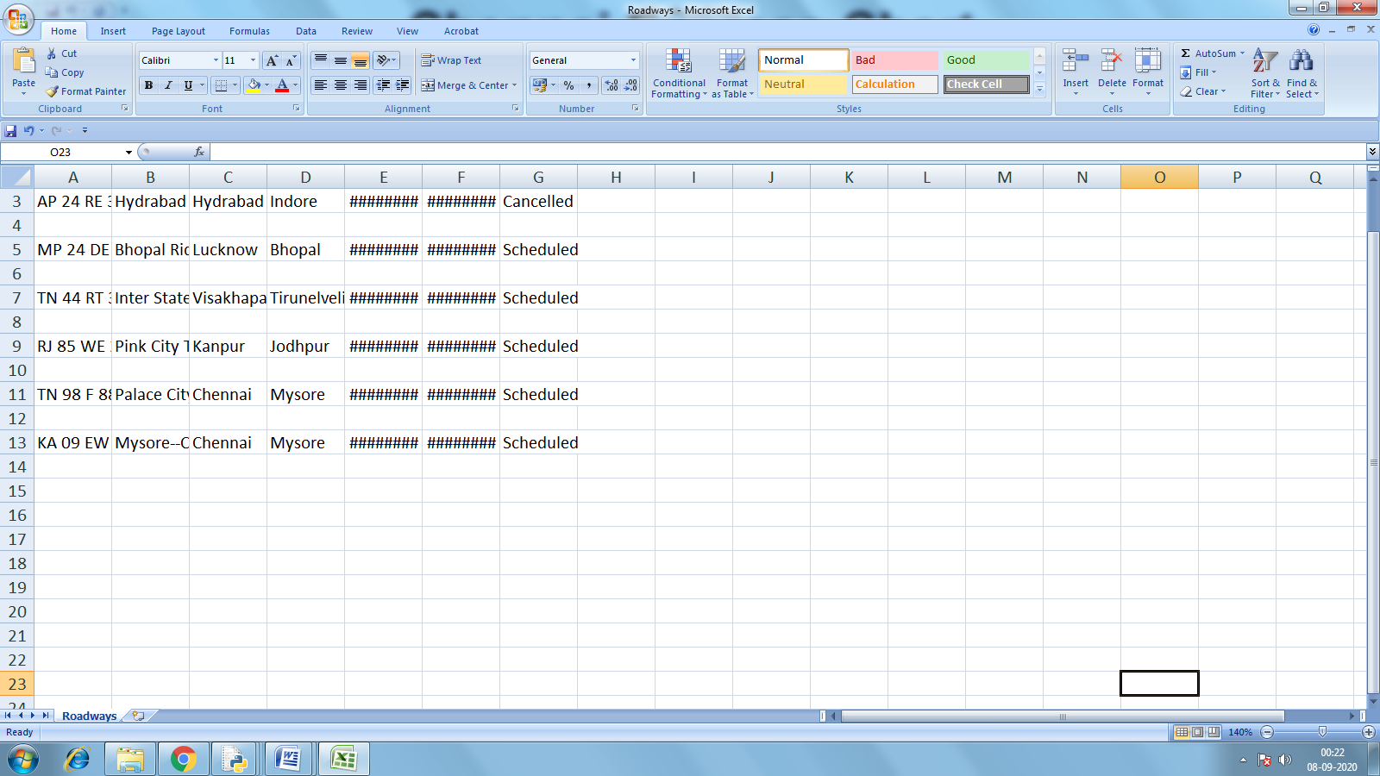

SOURCE CODE

from tkinter import *

from tkinter import ttk

import pickle

import os

import csv

from tkinter import messagebox

import tkinter.font as font

import datetime

import random

current_time = datetime.datetime.now()

def start():

global window

try:

adminwindow.destroy()

except:

try:

userwindow.destroy()

except:

try:

window1.destroy()

except:

try:

userportal.destroy()

except:

try:

adminportal.destroy()

except:

try:

reg.destroy()

except:

print()

window=Tk()

window.attributes('-fullscreen',True)

window.title("MRF.com")

myFont = font.Font(size=25)

Coverphoto=PhotoImage(file="Coverphoto1.png")

label2=Label(window,image=Coverphoto)

label2.place(relx = 0.5,rely = 0.5, anchor ='center')

label2.image = Coverphoto

label2.pack

photo=PhotoImage(file="project.png")

label=Label(window,image=photo)

label.place(relx = 0.94,rely = 0.1, anchor ='center')

label.image =photo

label.pack

l1=Label(window,text="Welcome to Move Run Fly", font=("Arial Bold",45))

l1.configure(fg="white",bg='black')

l1.pack()

bt=Button(window,text="Admin Login",fg="White",bg="Black",command=Admin_id)

bt['font'] = myFont

bt.place(relx = 0.5, rely = 0.25, anchor = 'c')

bt2=Button(window,text=" User Login",fg="White",bg="Black",command=user_login)

bt2['font'] = myFont

bt2.place(relx = 0.5, rely = 0.42, anchor = 'c')

bt3=Button(window,text="Guest Login",fg="White",bg="Black",command=Guest_login)

bt3['font'] = myFont

bt3.place(relx = 0.5, rely = 0.59, anchor = 'c')

bt4=Button(window,text=" Exit ",fg="White",bg="Black",command=Exit)

bt4['font'] = myFont

bt4.place(relx = 0.5, rely = 0.76, anchor = 'c')

bt5=Button(window,text="Help",fg="White",bg="Black",command=Help)

bt5['font'] = myFont

bt5.place(relx=0.1,rely=0.9,anchor="c")

bt6=Button(window,text="Know about Indian Transport",fg="White",bg="Black",command=ITSHOW)

bt6['font'] = myFont

bt6.place(relx=0.5,rely=0.9,anchor="c")

bt7=Button(window,text="About us",fg="White",bg="Black",command=About_us)

bt7['font'] = myFont

bt7.place(relx=0.9,rely=0.9,anchor="c")

def start1():

try:

bankin.destroy()

except:

try:

windowA.destroy()

Guest_login()

except:

try:

windowh.destroy()

start()

except:

try:

itshow.destroy()

start()

except:

try:

windowR.destroy()

Guest_login()

except:

try:

windowr.destroy()

Guest_login()

except:

try:

Roadwaysportal.destroy()

Admin_portal()

except:

try:

Airwaysportal.destroy()

Admin_portal()

except:

try:

Railwaysportal.destroy()

Admin_portal()

except:

try:

cav.destroy()

Admin_portal()

except:

try:

windowAa.destroy()

user_portal()

except:

try:

windowRa.destroy()

user_portal()

except:

try:

windowra.destroy()

user_portal()

except:

try:

addadmin.destroy()

Admin_portal()

except:

try:

deladmin.destroy()

Admin_portal()

except:

try:

aav.destroy()

Admin_portal()

except:

try:

bil.destroy()

start()

except:

print()

def start2():

try:

the.destroy()

Admin_portal()

except:

try:

ct.destroy()

user_portal()

except:

try:

paslist.destroy()

Admin_portal()

except:

try:

cv.destroy()

Admin_portal()

except:

try:

ca1v.destroy()

Admin_portal()

except:

print()

d=[["Railways","Train"],["Roadways","Bus"],["Airways","Flight"]]

adminku=[["Srijith","12f214"],["Devadarshan","12f207"],["Syed","12f242"],["1","1"]]

userlogin=[["Srijith","12f214"],["Devadarshan","12f207"],["Syed","12f242"],["1","1"]]

banklogin=[["Srijith","12f214"],["Devadarshan","12f207"],["Syed","12f242"],["1","1"]]

vai=ne=[]

banks=[("ICICI","ICICI"),("SBI","SBI"),('HDFC','HDFC')]

Railwayspassenger=[]

Airwayspassenger=[]

Roadwayspassenger=[]

Railwaysdestination=['AGRA FORT(AF)','BANGALORE CITY(SBC)','CHENNAI CENTRAL(MAS)','COIMBATORE Jn.(CBE)','DELHI(DLI)','HYDERABAD(HYB)','KOLKATA(KOAA)','MUMBAI CENTRAL(BCT)','PUNE Jn.(PUNE)','TIRUPATI(TPTY)']

Airports=['Rajiv Gandhi International Airport(Hyderabad, Telangana)',

'Sri Guru Ram Dass Jee International Airport(Amritsar, Punjab)',

'Indira Gandhi International Airport(New Delhi, Delhi)',

'Sardar Vallabhbhai Patel International Airport(Ahmedabad, Gujarat)',

'Kempegowda International Airport(Bengaluru, Karnataka)',

'Cochin International Airport(Kochi, Kerala)',

'Calicut International Airport(Kozhikode, Kerala)'

'Chhatrapati Shivaji International Airport(Mumbai, Maharashtra)',

'Pune Airport(Pune, Maharashtra)',

'Jaipur International Airport(Jaipur, Rajasthan)',

'Chennai International Airport(Chennai, Tamil Nadu)',

'Civil Aerodrome(Coimbatore, Tamil Nadu)',

'Chandigarh Airport(Chandigarh)',

'Dabolim Airport(Goa)']

Airwaysdestination=['Hyderabad','Amritsar','New Delhi','Ahmedabad','Bengaluru','Kochi','Kozhikode','Mumbai', 'Pune ','Jaipur','Chennai','Coimbatore','Chandigarh','Goa']

Roadwaysdestination=['Mumbai','Delhi','Bangalore','Hyderabad','Ahmedabad','Chennai','Kolkata','Surat','Pune','Jaipur',

'Lucknow','Kanpur','Nagpur','Indore','Bhopal','Visakhapatnam','Patna','Agra','Varanasi','Amritsar',

'Ranchi','Coimbatore','Gwalior','Vijayawada','Jodhpur','Madurai','Raipur','Kota','Chandigarh','Hubli',

'Mysore','Gurgaon','Tiruchirappalli','Salem','Thiruvananthapuram','Amravati','Noida','Firozabad',

'Kochi','Dehradun','Ujjain','Jhansi','Nellore','Mangalore','Tirunelveli','Udaipur']

Flightseat=[]

busseat=[]

for i in range(1,32):

vai.append(str(i))

for j in range (1,31):

Flightseat.append(str(j))

for k in range (1,31):

busseat.append(str(k))

teach=[]

e=[]

w12=[]

debit=['33','48','73','27','89','32','25','99']

available=[]

pnr=[]

def cav():

def cancelloop():

fna=cavc.get()

fna+=".csv"

f=open(fna,"r")

robj=csv.reader(f,delimiter=",")

r=list(robj)

x=0

for a in r:

if x%2==0:

a[6]="Cancelled"

x+=1

messagebox.showinfo("Success","All Scheduled Vehicles Cancelled")

f.close()

f=open(fna,"w")

wobj=csv.writer(f,delimiter=",")

m=0

for b in r:

if m%2==0:

wobj.writerow(b)

m+=1

f.close()

try:

Roadwaysportal.destroy()

except:

try:

Airwaysportal.destroy()

except:

try:

Railwaysportal.destroy()

except:

print()

global cav

cav=Tk()

cav.attributes('-fullscreen',True)

cav.title("Cancel all vehicles")

myFont = font.Font(size=25)

Coverphoto=PhotoImage(file="Coverphoto1.png")

label2=Label(cav,image=Coverphoto)

label2.place(relx = 0.5,rely = 0.5, anchor ='center')

label2.image = Coverphoto

label2.pack

photo=PhotoImage(file="project.png")

label=Label(cav,image=photo)

label.place(relx = 0.94,rely = 0.1, anchor ='center')

label.image = photo

label.pack

l1=Label(cav,text="Cancelling all vehicles",font=("Arial Bold",45))

l1.configure(fg="white",bg="black")

l1.place(relx=0.5, rely=0.04, anchor="center")

l2=Label(cav,text="Enter the chart",font=("Arial Bold",25))

l2.configure(fg="white",bg="black")

l2.place(relx=0.3, rely=0.5, anchor="center")

cavc=Entry(cav,width=25,font=('Arial Bold',20))

cavc.place(relx=0.6,rely=0.5, anchor="center")

but1=Button(cav,text="Confirm",fg="white",bg="black",command=cancelloop)

but1.place(relx = 0.35, rely = 0.6, anchor = 'c')

but1['font']=myFont

but2=Button(cav,text="Back",fg="white",bg="black",command=start1)

but2.place(relx = 0.55, rely = 0.6, anchor = 'c')

but2['font']=myFont

def update_chart():

def check():

def stillcheck():

def appendit():

q=fna+".csv"

king=open(q,"a")

w=0

wobj=csv.writer(king,delimiter=",")

wobj.writerow([numberu.get(),name.get(),From.get(),To.get(),Dept.get(),Arr.get(),Status.get()])

messagebox.showinfo("Sucess","Sucessfully updated the chart")

king.flush()

king.close()

q=fna+".csv"

f=open(q,"r")

aq=[]

robj=csv.reader(f,delimiter=",")

w=0

roeo=list(robj)

abc=0

for a in roeo :

if w%2==0:

if checkname.get()==a[1]:

ther=Tk()

ther.attributes('-fullscreen',True)

ther.title("Updating the Chart")

ther.configure(bg="Light Blue")

myFont = font.Font(size=25)

l=Label(ther,text="Enter the Details ",font=("Arial Bold",45))

l.configure(fg="white",bg="black")

l.place(relx=0.5, rely=0.1, anchor="center")

l1=Label(ther,text="Enter "+v+" number",font=("Arial Bold",25))

l1.configure(fg="white",bg="black")

l1.place(relx=0.4, rely=0.2, anchor="center")

numberu=Entry(ther,width=25,font=('Arial Bold',20))

numberu.place(relx=0.65,rely=0.2, anchor="center")

l2=Label(ther,text="Enter "+v+" name",font=("Arial Bold",25))

l2.configure(fg="white",bg="black")

l2.place(relx=0.4, rely=0.3, anchor="center")

name=Entry(ther,width=25,font=('Arial Bold',20))

name.place(relx=0.65,rely=0.3, anchor="center")

l3=Label(ther,text="From",font=("Arial Bold",25))

l3.configure(fg="white",bg="black")

l3.place(relx=0.4, rely=0.4, anchor="center")

From=Entry(ther,width=25,font=('Arial Bold',20))

From.place(relx=0.65,rely=0.4, anchor="center")

l4=Label(ther,text="To",font=("Arial Bold",25))

l4.configure(fg="white",bg="black")

l4.place(relx=0.4, rely=0.5, anchor="center")

To=Entry(ther,width=25,font=('Arial Bold',20))

To.place(relx=0.65,rely=0.5, anchor="center")

l5=Label(ther,text="Departure Date",font=("Arial Bold",25))

l5.configure(fg="white",bg="black")

l5.place(relx=0.4, rely=0.6, anchor="center")

Dept=Entry(ther,width=25,font=('Arial Bold',20))

Dept.place(relx=0.65,rely=0.6, anchor="center")

l6=Label(ther,text="Arrival Date",font=("Arial Bold",25))

l6.configure(fg="white",bg="black")

l6.place(relx=0.4, rely=0.7, anchor="center")

Arr=Entry(ther,width=25,font=('Arial Bold',20))

Arr.place(relx=0.65,rely=0.7, anchor="center")

l7=Label(ther,text="Status",font=("Arial Bold",25))

l7.configure(fg="white",bg="black")

l7.place(relx=0.4, rely=0.8, anchor="center")

Status=Entry(ther,width=25,font=('Arial Bold',20))

Status.place(relx=0.65,rely=0.8, anchor="center")

but1=Button(ther,text="Confirm",fg="white",bg="black",command=appendit)

but1.place(relx = 0.35, rely = 0.9, anchor = 'c')

but1['font'] = myFont

but2=Button(ther,text="Back",fg="white",bg="black",command=ther.destroy)

but2.place(relx = 0.55, rely = 0.9, anchor = 'c')

but2['font'] = myFont

abc+=1

else:

aq.append(a)

w+=1

if abc==0:

messagebox.showinfo("Oops!","None of the "+v+" names match to given name")

u=open(q,"w")

wobj=csv.writer(u,delimiter=",")

for b in aq:

wobj.writerow(b)

u.close()

cc=aavc.get()

w12.append(cc)

fna=w12[0]

abcd=0

for m in d:

if m[0]==fna:

v=m[1]

abcd+=1

if abcd==0:

messagebox.showinfo("Oops!","None of the chart names match to given name")

w12.pop()

else:

try:

adminportal.destroy()

except:

try:

cav.destroy()

except:

print()

global the

aav.destroy()

the=Tk()

the.attributes('-fullscreen',True)

the.title("Updating the Chart")

myFont = font.Font(size=25)

Coverphoto=PhotoImage(file="Coverphoto1.png")

label2=Label(the,image=Coverphoto)

label2.place(relx = 0.5,rely = 0.5, anchor ='center')

label2.image = Coverphoto

label2.pack

photo=PhotoImage(file="project.png")

label=Label(the,image=photo)

label.place(relx = 0.94,rely = 0.1, anchor ='center')

label.image = photo

label.pack

lt=Label(the,text="Updating the Chart",font=("Arial Bold",45))

lt.configure(fg="white",bg="black")

lt.place(relx=0.5, rely=0.04, anchor="center")

l=Label(the,text="Enter the name of the Vehicle ",font=("Arial Bold",25))

l.configure(fg="white",bg="black")

l.place(relx=0.4, rely=0.5, anchor="center")

checkname=Entry(the,width=25,font=('Arial Bold',20))

checkname.place(relx=0.7,rely=0.5, anchor="center")

cn=checkname.get()

but1=Button(the,text="Confirm",fg="white",bg="black",command=stillcheck)

but1.place(relx = 0.35, rely = 0.6, anchor = 'c')

but1['font'] = myFont

but2=Button(the,text="Back",fg="white",bg="black",command=start2)

but2.place(relx = 0.55, rely = 0.6, anchor = 'c')

but2['font'] = myFont

try:

Railwaysportal.destroy()

except:

try:

Roadwaysportal.destroy()

except:

try:

Airwaysportal.destroy()

except:

print()

global aav

aav=Tk()

aav.attributes('-fullscreen',True)

aav.title("Updating the Chart")

myFont = font.Font(size=25)

Coverphoto=PhotoImage(file="Coverphoto1.png")

label2=Label(aav,image=Coverphoto)

label2.place(relx = 0.5,rely = 0.5, anchor ='center')

label2.image = Coverphoto

label2.pack

photo=PhotoImage(file="project.png")

label=Label(aav,image=photo)

label.place(relx = 0.94,rely = 0.1, anchor ='center')

label.image = photo

label.pack

l1=Label(aav,text="Updating the Chart",font=("Arial Bold",45))

l1.configure(fg="white",bg="black")

l1.place(relx=0.5, rely=0.04, anchor="center")

l2=Label(aav,text="Enter the Chart",font=("Arial Bold",25))

l2.configure(fg="white",bg="black")

l2.place(relx=0.4, rely=0.5, anchor="center")

aavc=Entry(aav,width=25,font=('Arial Bold',20))

aavc.place(relx=0.6,rely=0.5, anchor="center")

but1=Button(aav,text="Confirm",fg="white",bg="black",command=check)

but1.place(relx = 0.35, rely = 0.6, anchor = 'c')

but1['font'] = myFont

but2=Button(aav,text="Back",fg="white",bg="black",command=start1)

but2.place(relx = 0.55, rely = 0.6, anchor = 'c')

but2['font'] = myFont

def put_chart():

ott=[]

def puttingchart():

def appendit():

def morea():

if ch.get()=="Yes":

ther.destroy()

puttingchart()

else:

q=fna+".csv"

f=open(q,"w")

w=0

wobj=csv.writer(f,delimiter=",")

for i in range(len(ott)):

if w%2==0:

wobj.writerow(ott[i])

w+=1

f.flush()

f.close()

messagebox.showinfo("Sucess","You just finished putting the "+fna+" Chart")

ther.destroy()

aav.destroy()

ott.append([numberu.get(),name.get(),From.get(),To.get(),Dept.get(),Arr.get(),Status.get()])

l1=Label(ther,text="Do you want to add more "+v+" ?Give Yes or No",font=("Arial Bold",25))

l1.configure(fg="Black",bg="Light Pink")

l1.place(relx=0.4, rely=0.1, anchor="center")

ch=Entry(ther,width=25,font=('Arial Bold',20))

ch.place(relx=0.78,rely=0.1, anchor="center")

but1=Button(ther,text="Confirm",fg="yellow",bg="Blue",command=morea)

but1.place(relx = 0.95, rely = 0.1, anchor = 'c')

but1['font']=myFont

fna= aavc.get()

abc=0

for m in d:

if m[0]==fna:

v=m[1]

abc+=1

print(abc)

if abc==0:

messagebox.showinfo("Oops!","None of the chart names match to given name")

else:

ther=Tk()

ther.attributes('-fullscreen',True)

ther.title("Putting the Chart")

ther.configure(bg ="Light Blue")

l=Label(ther,text="Enter the Details",font=("Arial Bold",45))

l.configure(fg="white",bg="black")

l.place(relx=0.45, rely=0.05, anchor="center")

l1=Label(ther,text="Enter "+v+" number",font=("Arial Bold",25))

l1.configure(fg="white",bg="black")

l1.place(relx=0.4, rely=0.2, anchor="center")

numberu=Entry(ther,width=25,font=('Arial Bold',20))

numberu.place(relx=0.65,rely=0.2, anchor="center")

l2=Label(ther,text="Enter "+v+" name",font=("Arial Bold",25))

l2.configure(fg="white",bg="black")

l2.place(relx=0.4, rely=0.3, anchor="center")

name=Entry(ther,width=25,font=('Arial Bold',20))

name.place(relx=0.65,rely=0.3, anchor="center")

l3=Label(ther,text="From",font=("Arial Bold",25))

l3.configure(fg="white",bg="black")

l3.place(relx=0.4, rely=0.4, anchor="center")

From=Entry(ther,width=25,font=('Arial Bold',20))

From.place(relx=0.65,rely=0.4, anchor="center")

l4=Label(ther,text="To",font=("Arial Bold",25))

l4.configure(fg="white",bg="black")

l4.place(relx=0.4, rely=0.5, anchor="center")

To=Entry(ther,width=25,font=('Arial Bold',20))

To.place(relx=0.65,rely=0.5, anchor="center")

l5=Label(ther,text="Departure Date",font=("Arial Bold",25))

l5.configure(fg="white",bg="black")

l5.place(relx=0.4, rely=0.6, anchor="center")

Dept=Entry(ther,width=25,font=('Arial Bold',20))

Dept.place(relx=0.65,rely=0.6, anchor="center")

l6=Label(ther,text="Arrival Date",font=("Arial Bold",25))

l6.configure(fg="white",bg="black")

l6.place(relx=0.4, rely=0.7, anchor="center")

Arr=Entry(ther,width=25,font=('Arial Bold',20))

Arr.place(relx=0.65,rely=0.7, anchor="center")

l7=Label(ther,text="Status",font=("Arial Bold",25))

l7.configure(fg="white",bg="black")

l7.place(relx=0.4, rely=0.8, anchor="center")

Status=Entry(ther,width=25,font=('Arial Bold',20))

Status.place(relx=0.65,rely=0.8, anchor="center")

but1=Button(ther,text="Confirm",fg="white",bg="black",command=appendit)

but1.place(relx = 0.35, rely = 0.9, anchor = 'c')

but1['font']=myFont

but2=Button(ther,text="Back",fg="white",bg="black",command=ther.destroy)

but2.place(relx = 0.55, rely = 0.9, anchor = 'c')

but2['font']=myFont

try:

Railwaysportal.destroy()

except:

try:

Roadwaysportal.destroy()

except:

try:

Airwaysportal.destroy()

except:

print()

global aav

aav=Tk()

aav.attributes('-fullscreen',True)

aav.title("Putting the Chart")

aav.configure(bg ="Light pink")

myFont = font.Font(size=20)

Coverphoto=PhotoImage(file="Coverphoto1.png")

label2=Label(aav,image=Coverphoto)

label2.place(relx = 0.5,rely = 0.5, anchor ='center')

label2.image = Coverphoto

label2.pack

photo=PhotoImage(file="project.png")

label=Label(aav,image=photo)

label.place(relx = 0.94,rely = 0.1, anchor ='center')

label.image = photo

label.pack

l1=Label(aav,text="Putting the Chart",font=("Arial Bold",45))

l1.configure(fg="white",bg="black")

l1.place(relx=0.5, rely=0.04, anchor="center")

l2=Label(aav,text="Enter the Chart",font=("Arial Bold",25))

l2.configure(fg="white",bg="black")

l2.place(relx=0.4, rely=0.5, anchor="center")

aavc=Entry(aav,width=25,font=('Arial Bold',20))

aavc.place(relx=0.6,rely=0.5, anchor="center")

but1=Button(aav,text="Confirm",fg="white",bg="black",command=puttingchart)

but1.place(relx = 0.35, rely = 0.6, anchor = 'c')

but1['font']=myFont

but2=Button(aav,text="Back",fg="white",bg="black",command=start1)

but2.place(relx = 0.55, rely = 0.6, anchor = 'c')

but2['font']=myFont

def add_a_Vehicle():

def addingvehicle():

def addda():

q=fna+".csv"

f=open(q,"a")

w=0

wobj=csv.writer(f,delimiter=",")

wobj.writerow([numberu.get(),name.get(),From.get(),To.get(),Dept.get(),Arr.get(),Status.get()])

f.flush()

f.close()

messagebox.showinfo("Sucess","The "+v+" Was added to the chart")

abc=0

fna= aavc.get()

for m in d:

if m[0]==fna:

v=m[1]

abc+=1

if abc==0:

messagebox.showinfo("Oops!","None of the chart names match to given name")

else:

ther=Tk()

ther.attributes('-fullscreen',True)

ther.title("Add a "+v)

ther.configure(bg ="Light Blue")

l=Label(ther,text="Enter the Details",font=("Arial Bold",45))

l.configure(fg="white",bg="black")

l.place(relx=0.5, rely=0.05, anchor="center")

l1=Label(ther,text="Enter "+v+" number",font=("Arial Bold",25))

l1.configure(fg="white",bg="black")

l1.place(relx=0.4, rely=0.2, anchor="center")

numberu=Entry(ther,width=25,font=('Arial Bold',20))

numberu.place(relx=0.65,rely=0.2, anchor="center")

l2=Label(ther,text="Enter "+v+" name",font=("Arial Bold",25))

l2.configure(fg="white",bg="black")

l2.place(relx=0.4, rely=0.3, anchor="center")

name=Entry(ther,width=25,font=('Arial Bold',20))

name.place(relx=0.65,rely=0.3, anchor="center")

l3=Label(ther,text="From",font=("Arial Bold",25))

l3.configure(fg="white",bg="black")

l3.place(relx=0.4, rely=0.4, anchor="center")

From=Entry(ther,width=25,font=('Arial Bold',20))

From.place(relx=0.65,rely=0.4, anchor="center")

l4=Label(ther,text="To",font=("Arial Bold",25))

l4.configure(fg="white",bg="black")

l4.place(relx=0.4, rely=0.5, anchor="center")

To=Entry(ther,width=25,font=('Arial Bold',20))

To.place(relx=0.65,rely=0.5, anchor="center")

l5=Label(ther,text="Departure Date",font=("Arial Bold",25))

l5.configure(fg="white",bg="black")

l5.place(relx=0.4, rely=0.6, anchor="center")

Dept=Entry(ther,width=25,font=('Arial Bold',20))

Dept.place(relx=0.65,rely=0.6, anchor="center")

l6=Label(ther,text="Arrival Date",font=("Arial Bold",25))

l6.configure(fg="white",bg="black")

l6.place(relx=0.4, rely=0.7, anchor="center")

Arr=Entry(ther,width=25,font=('Arial Bold',20))

Arr.place(relx=0.65,rely=0.7, anchor="center")

l7=Label(ther,text="Status",font=("Arial Bold",25))

l7.configure(fg="white",bg="black")

l7.place(relx=0.4, rely=0.8, anchor="center")

Status=Entry(ther,width=25,font=('Arial Bold',20))

Status.place(relx=0.65,rely=0.8, anchor="center")

but1=Button(ther,text="Confirm",fg="white",bg="black",command=addda)

but1.place(relx = 0.35, rely = 0.9, anchor = 'c')

but1['font']=myFont

but2=Button(ther,text="Back",fg="white",bg="black",command=ther.destroy)

but2.place(relx = 0.55, rely = 0.9, anchor = 'c')

but2['font']=myFont

try:

Railwaysportal.destroy()

except:

try:

Roadwaysportal.destroy()

except:

try:

Airwaysportal.destroy()

except:

print()

global aav

aav=Tk()

aav.attributes('-fullscreen',True)

aav.title("Add a vehicle")

myFont = font.Font(size=20)

Coverphoto=PhotoImage(file="Coverphoto1.png")

label2=Label(aav,image=Coverphoto)

label2.place(relx = 0.5,rely = 0.5, anchor ='center')

label2.image = Coverphoto

label2.pack

photo=PhotoImage(file="project.png")

label=Label(aav,image=photo)

label.place(relx = 0.94,rely = 0.1, anchor ='center')

label.image = photo

label.pack

l1=Label(aav,text="Adding a vehicle",font=("Arial Bold",45))

l1.configure(fg="white",bg="black")

l1.place(relx=0.5, rely=0.04, anchor="center")

l2=Label(aav,text="Enter the Chart",font=("Arial Bold",25))

l2.configure(fg="white",bg="black")

l2.place(relx=0.4, rely=0.5, anchor="center")

aavc=Entry(aav,width=25,font=('Arial Bold',20))

aavc.place(relx=0.6,rely=0.5, anchor="center")

but1=Button(aav,text="Confirm",fg="white",bg="black",command=addingvehicle)

but1.place(relx = 0.35, rely = 0.6, anchor = 'c')

but1['font']=myFont

but2=Button(aav,text="Back",fg="white",bg="black",command=start1)

but2.place(relx = 0.55, rely = 0.6, anchor = 'c')

but2['font']=myFont

def cancel_a_Vehicle():

def cancelvehicle():

def c_v_n():

name=cvname.get()

c,s=0,[]

q=fna+".csv"

f=open(q,"r")

robj=csv.reader(f,delimiter=",")

for h in robj:

if c%2==0 and h[1]!=name:

s.append(h)

elif c%2==0:

messagebox.showinfo("Sucess","Sucessfully cancelled the "+v)

c+=1

f.close()

j=open(q,"w")

wobj=csv.writer(j,delimiter=",")

for h in s:

wobj.writerow(h)

j.close()

abc=0

fna=aavc.get()

for m in d:

if m[0]==fna:

v=m[1]

abc+=1

if abc==0:

messagebox.showinfo("Oops!","None of the chart names match to given name")

else:

ca1v.destroy()

cv=Tk()

cv.title("Cancel a "+v+" from "+fna+" Chart")

cv.attributes('-fullscreen',True)

myFont = font.Font(size=20)

Coverphoto=PhotoImage(file="Coverphoto1.png")

label2=Label(cv,image=Coverphoto)

label2.place(relx = 0.5,rely = 0.5, anchor ='center')

label2.image = Coverphoto

label2.pack

photo=PhotoImage(file="project.png")

label=Label(cv,image=photo)

label.place(relx = 0.94,rely = 0.1, anchor ='center')

label.image = photo

label.pack

l=Label(cv,text="Cancelling a "+v,font=("Arial Bold",45))

l.configure(fg="white",bg="black")

l.place(relx=0.45, rely=0.05, anchor="center")

ll=Label(cv,text="Enter the "+v+" Name",font=("Arial Bold",25))

ll.configure(fg="white",bg="black")

ll.place(relx=0.2, rely=0.4, anchor="center")

cvname=Entry(cv,width=25,font=('Arial Bold',25))

cvname.place(relx=0.5,rely=0.4, anchor="center")

but1=Button(cv,text="Confirm",fg="white",bg="black",command=c_v_n)

but1.place(relx = 0.3, rely = 0.5, anchor = 'c')

but1['font']=myFont

but2=Button(cv,text="Back",fg="white",bg="black",command=start2)

but2.place(relx = 0.5, rely = 0.5, anchor = 'c')

but2['font']=myFont

try:

Railwaysportal.destroy()

except:

try:

Roadwaysportal.destroy()

except:

try:

Airwaysportal.destroy()

except:

print()

global ca1v

ca1v=Tk()

ca1v.attributes('-fullscreen',True)

ca1v.title("Cancel a vehicle")

myFont = font.Font(size=20)

Coverphoto=PhotoImage(file="Coverphoto1.png")

label2=Label(ca1v,image=Coverphoto)

label2.place(relx = 0.5,rely = 0.5, anchor ='center')

label2.image = Coverphoto

label2.pack

photo=PhotoImage(file="project.png")

label=Label(ca1v,image=photo)

label.place(relx = 0.94,rely = 0.1, anchor ='center')

label.image = photo

label.pack

l1=Label(ca1v,text="Cancelling a vehicle",font=("Arial Bold",45))

l1.configure(fg="white",bg="black")

l1.place(relx=0.5, rely=0.04, anchor="center")

l2=Label(ca1v,text="Enter the Chart",font=("Arial Bold",25))

l2.configure(fg="white",bg="black")

l2.place(relx=0.4, rely=0.5, anchor="center")

aavc=Entry(ca1v,width=25,font=('Arial Bold',20))

aavc.place(relx=0.6,rely=0.5, anchor="center")

but1=Button(ca1v,text="Confirm",fg="white",bg="black",command=cancelvehicle)

but1.place(relx = 0.35, rely = 0.6, anchor = 'c')

but1['font']=myFont

but2=Button(ca1v,text="Back",fg="white",bg="black",command=start2)

but2.place(relx = 0.55, rely = 0.6, anchor = 'c')

but2['font']=myFont

def showpaslist():

def show_chart():

class Table:

def __init__(self,root):

c=0

for i in range(10,total_rows+10):

if c%2==0:

for j in range(10,total_columns+10):

self.e = Entry(root, width=17, fg='blue',

font=('Arial',16,'bold'))

self.e.grid(row=i+1,column=j+1)

self.e.insert(END, e[i-10][j-10])

c+=1

fna=vname.get()

q=fna+".csv"

r=fna+"Chart"

f=open(q,"r")

f.seek(0)

robj=csv.reader(f,delimiter=",")

e=list(robj)

print(e)

total_rows = len(e)

total_columns = len(e[0])

f.close()

for m in d:

if m[0]==fna:

j=m[1]

root = Tk()

root.attributes('-fullscreen',True)

root.title(fna+" chart")

myFont = font.Font(size=20)

root.configure(bg ="Light Blue")

l1=Label(root,text=fna+" Chart",font=("Arial Bold",45))

l1.configure(fg="Black",bg="Light Blue")

l1.place(relx=0.5, rely=0.04, anchor="center")

goq='Name \t Age\t\tGender\t\tClass\t Seat Number'

l2=Label(root,text=goq,font=("Arial Bold",20))

l2.configure(fg="Black",bg="Light Blue")

l2.place(relx=0.33, rely=0.15, anchor="center")

for r in range(9):

bi=Label(root,text=" ",bg="Light Blue")

bi.grid(row=r,column=0)

but1=Button(root,text="Back",fg="White",bg="Black",command=root.destroy)

but1.place(relx = 0.5, rely = 0.8, anchor = 'c',)

but1['font'] = myFont

t = Table(root)

root.mainloop()

try:

Railwaysportal.destroy()

except:

try:

Roadwaysportal.destroy()

except:

try:

Airwaysportal.destroy()

except:

print()

global paslist

paslist=Tk()

paslist.attributes('-fullscreen',True)

paslist.title("Cancel a vehicle")

myFont = font.Font(size=20)

Coverphoto=PhotoImage(file="Coverphoto1.png")

label2=Label(paslist,image=Coverphoto)

label2.place(relx = 0.5,rely = 0.5, anchor ='center')

label2.image = Coverphoto

label2.pack

photo=PhotoImage(file="project.png")

label=Label(paslist,image=photo)

label.place(relx = 0.94,rely = 0.1, anchor ='center')

label.image = photo

label.pack

l1=Label(paslist,text="Passenger List",font=("Arial Bold",45))

l1.configure(fg="White",bg="Black")

l1.place(relx=0.5, rely=0.04, anchor="center")

l2=Label(paslist,text="Enter the vehicle's name",font=("Arial Bold",25))

l2.configure(fg="White",bg="Black")

l2.place(relx=0.25, rely=0.5, anchor="center")

vname=Entry(paslist,width=25,font=('Arial Bold',20))

vname.place(relx=0.6,rely=0.5, anchor="center")

but1=Button(paslist,text="Back",fg="White",bg="Black",command=start2)

but1.place(relx = 0.6, rely = 0.6, anchor = 'c',)

but1['font'] = myFont

but2=Button(paslist,text="Submit",fg="White",bg="Black",command=show_chart)

but2.place(relx = 0.4, rely = 0.6, anchor = 'c',)

but2['font'] = myFont

def deladmin():

def deladinput():

g=0

d=deladname.get()

for i in range(len(adminku)):

if d in adminku[i][0]:

adminku.remove(adminku[i])

messagebox.showinfo("Sucess","Admin Deleted Sucessfully")

g+=1

break

if g==0:

messagebox.showinfo("Error","Admin name not found")

try:

adminportal.destroy()

except:

try:

cav.destroy()

except:

print()

global deladmin

deladmin=Tk()

deladmin.title("Delete an Admin")

deladmin.attributes('-fullscreen',True)

myFont = font.Font(size=20)

Coverphoto=PhotoImage(file="Coverphoto1.png")

label2=Label(deladmin,image=Coverphoto)

label2.place(relx = 0.5,rely = 0.5, anchor ='center')

label2.image = Coverphoto

label2.pack

photo=PhotoImage(file="project.png")

label=Label(deladmin,image=photo)

label.place(relx = 0.94,rely = 0.1, anchor ='center')

label.image = photo

label.pack

l=Label(deladmin,text="Deleting an Admin",font=("Arial Bold",45))

l.configure(fg="white",bg="black")

l.place(relx=0.5, rely=0.1, anchor="center")

ll=Label(deladmin,text="Enter admin name to be deleted",font=("Arial Bold",25))

ll.configure(fg="white",bg="black")

ll.place(relx=0.2, rely=0.4, anchor="center")

deladname=Entry(deladmin,width=25,font=('Arial Bold',20))

deladname.place(relx=0.6,rely=0.4, anchor="center")

but1=Button(deladmin,text="Confirm",fg="white",bg="black",command=deladinput)

but1.place(relx = 0.3, rely = 0.5, anchor = 'c')

but1['font'] = myFont

but2=Button(deladmin,text="Back",fg="white",bg="black",command=start1)

but2.place(relx = 0.4 ,rely = 0.5, anchor = 'c')

but2['font'] = myFont

def addadmin():

def addidpass():

e1=[]

user=addadname.get()

passw=addadnamep.get()

e1.append(user)

e1.append(passw)

adminku.append(e1)

messagebox.showinfo("Sucess","Admin Added Sucessfully")

try:

adminportal.destroy()

except:

try:

cav.destroy()

except:

print()

global addadmin

addadmin=Tk()

addadmin.title("Add an Admin")

addadmin.attributes('-fullscreen',True)

myFont = font.Font(size=20)

Coverphoto=PhotoImage(file="Coverphoto1.png")

label2=Label(addadmin,image=Coverphoto)

label2.place(relx = 0.5,rely = 0.5, anchor ='center')

label2.image = Coverphoto

label2.pack

photo=PhotoImage(file="project.png")

label=Label(addadmin,image=photo)

label.place(relx = 0.94,rely = 0.1, anchor ='center')

label.image = photo

label.pack

l=Label(addadmin,text="Adding an Admin",font=("Arial Bold",45))

l.configure(fg="white",bg="black")

l.place(relx=0.5,rely=0.1, anchor="center")

l3=Label(addadmin,text="Enter the Required Credentials",font=("Arial Bold",30))###

l3.configure(fg="white",bg="black")

l3.place(relx=0.5,rely=0.2, anchor="center")

ll=Label(addadmin,text="Enter admin name to be added",font=("Arial Bold",25))

ll.configure(fg="white",bg="black")

ll.place(relx=0.3, rely=0.4, anchor="center")

addadname=Entry(addadmin,width=25,font=('Arial Bold',20))

addadname.place(relx=0.6,rely=0.4, anchor="center")

l2=Label(addadmin,text="Enter admin password to be added",font=("Arial Bold",25))

l2.configure(fg="white",bg="black")

l2.place(relx=0.3, rely=0.6, anchor="center")

addadnamep=Entry(addadmin,width=25,font=('Arial Bold',20))

addadnamep.place(relx=0.6,rely=0.6, anchor="center")

but1=Button(addadmin,text="Confirm",fg="white",bg="black",command=addidpass)

but1.place(relx = 0.4 ,rely = 0.7, anchor = 'c')

but1['font'] = myFont

but2=Button(addadmin,text="Back",fg="white",bg="black",command=start1)

but2.place(relx = 0.5 ,rely = 0.7, anchor = 'c')

but2['font'] = myFont

def Admin_portal():

def Airways_portal():

def show_chart():

class Table:

def __init__(self,root):

c=0

for i in range(10,total_rows+10):

if c%2==0:

for j in range(10,total_columns+10):

self.e = Entry(root, width=17, fg='blue',

font=('Arial',16,'bold'))

self.e.grid(row=i+1,column=j+1)

self.e.insert(END, e[i-10][j-10])

c+=1

fna='Airways'

q=fna+".csv"

r=fna+"portal"

f=open(q,"r")

f.seek(0)

robj=csv.reader(f,delimiter=",")

e=list(robj)

total_rows = len(e)

total_columns = len(e[0])

f.close()

for m in d:

if m[0]==fna:

j=m[1]

root = Tk()

root.attributes('-fullscreen',True)

root.title(fna+" chart")

myFont = font.Font(size=20)

root.configure(bg ="Light blue")

l1=Label(root,text="Available "+j+"s",font=("Arial Bold",40))

l1.configure(fg="Black",bg="Light Blue")

l1.place(relx=0.5, rely=0.04, anchor="center")

goq='Flight No. \t Flight Name\t Origin\t\tDestination\t Departure\t Arrival\t\tStatus'

l2=Label(root,text=goq,font=("Arial Bold",20))

l2.configure(fg="Black",bg="Light Blue")

l2.place(relx=0.43, rely=0.15, anchor="center")

for r in range(9):

bi=Label(root,text=" ",bg="Light blue")

bi.grid(row=r,column=0)

but1=Button(root,text="Back",fg="White",bg="Black",command=root.destroy)

but1.place(relx = 0.5, rely = 0.8, anchor = 'c',)

but1['font'] = myFont

t = Table(root)

root.mainloop()

try:

adminportal.destroy()

except:

try:

cav.destroy()

except:

print()

global Airwaysportal

Airwaysportal=Tk()

Airwaysportal.title("Airways portal")

Airwaysportal.attributes('-fullscreen',True)

myFont = font.Font(size=20)

Coverphoto=PhotoImage(file="1307258.png")

label2=Label(Airwaysportal,image=Coverphoto)

label2.place(relx = 0.5,rely = 0.5, anchor ='center')

label2.image = Coverphoto

label2.pack

photo=PhotoImage(file="project.png")

label=Label(Airwaysportal,image=photo)

label.place(relx = 0.94,rely = 0.1, anchor ='center')

label.image = photo

label.pack

l1=Label(Airwaysportal,text="Airways Portal",font=("Arial Bold",45))

l1.configure(fg="White",bg="Black")

l1.place(relx=0.5, rely=0.07, anchor="center")

bt1=Button(Airwaysportal,text="Show scheduled flight chart",fg="white",bg="black",command=show_chart)

bt1.place(relx = 0.5, rely = 0.3, anchor = 'c')

bt1['font'] = myFont

bt2=Button(Airwaysportal,text="Add a flight",fg="white",bg="black",command=add_a_Vehicle)

bt2.place(relx = 0.5, rely = 0.4, anchor = 'c')

bt2['font'] = myFont

bt3=Button(Airwaysportal,text="Cancel a flight",fg="white",bg="black",command=cancel_a_Vehicle)

bt3.place(relx = 0.5, rely = 0.5, anchor = 'c')

bt3['font'] = myFont

bt4=Button(Airwaysportal,text="Update the chart",fg="white",bg="black",command=update_chart)

bt4.place(relx = 0.5, rely = 0.6, anchor = 'c')

bt4['font'] = myFont

bt5=Button(Airwaysportal,text="Cancel all flights",fg="white",bg="black",command=cav)

bt5.place(relx = 0.5, rely = 0.7, anchor = 'c')

bt5['font'] = myFont

bt6=Button(Airwaysportal, text="Put up the chart",fg="white",bg="black",command=put_chart)

bt6.place(relx = 0.5, rely= 0.2 , anchor='c')

bt6['font'] = myFont

bt7=Button(Airwaysportal,text="Show passenger list",fg="white",bg="black",command=showpaslist)

bt7.place(relx=0.5,rely=0.8,anchor="center")

bt7['font'] = myFont

bt8=Button(Airwaysportal,text="Back",fg="white",bg="black",command=start1)

bt8.place(relx=0.5,rely=0.9,anchor="center")

bt8['font'] = myFont

def Roadways_portal():

def show_chart():

class Table:

def __init__(self,root):

c=0

for i in range(10,total_rows+10):

if c%2==0:

for j in range(10,total_columns+10):

self.e = Entry(root, width=17, fg='blue',

font=('Arial',16,'bold'))

self.e.grid(row=i+1,column=j+1)

self.e.insert(END, e[i-10][j-10])

c+=1

fna='Roadways'

q=fna+".csv"

r=fna+"portal"

f=open(q,"r")

f.seek(0)

robj=csv.reader(f,delimiter=",")

e=list(robj)

total_rows = len(e)

total_columns = len(e[0])

f.close()

for m in d:

if m[0]==fna:

j=m[1]

goq='Bus No. \t Bus Name\t Origin\t\tDestination\t Departure\t Arrival\t\tStatus'

root = Tk()

root.attributes('-fullscreen',True)

root.title(fna+" chart")

root.configure(bg ="Light Blue")

myFont = font.Font(size=20)

l1=Label(root,text=fna+" Chart",font=("Arial Bold",45))

l1.configure(fg="Black",bg="Light Blue")

l1.place(relx=0.5, rely=0.04, anchor="center")

l2=Label(root,text=goq,font=("Arial Bold",17))

l2.configure(fg="Black",bg="Light Blue")

l2.place(relx=0.43, rely=0.15, anchor="center")

for r in range(9):

bi=Label(root,text=" ",bg="Light Blue")

bi.grid(row=r,column=0)

but1=Button(root,text="Back",fg="White",bg="Black",command=root.destroy)

but1.place(relx = 0.5, rely = 0.8, anchor = 'c')

but1['font'] = myFont

t = Table(root)

root.mainloop()

try:

adminportal.destroy()

except:

try:

cav.destroy()

except:

print()

global Roadwaysportal

Roadwaysportal=Tk()

Roadwaysportal.title("Roadways portal")

Roadwaysportal.attributes('-fullscreen',True)

myFont = font.Font(size=20)

Coverphoto=PhotoImage(file="Roadw.png")

label2=Label(Roadwaysportal,image=Coverphoto)

label2.place(relx = 0.5,rely = 0.5, anchor ='center')

label2.image = Coverphoto

label2.pack

photo=PhotoImage(file="project.png")

label=Label(Roadwaysportal,image=photo)

label.place(relx = 0.94,rely = 0.1, anchor ='center')

label.image = photo

label.pack

l1=Label(Roadwaysportal,text="Roadways Portal",font=("Arial Bold",45))

l1.configure(fg="White",bg="Black")

l1.place(relx=0.5, rely=0.07, anchor="center")

bt1=Button(Roadwaysportal,text="Show scheduled bus chart",fg="white",bg="black",command=show_chart)

bt1.place(relx = 0.5, rely = 0.3, anchor = 'c')

bt1['font'] = myFont

bt2=Button(Roadwaysportal,text="Add a bus",fg="white",bg="black",command=add_a_Vehicle)

bt2.place(relx = 0.5, rely = 0.4, anchor = 'c')

bt2['font'] = myFont

bt3=Button(Roadwaysportal,text="Cancel a bus",fg="white",bg="black",command=cancel_a_Vehicle)

bt3.place(relx = 0.5, rely = 0.5, anchor = 'c')

bt3['font'] = myFont

bt4=Button(Roadwaysportal,text="Update the chart",fg="white",bg="black",command=update_chart)

bt4.place(relx = 0.5, rely = 0.6, anchor = 'c')

bt4['font'] = myFont

bt5=Button(Roadwaysportal,text="Cancel all buses",fg="white",bg="black",command=cav)

bt5.place(relx = 0.5, rely = 0.7, anchor = 'c')

bt5['font'] = myFont

bt6=Button(Roadwaysportal, text="Put up the chart",fg="white",bg="black",command=put_chart)

bt6.place(relx = 0.5, rely= 0.2 , anchor='c')

bt6['font'] = myFont

bt7=Button(Roadwaysportal,text="Show passenger list",fg="white",bg="black",command=showpaslist)

bt7.place(relx=0.5,rely=0.8,anchor="center")

bt7['font'] = myFont

bt8=Button(Roadwaysportal,text="Back",fg="white",bg="black",command=start1)

bt8.place(relx=0.5,rely=0.9,anchor="center")

bt8['font'] = myFont

def Railways_portal():

def show_chart():

class Table:

def __init__(self,root):

c=0

for i in range(10,total_rows+10):

if c%2==0:

for j in range(10,total_columns+10):

self.e = Entry(root, width=17, fg='blue',

font=('Arial',16,'bold'))

self.e.grid(row=i+1,column=j+1)

self.e.insert(END, e[i-10][j-10])

c+=1

fna='Railways'

q=fna+".csv"

r=fna+"portal"

f=open(q,"r")

f.seek(0)

robj=csv.reader(f,delimiter=",")

e=list(robj)

total_rows = len(e)

total_columns = len(e[0])

f.close()

for m in d:

if m[0]==fna:

j=m[1]

goq='Train No. \t Train Name\t Origin\t\tDestination\t Departure\t Arrival\t\tStatus'

root = Tk()

root.attributes('-fullscreen',True)

root.title(fna+" chart")

root.configure(bg ="Light blue")

myFont = font.Font(size=20)

l1=Label(root,text=fna+" Chart",font=("Arial Bold",45))

l1.configure(fg="Black",bg="Light blue")

l1.place(relx=0.5, rely=0.04, anchor="center")

l2=Label(root,text=goq,font=("Arial Bold",17))

l2.configure(fg="Black",bg="Light Blue")

l2.place(relx=0.43, rely=0.15, anchor="center")

for r in range(9):

bi=Label(root,text=" ",bg="Light blue")

bi.grid(row=r,column=0)

but1=Button(root,text="Back",fg="White",bg="black",command=root.destroy)

but1.place(relx = 0.5, rely = 0.8, anchor = 'c')

but1['font'] = myFont

t = Table(root)

root.mainloop()

try:

adminportal.destroy()

except:

try:

cav.destroy()

except:

print()

global Railwaysportal

Railwaysportal=Tk()

Railwaysportal.title("Railways portal")

Railwaysportal.attributes('-fullscreen',True)

myFont = font.Font(size=20)

Coverphoto=PhotoImage(file="Coverphoto1.png")

label2=Label(Railwaysportal,image=Coverphoto)

label2.place(relx = 0.5,rely = 0.5, anchor ='center')

label2.image = Coverphoto

label2.pack

photo=PhotoImage(file="project.png")

label=Label(Railwaysportal,image=photo)

label.place(relx = 0.94,rely = 0.1, anchor ='center')

label.image = photo

label.pack

l1=Label(Railwaysportal,text="Railways Portal",font=("Arial Bold",45))

l1.configure(fg="white",bg="black")

l1.place(relx=0.5, rely=0.07, anchor="center")

bt1=Button(Railwaysportal,text="Show scheduled train chart",fg="white",bg="black",command=show_chart)

bt1.place(relx = 0.5, rely = 0.3, anchor = 'c')

bt1['font'] = myFont

bt2=Button(Railwaysportal,text="Add a train",fg="white",bg="black",command=add_a_Vehicle)

bt2.place(relx = 0.5, rely = 0.4, anchor = 'c')

bt2['font'] = myFont

bt3=Button(Railwaysportal,text="Cancel a train",fg="white",bg="black",command=cancel_a_Vehicle)

bt3.place(relx = 0.5, rely = 0.5, anchor = 'c')

bt3['font'] = myFont

bt4=Button(Railwaysportal,text="Update the chart",fg="white",bg="black",command=update_chart)

bt4.place(relx = 0.5, rely = 0.6, anchor = 'c')

bt4['font'] = myFont

bt5=Button(Railwaysportal,text="Cancel all trains",fg="white",bg="black",command=cav)

bt5.place(relx = 0.5, rely = 0.7, anchor = 'c')

bt5['font'] = myFont

bt6=Button(Railwaysportal, text="Put up the chart",fg="white",bg="black",command=put_chart)

bt6.place(relx = 0.5, rely= 0.2 , anchor='c')

bt6['font'] = myFont

bt7=Button(Railwaysportal,text="Show passenger list",fg="white",bg="black",command=showpaslist)

bt7.place(relx=0.5,rely=0.8,anchor="center")

bt7['font'] = myFont

bt8=Button(Railwaysportal,text="Back",fg="white",bg="black",command=start1)

bt8.place(relx=0.5,rely=0.9,anchor="center")

bt8['font'] = myFont

try:

adminwindow.destroy()

except:

try:

window1.destroy()

except:

print()

global adminportal

adminportal=Tk()

adminportal.title("Admin portal")

adminportal.attributes('-fullscreen',True)

myFont = font.Font(size=25)

Coverphoto=PhotoImage(file="Coverphoto1.png")

label2=Label(adminportal,image=Coverphoto)

label2.place(relx = 0.5,rely = 0.5, anchor ='center')

label2.image = Coverphoto

label2.pack

photo=PhotoImage(file="project.png")

label=Label(adminportal,image=photo)

label.place(relx = 0.94,rely = 0.1, anchor ='center')

label.image = photo

label.pack

l1=Label(adminportal,text="Admin Portal",font=("Arial Bold",45))

l1.configure(fg="white",bg="black")

l1.place(relx=0.5, rely=0.07, anchor="center")

bu1=Button(adminportal,text="Enter Railways Portal",fg="white",bg="black",command=Railways_portal)

bu1.place(relx = 0.5, rely = 0.4, anchor = 'c')

bu1['font'] = myFont

bu2=Button(adminportal,text="Enter Roadways Portal",fg="white",bg="black",command=Roadways_portal)

bu2.place(relx = 0.5, rely = 0.55, anchor = 'c')

bu2['font'] = myFont

bu3=Button(adminportal,text="Enter Airways Portal",fg="white",bg="black",command=Airways_portal)

bu3.place(relx = 0.5, rely = 0.7, anchor = 'c')

bu3['font'] = myFont

bu4=Button(adminportal,text="Add an Admin",fg="white",bg="black",command=addadmin)

bu4.place(relx = 0.1, rely = 0.9, anchor = 'c')

bu4['font'] = myFont

bu5=Button(adminportal,text="Delete an Admin",fg="white",bg="black",command=deladmin)

bu5.place(relx = 0.9, rely = 0.9, anchor = 'c')

bu5['font'] = myFont

bu6=Button(adminportal,text="Exit Admin Portal",fg="white",bg="black",command=start)

bu6.place(relx = 0.5, rely = 0.9, anchor = 'c')

bu6['font'] = myFont

def Admin_id():

def adminidpassword():

c=0

num1=username.get()

num2=password.get()

for i in range(len(adminku)):

if num1 in adminku[i][0] and num2 in adminku[i][1]:

c+=1

if c==1:

Admin_portal()

else:

messagebox.showinfo("Attention","Invalid Username or Password!")

try:

window.destroy()

except:

try:

cav.destroy()

except:

print()

global adminwindow

adminwindow=Tk()

adminwindow.title("Admin login")

adminwindow.attributes('-fullscreen',True)

Coverphoto=PhotoImage(file="Coverphoto1.png")

myFont = font.Font(size=25)

label2=Label(adminwindow,image=Coverphoto)

label2.place(relx = 0.5,rely = 0.5, anchor ='center')

label2.image = Coverphoto

label2.pack

photo=PhotoImage(file="project.png")

label=Label(adminwindow,image=photo)

label.place(relx = 0.94,rely = 0.1, anchor ='center')

label.image = photo

label.pack

l4=Label(adminwindow,text="Enter required credentials to enter the portal",font=("Arial",30))

l4.configure(fg="white",bg="black")

l4.place(relx=0.55,rely=0.2,anchor="center")

l2=Label(adminwindow,text="Username",font=("Arial Bold",25))

l2.place(relx=0.4,rely=0.4,anchor="center")

l2.configure(fg="white",bg="black")

username=Entry(adminwindow,width=25,font=('Arial Bold',20))

username.place(relx=0.6,rely=0.4,anchor="center")

l3=Label(adminwindow,text="Password",font=("Arial Bold",25))

l3.configure(fg="white",bg="black")

l3.place(relx=0.4,rely=0.45,anchor="center")

password=Entry(adminwindow,show="*",width=25,font=('Arial Bold',20))

password.place(relx=0.6,rely=0.45,anchor="center")

bt6=Button(adminwindow,text="Submit",fg="white",bg="black",command=adminidpassword)

bt6.place(relx=0.55,rely=0.6,anchor="center")

bt6['font'] = myFont

bt7=Button(adminwindow,text="Back",fg="white",bg="black",command=start)

bt7.place(relx=0.65,rely=0.6,anchor="center")

bt7['font'] = myFont

def About_us():

def destroy_text():

T.destroy()

button.destroy()

a="""MRF stands for Move Run Fly, matching to the modes of transport; the Railways,Roadways and the Airways.

We,here, provide booking platform for researving your tickets for your breathtaking journey round the world, at

mindblowing discounted rates.

MRF was found by Mr.K.Rakesh, who was suceeded by his son, Mr.R Suresh,the current CEO of MRF.

Your complaints and queries are most welcomed and can be addressed to us.

Contact us @ mrfbkssd@gmail.com or Phone 3535024024

A project by- K.Devadarshan

K.Srijith

Syed Ameen

12 F2"""

myFont = font.Font(size=20)

T = Text(window, height=10, width=100)

T.pack()

T.insert(END, a)

T['font']=myFont

button = Button(window, text='Close',fg="White",bg="Black",command=destroy_text)

button.place(relx=0.9,rely=0.4,anchor="center")

button['font'] = myFont

def ITSHOW():

def itroadways():

def destroy_text():

T.destroy()

button.destroy()

a="""A bus (contracted from omnibus, with variants multibus, motorbus, autobus, etc.) is a road vehicle designed to carry many passengers.

* Buses can have a capacity as high as 300 passengers.[2] The most common type is the single-deck rigid bus, with larger loads carried by double-decker and articulated buses, and smaller loads carried by midibuses and minibuses while coaches are used for longer-distance services.

* Many types of buses, such as city transit buses and inter-city coaches, charge a fare. Other types, such as elementary or secondary school buses or shuttle buses within a post-secondary education campus do not charge a fare. In many jurisdictions, bus drivers require a special licence above and beyond a regular drivers licence.Buses may be used for scheduled bus transport, scheduled coach transport, school transport, private hire, or tourism;

promotional buses may be used for political campaigns and others are privately operated for a wide range of purposes, including rock and pop band tour vehicles. """

myFont = font.Font(size=20)

T = Text(itshow, height=10, width=100)

T.pack()

T.insert(END, a)

T['font']=myFont

button = Button(itshow, text='Close',fg="White",bg="Black", command=destroy_text)

button.place(relx=0.9,rely=0.4,anchor="center")

button['font'] = myFont

def itrailways():

def destroy_text():

T.destroy()

button.destroy()

a="""Indian Railways (IR) is Indias national railway system operated by the Ministry of Railways.

* It is run by the government as a public good and manages the fourth largest railway network in the world by size, with a route length of 68,155 km (42,350 mi) as of March 2019. 39,866 km (24,772 mi) or 58.49% of all the routes are electrified with 25 kV 50 Hz AC electric traction as of 1 April 2020.

* In the fiscal year ending March 2019, IR carried 844 crore (8.44 billion) passengers and transported 123 crore (1.23 billion) tonnes of freight.

* IR runs 13,523 passenger trains daily, on both long-distance and suburban routes, covering 7,321 stations across India.

* Mail or Express trains, the most common types, run at an average speed of 50.6 km/h (31.4 mph).

* Suburban EMUs run at an average speed of 37.5 km/h (23.3 mph).

* Ordinary Passenger Trains (incl. mixed) run at an average speed of 33.5 km/h (20.8 mph).

* Maximum speed of passenger trains varies with the Vande Bharat Express running at the peak speed of 180 km/h (110 mph).

* In the freight segment, IR runs more than 9,146 trains daily.

* The average speed of freight trains is around 24 km/h (15 mph). Maximum speed of freight trains varies from 60 to 75 km/h (37 to 47 mph) depending on their axle load with "container special" trains running at a peak speed of 100 km/h (62 mph).

* As of March 2019, Indian Railways rolling stock consisted of 289,185 freight wagons, 74,003 passenger coaches and 12,147 locomotives.

* IR owns locomotive and coach-production facilities at several locations in India.

* Being the worlds eighth-largest employer, it had 1.227 million employees as of March 2019.

* The government has committed to electrify its entire rail network by 2023-24, and become a "net-zero railway" by 2030"""

myFont = font.Font(size=20)

T = Text(itshow, height=10, width=100)

T.pack()

T.insert(END, a)

T['font']=myFont

button = Button(itshow, text='Close',fg="White",bg="Black", command=destroy_text)

button.place(relx=0.9,rely=0.4,anchor="center")

button['font'] = myFont

def itairways():

def destroy_text():

T.destroy()

button.destroy()

a="""Indian Airlines, later Indian, was a major Indian airline based in Delhi and focused primarily on domestic routes, along with several international services to neighbouring countries in Asia.

* It was state-owned after merger of eight pre-Independence domestic airlines and was administered by the Ministry of Civil Aviation.

* Indian was one of the two flag carriers of India, the other being Air India.On 7 December 2005, the airline was rebranded as Indian for advertising purposes as a part of a program to revamp its image in preparation for an initial public offering (IPO).

* The airline operated closely with Air India, Indias national overseas carrier. Alliance Air was a fully owned subsidiary of Indian.

* In 2007, the Government of India announced that Indian would be merged into Air India.

* As part of the merger process, a new company called the National Aviation Company of India Limited (now called Air India Limited) was established, into which both Air India (along with Air India Express) and Indian (along with Alliance Air) would be merged.

* Once the merger was completed, the airline – called Air India – would continue to be headquartered in Mumbai and would have a fleet of over 130 aircraft."""

myFont = font.Font(size=20)

T = Text(itshow, height=10, width=100)

T.pack()

T.insert(END, a)

T['font']=myFont

button = Button(itshow, text='Close',fg="White",bg="Black", command=destroy_text)

button.place(relx=0.9,rely=0.4,anchor="center")

button['font'] = myFont

try:

window.destroy()

except:

try:

cav.destroy()

except:

print()

global itshow

itshow=Tk()

itshow.title=("Indian Transport")

itshow.attributes('-fullscreen',True)

Coverphoto=PhotoImage(file="123.png")

label2=Label(itshow,image=Coverphoto)

label2.place(relx = 0.5,rely = 0.5, anchor ='center')

label2.image = Coverphoto

label2.pack

photo=PhotoImage(file="project.png")

label=Label(itshow,image=photo)

label.place(relx = 0.94,rely = 0.1, anchor ='center')

label.image = photo

label.pack

myFont = font.Font(size=20)

l1=Label(itshow,text="Select an option",font=("Arial Bold",45))

l1.configure(fg="White",bg="Black")

l1.place(relx=0.5, rely=0.2, anchor="center")

bt1=Button(itshow,text="Roadways(Bus Services)",fg="Black",bg="White",command=itroadways)

bt1.place(relx = 0.5, rely = 0.4, anchor = 'c')

bt1['font']=myFont

bt2=Button(itshow,text="Railways",fg="Black",bg="White",command=itrailways)

bt2.place(relx = 0.5, rely = 0.5, anchor = 'c')

bt2['font']=myFont

bt3=Button(itshow,text="Airways",fg="Black",bg="White",command=itairways)

bt3.place(relx = 0.5, rely = 0.6, anchor = 'c')

bt3['font']=myFont

bt4=Button(itshow,text="Back",fg="Black",bg="White",command=start1)

bt4.place(relx = 0.5, rely = 0.7, anchor = 'c')

bt4['font']=myFont

def Help():

try:

window.destroy()

except:

try:

cav.destroy()

except:

print()

global windowh

windowh=Tk()

windowh.title("MRF.com/Help")

windowh.attributes('-fullscreen',True)

myFont = font.Font(size=15)

Coverphoto=PhotoImage(file="help.png")

label2=Label(windowh,image=Coverphoto)

label2.place(relx = 0.5,rely = 0.5, anchor ='center')

label2.image = Coverphoto

label2.pack

photo=PhotoImage(file="project.png")

label=Label(windowh,image=photo)

label.place(relx = 0.94,rely = 0.1, anchor ='center')

label.image = photo

label.pack

l0=Label(windowh,text='Help',font=("Arial Bold",45))

l0.place(relx = 0.46, rely = 0.0)

l0.configure(fg="White",bg="Black")

l=Label(windowh,text='How to search for different modes of transport?',font=("Arial Bold",30))

l.place(relx = 0.2, rely = 0.1)

l.configure(fg="Orange",bg="Black")

l1=Label(windowh,text='Our search is designed on the principle of easy access',font=("Arial Bold",20))

l1.place(relx = 0.2, rely = 0.15)

l1.configure(fg="White",bg="Black")

l2=Label(windowh,text='*Choose mode of transport in the Guest/User window',font=("Arial Bold",20))

l2.place(relx = 0.3, rely = 0.2)

l2.configure(fg="White",bg="Black")

l3=Label(windowh,text='*Enter from and to city/airport',font=("Arial Bold",20))

l3.place(relx =0.3, rely = 0.25)

l3.configure(fg="White",bg="Black")

l4=Label(windowh,text='*Select the date of travel',font=("Arial Bold",20))

l4.place(relx = 0.3, rely = 0.3)

l4.configure(fg="White",bg="Black")

l5=Label(windowh,text='*Choose the number of travellers ',font=("Arial Bold",20))

l5.place(relx = 0.3, rely = 0.35)

l5.configure(fg="White",bg="Black")

l6=Label(windowh,text='(OR) Directly choose mode of transport here:',font=("Arial Bold",20))

l6.place(relx = 0.3, rely = 0.4)

l6.configure(fg="White",bg="Black")

gt=Button(windowh,text="Airways",fg="Black",bg="White",command= Airways_booking)

gt.place(relx = 0.4, rely = 0.45)

gt['font']=myFont

gt1=Button(windowh,text="Railways",fg="Black",bg="White",command= Railways_booking)

gt1.place(relx = 0.5, rely = 0.45)

gt1['font']=myFont

gt2=Button(windowh,text="Roadways",fg="Black",bg="White",command= Roadways_booking)

gt2.place(relx = 0.6, rely = 0.45)

gt2['font']=myFont

l7=Label(windowh,text='How to create an account?',font=("Arial Bold",30))

l7.place(relx = 0.2, rely = 0.5)

l7.configure(fg="Orange",bg="Black")

l8=Label(windowh,text='*Go to user login in the Welcome to move run fly window',font=("Arial Bold",20))

l8.place(relx = 0.3, rely = 0.55)

l8.configure(fg="White",bg="Black")

l9=Label(windowh,text='*Click on Register button',font=("Arial Bold",20))

l9.place(relx = 0.3, rely = 0.6)

l9.configure(fg="White",bg="Black")

l11=Label(windowh,text='*Fill in all required credentials and click on Submit',font=("Arial Bold",20))

l11.place(relx = 0.3, rely = 0.65)

l11.configure(fg="White",bg="Black")

l10=Label(windowh,text='(OR) Directly Register from here:',font=("Arial Bold",20))

l10.place(relx = 0.3, rely = 0.7)

l10.configure(fg="White",bg="Black")

gt3=Button(windowh,text="Register",fg="Black",bg="White",command= Registration)

gt3.place(relx = 0.45, rely = 0.75)

gt3['font']=myFont

l12=Label(windowh,text='For further details:',font=("Arial Bold",30))

l12.place(relx = 0.2, rely = 0.8)

l12.configure(fg="Orange",bg="Black")

l13=Label(windowh,text='*Contact 1000 1000',font=("Arial Bold",20))

l13.place(relx = 0.3, rely = 0.85)

l13.configure(fg="White",bg="Black")

l14=Label(windowh,text='*Mail:mrf@gmail.com',font=("Arial Bold",20))

l14.place(relx = 0.3, rely = 0.9)

l14.configure(fg="White",bg="Black")

g2=Button(windowh,text="BACK",fg="white",bg="black",command=start1)

g2.place(relx=0.1,rely=0.88)

g2['font']=myFont

def Exit():

messagebox.showinfo("Quit","Thank you")

window.destroy()

def cantic():

def can():

print(pnr)

awe=pnrr.get()

if awe in pnr:

messagebox.showinfo("Sucess","Your ticket has been cancelled with 50% deduction")

else:

messagebox.showinfo("Error","PNR Number does not exist")

try:

userwindow.destroy()

except:

try:

userportal.destroy()

except:

print()

global ct

ct=Tk()

ct.title("Cancel Ticket")

ct.attributes('-fullscreen',True)

myFont = font.Font(size=20)

Coverphoto=PhotoImage(file="Coverphoto1.png")

label2=Label(ct,image=Coverphoto)

label2.place(relx = 0.5,rely = 0.5, anchor ='center')

label2.image = Coverphoto

label2.pack

photo=PhotoImage(file="project.png")

label=Label(ct,image=photo)

label.place(relx = 0.94,rely = 0.1, anchor ='center')

label.image = photo

label.pack

l1=Label(ct,text="Deleting Ticket",font=("Arial Bold",40))

l1.configure(fg="White",bg="Black")

lab1=Label(ct,text="Enter Credentials ",font=("Arial",45))

lab1.configure(fg="White",bg="Black")

lab1.place(relx=0.5,rely=0.2,anchor="center")

lab2=Label(ct,text="Enter PNR number",font=("Arial Bold",25))

lab2.configure(fg="White",bg="Black")

lab2.place(relx=0.4,rely=0.4,anchor="center")

pnrr=Entry(ct,width=25,font=('Arial Bold',20))

pnrr.place(relx=0.65,rely=0.4,anchor="center")

bu5=Button(ct,text="Cancel Ticket",fg="White",bg="Black",command=can)

bu5.place(relx = 0.4, rely = 0.75, anchor = 'c')

bu5['font']=myFont

bu6=Button(ct,text="Back",fg="White",bg="Black",command=start2)

bu6.place(relx = 0.6, rely = 0.75, anchor = 'c')

bu6['font']=myFont

def user_login():

def useridpassword():

c=0

num1=username.get()

num2=password.get()

for i in range(len(userlogin)):

if num1 in userlogin[i][0] and num2 in userlogin[i][1]:

c+=1

if c==1:

user_portal()

else:

messagebox.showwarning("Attention","Invalid Username or Password!")

try:

window.destroy()

except:

try:

windowA.destroy()

except:

try:

windowR.destroy()

except:

try:

windowr.destroy()

except:

print()

global userwindow

userwindow=Tk()

userwindow.title("User login")

userwindow.attributes('-fullscreen',True)

myFont = font.Font(size=20)

Coverphoto=PhotoImage(file="1307258.png")

label2=Label(userwindow,image=Coverphoto)

label2.place(relx = 0.5,rely = 0.5, anchor ='center')

label2.image = Coverphoto

label2.pack

photo=PhotoImage(file="project.png")

label=Label(userwindow,image=photo)

label.place(relx = 0.94,rely = 0.1, anchor ='center')

label.image = photo

label.pack

lab1=Label(userwindow,text="Enter Credentials ",font=("Arial",45))

lab1.configure(fg="White",bg="Black")

lab1.place(relx=0.5,rely=0.2,anchor="center")

lab2=Label(userwindow,text="Username",font=("Arial Bold",25))

lab2.configure(fg="White",bg="Black")

lab2.place(relx=0.35,rely=0.4,anchor="center")

lab3=Label(userwindow,text="New user? Click to Register",font=("Arial Bold",25))

lab3.configure(fg="White",bg="Black")

lab3.place(relx=0.35,rely=0.6,anchor="center")

bu3=Button(userwindow,text="Register",fg="White",bg="Black",command=Registration)

bu3.place(relx=0.6,rely=0.6,anchor="center")

bu3['font']=myFont

username=Entry(userwindow,width=25,font=('Arial Bold',20))

username.place(relx=0.6,rely=0.4,anchor="center")

lab3=Label(userwindow,text="Password",font=("Arial Bold",25))

lab3.configure(fg="White",bg="Black")

lab3.place(relx=0.35,rely=0.45,anchor="center")

password=Entry(userwindow,show="*",width=25,font=('Arial Bold',20))

password.place(relx=0.6,rely=0.45,anchor="center")

bu1=Button(userwindow,text="Submit",fg="White",bg="Black",command=useridpassword)

bu1.place(relx=0.55,rely=0.53,anchor="center")

bu1['font']=myFont

bu2=Button(userwindow,text="Back",fg="White",bg="Black",command=start)

bu2.place(relx=0.65,rely=0.53,anchor="center")

bu2['font']=myFont

def user_portal():

try:

userwindow.destroy()

except:

try:

cav.destroy()

except:

print()

global userportal

userportal=Tk()

userportal.title("user portal")

userportal.attributes('-fullscreen',True)

myFont = font.Font(size=20)

Coverphoto=PhotoImage(file="Coverphoto1.png")

label2=Label(userportal,image=Coverphoto)

label2.place(relx = 0.5,rely = 0.5, anchor ='center')

label2.image = Coverphoto

label2.pack

photo=PhotoImage(file="project.png")

label=Label(userportal,image=photo)

label.place(relx = 0.94,rely = 0.1, anchor ='center')

label.image = photo

label.pack

l1=Label(userportal,text="User Portal",font=("Arial Bold",40))

l1.configure(fg="White",bg="Black")

l1.place(relx=0.5, rely=0.15, anchor="center")

bu1=Button(userportal,text="Book a Train",fg="White",bg="Black",command=Railways_booking)

bu1.place(relx = 0.5, rely = 0.3, anchor = 'c')

bu1['font']=myFont

bu2=Button(userportal,text="Book a Bus",fg="White",bg="Black",command=Roadways_booking)

bu2.place(relx = 0.5, rely = 0.45, anchor = 'c')

bu2['font']=myFont

bu3=Button(userportal,text="Book a Flight",fg="White",bg="Black",command=Airways_booking)

bu3.place(relx = 0.5, rely = 0.6, anchor = 'c')

bu3['font']=myFont

bu5=Button(userportal,text="Cancel Ticket",fg="White",bg="Black",command=cantic)

bu5.place(relx = 0.5, rely = 0.75, anchor = 'c')

bu5['font']=myFont

bu4=Button(userportal,text="Exit User Portal",fg="White",bg="Black",command=start)

bu4.place(relx = 0.5, rely = 0.9, anchor = 'c')

bu4['font']=myFont

def Railways_booking():

def banking():

def bill():

thisis=[]

ohm=[]

ay=[]

global bil

bil=Tk()

bil.attributes('-fullscreen',True)

bil.title("bill")

bil.configure(bg ="light blue")

beu1=Button(bil,text="Back",fg="White",bg="Black",command=start1)

beu1.place(relx=0.5,rely=0.9)

beu1['font']=myFont

dr=Label(bil,text="Ticket Conformation",font=("arial bold",30),bg="light blue",fg="black")

dr.place(relx=0.01,rely=0.01)

rr=Label(bil,text="Congratulations!! Thank you for using MRF's online Rail reservation facility.",font=("arial bold",20),bg="light blue",fg="black")

tt=Label(bil,text="Your Booking Details are Indicated Below:",font=("arial bold",20),bg="light blue",fg="black")

rr.place(relx=0.01,rely=0.08)

tt.place(relx=0.01,rely=0.15)

j123=Label(bil,text="PNR Number:",font=("arial bold",19),bg="light blue",fg="black")

j123.place(relx=0.75,rely=0.01)

pnrr=random.randint(1000000000,9999999999)

pnr.append(str(pnrr))

k123=Label(bil,text=pnrr,font=("arial bold",19),bg="light blue",fg="black")

k123.place(relx=0.85,rely=0.01)

j=Label(bil,text="Train No:",font=("arial bold",19),bg="light blue",fg="black")

j.place(relx=0.01,rely=0.20)

k=Label(bil,text=available[0][0],font=("arial bold",19),bg="light blue",fg="black")

k.place(relx=0.16,rely=0.20)

current_time = datetime.datetime.now()

j2=Label(bil,text="Date and Time of booking:",font=("arial bold",19),bg="light blue",fg="black")

j2.place(relx=0.3,rely=0.20)

konga=Label(bil,text=current_time,font=("arial bold",19),bg="light blue",fg="black")

konga.place(relx=0.6,rely=0.20)

y1=Label(bil,text="--"*100,font=("arial bold",19),bg="light blue",fg="black")

y1.place(relx=0.01,rely=0.25)

j3=Label(bil,text="From:",font=("arial bold",19),bg="light blue",fg="black")

j3.place(relx=0.01,rely=0.30)

k3=Label(bil,text=available[0][2],font=("arial bold",19),bg="light blue",fg="black")

k3.place(relx=0.1,rely=0.30)

j4=Label(bil,text="Departure:",font=("arial bold",19),bg="light blue",fg="black")

j4.place(relx=0.3,rely=0.30)

k4=Label(bil,text=available[0][4],font=("arial bold",19),bg="light blue",fg="black")

k4.place(relx=0.4,rely=0.30)

j5=Label(bil,text="To:",font=("arial bold",19),bg="light blue",fg="black")

j5.place(relx=0.6,rely=0.30)

k5=Label(bil,text=available[0][3],font=("arial bold",19),bg="light blue",fg="black")

k5.place(relx=0.7,rely=0.30)

y2=Label(bil,text="--"*100,font=("arial bold",19),bg="light blue",fg="black")

y2.place(relx=0.01,rely=0.35)

j6=Label(bil,text="Arrival:",font=("arial bold",19),bg="light blue",fg="black")

j6.place(relx=0.01,rely=0.40)

k6=Label(bil,text=available[0][4],font=("arial bold",19),bg="light blue",fg="black")

k6.place(relx=0.1,rely=0.40)

j7=Label(bil,text="Class:",font=("arial bold",19),bg="light blue",fg="black")

j7.place(relx=0.3,rely=0.40)

k1=Label(bil,text=clas,font=("arial bold",19),bg="light blue",fg="black")

k1.place(relx=0.37,rely=0.40)

j8=Label(bil,text="Adult:",font=("arial bold",19),bg="light blue",fg="black")

j8.place(relx=0.60,rely=0.40)

k8=Label(bil,text=ad,font=("arial bold",19),bg="light blue",fg="black")

k8.place(relx=0.67,rely=0.40)

j9=Label(bil,text="Child:",font=("arial bold",19),bg="light blue",fg="black")

j9.place(relx=0.75,rely=0.40)

k9=Label(bil,text=ch,font=("arial bold",19),bg="light blue",fg="black")

k9.place(relx=0.8,rely=0.40)

y3=Label(bil,text="--"*100,font=("arial bold",19),bg="light blue",fg="black")

y3.place(relx=0.01,rely=0.44)

j10=Label(bil,text="Passenger details:",font=("arial bold",30),bg="light blue",fg="black")

j10.place(relx=0.01,rely=0.50)

j11=Label(bil,text="S.I",font=("arial bold",19),bg="light blue",fg="black")

j11.place(relx=0.01,rely=0.57)

for i in range(s):

k11=Label(bil,text=(i+1),font=("arial bold",15),bg="light blue",fg="black")

k11.place(relx=0.01,rely=0.60+(i/30))

j12=Label(bil,text="Name",font=("arial bold",19),bg="light blue",fg="black")

j12.place(relx=0.1,rely=0.57)

for i in range(s):

k12=Label(bil,text=go[i],font=("arial bold",15),bg="light blue",fg="black")

k12.place(relx=0.1,rely=0.60+(i/30))

j13=Label(bil,text="Age",font=("arial bold",19),bg="light blue",fg="black")

j13.place(relx=0.25,rely=0.57)

for i in range(s):

k13=Label(bil,text=re[i],font=("arial bold",15),bg="light blue",fg="black")

k13.place(relx=0.25,rely=0.60+(i/30))

j14=Label(bil,text="Gender",font=("arial bold",19),bg="light blue",fg="black")

j14.place(relx=0.35,rely=0.57)

for i in range(s):

k14=Label(bil,text=bo[i],font=("arial bold",15),bg="light blue",fg="black")

k14.place(relx=0.35,rely=0.60+(i/30))

j15=Label(bil,text="Coach",font=("arial bold",19),bg="light blue",fg="black")

j15.place(relx=0.45,rely=0.57)

if clas=="First A.C":

rand=random.randint(1,2)

rand1=random.randint(1,29)

coach="F"+str(rand)

for i in range(s):

k15=Label(bil,text=coach,font=("arial bold",15),bg="light blue",fg="black")

k15.place(relx=0.45,rely=0.60+(i/30))

for i in range(s):

k16=Label(bil,text=rand1+i,font=("arial bold",15),bg="light blue",fg="black")

k16.place(relx=0.55,rely=0.61+(i/30))

elif clas=="Second A.C":

rand=random.randint(1,3)

rand1=random.randint(1,51)

coach="A"+str(rand)

for i in range(s):

k15=Label(bil,text=coach,font=("arial bold",15),bg="light blue",fg="black")

k15.place(relx=0.45,rely=0.60+(i/30))

for i in range(s):

k16=Label(bil,text=rand1+i,font=("arial bold",15),bg="light blue",fg="black")

k16.place(relx=0.55,rely=0.61+(i/30))

elif clas=="Third A.C":

rand=random.randint(1,3)

rand1=random.randint(1,69)

coach="B"+str(rand)

for i in range(s):

k15=Label(bil,text=coach,font=("arial bold",15),bg="light blue",fg="black")

k15.place(relx=0.45,rely=0.61+(i/30))

for i in range(s):

k16=Label(bil,text=rand1+i,font=("arial bold",15),bg="light blue",fg="black")

k16.place(relx=0.55,rely=0.60+(i/30))

elif clas=="Sleeper":

rand=random.randint(1,11)

rand1=random.randint(1,72)

coach="S"+str(rand)

for i in range(s):

k15=Label(bil,text=coach,font=("arial bold",15),bg="light blue",fg="black")

k15.place(relx=0.45,rely=0.60+(i/30))

for i in range(s):

k16=Label(bil,text=rand1+i,font=("arial bold",15),bg="light blue",fg="black")

k16.place(relx=0.55,rely=0.60+(i/30))

j16=Label(bil,text="Seat",font=("arial bold",19),bg="light blue",fg="black")

j16.place(relx=0.55,rely=0.57)

y4=Label(bil,text="--"*100,font=("arial bold",19),bg="light blue",fg="black")

y4.place(relx=0.01,rely=0.74)

j17=Label(bil,text="Fare Details:",font=("arial bold",30),bg="light blue",fg="black")

j17.place(relx=0.01,rely=0.77)

j18=Label(bil,text="Ticket Fee",font=("arial bold",19),bg="light blue",fg="black")

j18.place(relx=0.01,rely=0.84)

k18=Label(bil,text=c,font=("arial bold",25),bg="light blue",fg="black")

k18.place(relx=0.01,rely=0.87)

j19=Label(bil,text="Convenience Fee",font=("arial bold",19),bg="light blue",fg="black")

j19.place(relx=0.2,rely=0.84)

k19=Label(bil,text=s*15,font=("arial bold",25),bg="light blue",fg="black")

k19.place(relx=0.2,rely=0.87)

j20=Label(bil,text="Total Fee",font=("arial bold",19),bg="light blue",fg="black")

j20.place(relx=0.4,rely=0.84)

k20=Label(bil,text=c+(s*15),font=("arial bold",25),bg="light blue",fg="black")

k20.place(relx=0.4,rely=0.87)

thisis.append(go)

thisis.append(re)

thisis.append(bo)

for i in range(s):

ohm.append(clas)

for i in range(s):

ay.append(coach)

thisis.append(ohm)

thisis.append(ay)

print(thisis)

okq=available[0][1]+'.csv'

fq=open(okq,'a')

wobj=csv.writer(fq,delimiter=',')

for i in range(0,s):

wobj.writerow([thisis[0][i],thisis[1][i],thisis[2][i],thisis[3][i],thisis[4][i]])

fq.close()

teach.pop()

def payment_mode():

def debit_card():

def debit_check():

num1=cardno.get()

num2=pinno.get()

if num1 in debit and num2 in debit:

print("oho")

bill()

debitwindow.destroy()

else:

messagebox.showwarning("Attention","Numbers do not match")

debitwindow.destroy()

paymentwindow.destroy()

debitwindow=Tk()

debitwindow.title("payment mode")

debitwindow.attributes('-fullscreen',True)

debitwindow.configure(bg ="light Blue")

deb1=Label(debitwindow,text="Enter required credentials to enter the portal",font=("Arial Bold",25))

deb1.configure(fg="Black",bg="light Blue")

deb1.place(relx=0.55,rely=0.2,anchor="center")

lb0=Label(debitwindow,text="Amount:",font=("Arial Bold",25))

lb0.configure(fg="black",bg="light blue")

lb0.place(relx=0.45,rely=0.1)

lbb0=Label(debitwindow,text=c+(s*15),font=("Arial Bold",25))

lbb0.configure(fg="Red",bg="light blue")

lbb0.place(relx=0.65,rely=0.1)

deb2=Label(debitwindow,text="Enter number in D",font=("Arial",20))

deb2.place(relx=0.4,rely=0.4,anchor="center")

deb2.configure(fg="Black",bg="Light Blue")

cardno=Entry(debitwindow,show="*",width=10,font=('Arial Bold',15))

cardno.place(relx=0.65,rely=0.4,anchor="center")

deb3=Label(debitwindow,text="Enter number in M",font=("Arial",20))

deb3.place(relx=0.4,rely=0.45,anchor="center")

deb3.configure(fg="Black",bg="Light Blue")

pinno=Entry(debitwindow,show="*",width=10,font=('Arial Bold',15))

pinno.place(relx=0.65,rely=0.45,anchor="center")

du1=Button(debitwindow,text="Submit",fg="White",bg="Black",command=debit_check)

du1.place(relx=0.55,rely=0.5,anchor="center")

du1['font']=myFont

du2=Button(debitwindow,text="Back",fg="White",bg="Black",command=debitwindow.destroy)

du2.place(relx=0.65,rely=0.5,anchor="center")

du2['font']=myFont

def bank_login():

def bankidpassword():

c=0

num1=usename.get()

num2=password1.get()

for i in range(len(banklogin)):

if num1 in banklogin[i][0] and num2 in banklogin[i][1]:

c+=1

if c==1:

bill()

banklog.destroy()

else:

messagebox.showwarning("Attention","Invalid Username or Password!")

banklog.destroy()

paymentwindow.destroy()

banklog=Tk()

banklog.attributes('-fullscreen',True)

banklog.title("bank login")

banklog.configure(bg ="light blue")

lb0=Label(banklog,text="Amount:",font=("Arial Bold",25))

lb0.configure(fg="black",bg="light blue")

lb0.place(relx=0.45,rely=0.1)

lbb0=Label(banklog,text=c+(s*15),font=("Arial Bold",25))

lbb0.configure(fg="Red",bg="Light Blue")

lbb0.place(relx=0.65,rely=0.1)

lb1=Label(banklog,text="Enter required bank credentials for payment",font=("Arial",25))

lb1.configure(fg="Black",bg="Light Blue")

lb1.place(relx=0.55,rely=0.2,anchor="center")

lb2=Label(banklog,text="Username",font=("Arial",20))

lb2.place(relx=0.5,rely=0.4,anchor="center")

lb2.configure(fg="Black",bg="Light Blue")

usename=Entry(banklog,width=10,font=('Arial Bold',15))

usename.place(relx=0.6,rely=0.4,anchor="center")

lb3=Label(banklog,text="Password",font=("Arial",20))

lb3.place(relx=0.5,rely=0.45,anchor="center")

lb3.configure(fg="Black",bg="Light Blue")

password1=Entry(banklog,show="*",width=10,font=('Arial Bold',15))

password1.place(relx=0.6,rely=0.45,anchor="center")

bue1=Button(banklog,text="Submit",fg="White",bg="Black",command=bankidpassword)

bue1.place(relx=0.55,rely=0.5,anchor="center")

bue1['font']=myFont

bue2=Button(banklog,text="Back",fg="White",bg="Black",command=banklog.destroy)

bue2.place(relx=0.65,rely=0.5,anchor="center")

bue2['font']=myFont

paymentwindow=Tk()

paymentwindow.title("payment mode")

paymentwindow.attributes('-fullscreen',True)

paymentwindow.configure(bg ="Light Blue")

pa1=Button(paymentwindow,text="Net banking",fg="White",bg="Black",command=bank_login)

pa1.place(relx=0.5,rely=0.4,anchor="center")

pa1['font']=myFont

pa2=Button(paymentwindow,text="Debit card",fg="White",bg="Black",command=debit_card)

pa2.place(relx=0.5,rely=0.66,anchor="center")

pa2['font']=myFont

p1=Label(paymentwindow,text="Payment Mode",font=("Arial Bold",45))

p1.configure(fg="Black",bg="Light Blue")

p1.place(relx=0.5, rely=0.12, anchor="center")

p2=Button(paymentwindow,text="Back",fg="White",bg="Black",command=paymentwindow.destroy)

p2.place(relx=0.05,rely=0.9,anchor="center")

p2['font']=myFont

try:

userportal.destroy()

except:

try:

cav.destroy()

except:

print()

global ad

global ch

global c

c=0

ad=0

ch=0

clas=teach[0].get()

global s

s=e[0]

print(s)

re=[]

go=[]

bo=[]

for i in range (s):

go.append(Railwayspassenger[i][0].get())

bo.append(Railwayspassenger[i][2].get())

for i in range(s):

gh=0

gh+=int(Railwayspassenger[i][1].get())

re.append(gh)

print(re)

for i in range(s):

op=0

if re[i]<=13 or re[i]>=60 :

if clas=="First A.C":

op+=1000

c+=op

print(c)

elif clas=="Second A.C":

op+=750

c+=op

elif clas=="Third A.C":

op+=500

c+=op

elif clas=="Sleeper":

op+=250

c+=op

else:

if clas=="First A.C":

op+=2000

c+=op

elif clas=="Second A.C":

op+=1500

c+=op

elif clas=="Third A.C":

op+=1000

c+=op

elif clas=="Sleeper":

op+=500

c+=op

for i in range(s):

if re[i]>=13:

ad+=1

else:

ch+=1

print(c)

inform.destroy()

global bankin

bankin=Tk()

bankin.attributes('-fullscreen',True)

bankin.title("banking")

C=PhotoImage(file="money.png")

label2=Label(bankin,image=C)

label2.place(relx = 0.5,rely = 0.5, anchor ='center')

label2.image =C

label2.pack

Title=Label(bankin,text="PAYMENT",font=("arial bold",45),bg="Black",fg="White")

Title.place(relx=0.4,rely=0.05)

df=Label(bankin,text="AMOUNT TO BE PAYED",font=("arial bold",25),bg="Black",fg="White")

df.place(relx=0.1,rely=0.2)

rf=Label(bankin,text="Rs"+str(c),font=("arial bold",25),bg="Black",fg="red")

rf.place(relx=0.4,rely=0.19)

be1=Button(bankin,text="Back",fg="White",bg="Black",command=start1)

be1.place(relx=0.1,rely=0.9)

be1['font']=myFont

ef=Label(bankin,text="CHOOSE A BANK",font=("arial bold",25),bg="Black",fg="White")

ef.place(relx=0.1,rely=0.3)

t=StringVar()

io=Radiobutton(bankin,text="ICICI",variable=t,value="ICICI",bg="Black",fg="White",font=("arial bold",20))

io.place(relx=0.1,rely=0.4)

io1=Radiobutton(bankin,text="SBI",variable=t,value="SBI",bg="Black",fg="White",font=("arial bold",20))

io1.place(relx=0.1,rely=0.5)

io2=Radiobutton(bankin,text="HDFC",variable=t,value="HDFC",bg="Black",fg="White",font=("arial bold",20))

io2.place(relx=0.1,rely=0.6)

br=Button(bankin,text="Continue",fg="White",bg="Black",command=payment_mode)

br.place(relx=0.9,rely=0.9)

br['font']=myFont

def input_information():

try:

userportal.destroy()

except:

try:

cav.destroy()

except:

print()

global inform

e2=int(adult.get())+int(children.get())+int(seniormen.get())+int(seniorwomen.get())

e.append(e2)

windowRa.destroy()

inform=Tk()

inform.attributes('-fullscreen',True)

inform.title("input information")

inform.configure(bg="Light pink")

photo=PhotoImage(file="project.png")

label=Label(inform,image=photo)

label.place(relx = 0.94,rely = 0.1, anchor ='center')

label.image = photo

label.pack

l1=Label(inform,text="Enter the Details",font=("Arial Bold",45))

l1.configure(fg="White",bg="Black")

l1.place(relx=0.5,rely=0.1,anchor='center')

for j in range (11):

if e2==j:

for i in range(j):

ne=[]

o1=Label(inform,text="Name",font=("Arial Bold",15))

o1.place(relx=0.11,rely=0.3+(i/10))

o1.configure(fg="Black",bg="Light Pink")

o2=Entry(inform,width=10,font=('Arial Bold',15))

o2.place(relx=0.15,rely=0.3+(i/10))

age=Label(inform,text="Age",font=("Arial Bold",15))

age.place(relx=0.25,rely=0.3+(i/10))

age.configure(fg="Black",bg="Light Pink")

age1=Entry(inform,width=10,font=('Arial Bold',15))

age1.place(relx=0.3,rely=0.3+(i/10))

ge=Label(inform,text="Gender",font=("Arial Bold",15))

ge.place(relx=0.4,rely=0.3+(i/10))

ge.configure(fg="Black",bg="Light Pink")

ge1=ttk.Combobox(inform,values=["Male","Female","Transgender"])

ge1.place(relx=0.45,rely=0.3+(i/10))

quo=Label(inform,text="Class",fg="Blue",bg="yellow",font=("Arial Bold",15))

quo.place(relx=0.55,rely=0.3+(i/10))

quo.configure(fg="Black",bg="Light Pink")

drop3=ttk.Combobox(inform,values=["First A.C","Second A.C","Third A.C","Sleeper"])

drop3.place(relx=0.64,rely=0.31+(i/10),anchor="center")

teach.append(drop3)

pre=Label(inform,text="Preference",font=("Arial Bold",15))

pre.place(relx=0.7,rely=0.3+(i/10))

pre.configure(fg="Black",bg="Light Pink")

pre1=ttk.Combobox(inform,values=["No Preferences","Lower","Middle","Upper"])

pre1.place(relx=0.78,rely=0.3+(i/10))

pre1.current()

bu1=Button(inform,text="Back",fg="White",bg="Black",command=inform.destroy)

bu1.place(relx=0.4,rely=0.8,anchor="center")

bu1['font']=myFont

bu2=Button(inform,text="Proceed",fg="White",bg="Black",command=banking)

bu2.place(relx=0.6,rely=0.8,anchor="center")

bu2['font']=myFont

ne.append(o2)

ne.append(age1)

ne.append(ge1)

ne.append(pre1)

Railwayspassenger.append(ne)

def comsearchit():

def namecheck():

qwe=d1.get()

iru=0

for i in range(len(m)):

if qwe==m[i][1]:

input_information()

root.destroy()

iru+=1

if iru ==0:

messagebox.showinfo("Oops!","Give a Train name which is the chart")

root.destroy()

global available

m=[]

of=userfrom.get()

ot=userto.get()

dateo=day.get()+' '+month.get()+' '+year.get()

f=open("Railways.csv",'r')

lab=tom=0

robj=csv.reader(f,delimiter=",")

for a in robj:

if tom%2==0:

if a[2]==of and a[3]==ot and dateo==a[4]:

m.append(a)

lab+=1

tom+=1

available=m

print(available)

if lab==0:

messagebox.showinfo("Oops!","No Train found")

class Table:

def __init__(self,root):

for i in range(10,total_rows+10):

for j in range(10,total_columns+10):

self.e = Entry(root, width=17, fg='blue',

font=('Arial',15,'bold'))

self.e.grid(row=i+1, column=j+1)

self.e.insert(END, m[i-10][j-10])

total_rows = len(m)

total_columns = len(m[0])

fna='Railways'

root = Tk()

root.attributes('-fullscreen',True)

root.title("Available Trains")

myFont = font.Font(size=20)

root.configure(bg ="Light blue")

l1=Label(root,text="Available Trains",font=("Arial Bold",40))

l1.configure(fg="Black",bg="Light Blue")

l1.place(relx=0.5, rely=0.05, anchor="center")

goq='Train No. \t Train Name\t Origin\t\tDestination\t Departure\t Arrival\t\tStatus'

l2=Label(root,text=goq,font=("Arial Bold",17))

l2.configure(fg="Black",bg="Light Blue")

l2.place(relx=0.43, rely=0.15, anchor="center")

for r in range(9):

bi=Label(root,text=" ",bg="Light Blue")

bi.grid(row=r,column=0)

g1=Button(root,text="BOOK",fg="White",bg="Black",command=namecheck)

g1.place(relx=0.9,rely=0.9)

g1['font']=myFont

g2=Button(root,text="BACK",fg="White",bg="Black",command=root.destroy)

g2.place(relx=0.1,rely=0.9)

g2['font']=myFont

bi2=Label(root,text="Enter the name of the Train you want to book",font=("Arial Bold",20))

bi2.place(relx=0.1,rely=0.6)

bi2.configure(fg="Black",bg="Light Blue")

d1=Entry(root,fg="Blue",bg="White",width=25,font=('Arial Bold',20))

d1.place(relx=0.5,rely=0.6)

t = Table(root)

root.mainloop()

try:

userportal.destroy()

except:

try:

cav.destroy()

except:

print()

global windowRa

windowRa=Tk()

windowRa.title("MRF.com/Guest/choosing mode of transport/Railays")

windowRa.attributes('-fullscreen',True)

myFont = font.Font(size=20)

Coverphoto=PhotoImage(file="Coverphoto1.png")

label2=Label(windowRa,image=Coverphoto)

label2.place(relx = 0.5,rely = 0.5, anchor ='center')

label2.image = Coverphoto

label2.pack

photo=PhotoImage(file="project.png")

label=Label(windowRa,image=photo)

label.place(relx = 0.94,rely = 0.1, anchor ='center')

label.image = photo

label.pack

lc=Label(windowRa,text='Enter the required details',font=("Arial Bold",45))

lc.place(relx = 0.3, rely = 0.14)

lc.configure(fg="White",bg="Black")

l1=Label(windowRa,text='From:',font=("Arial Bold",20))

l1.place(relx = 0.25, rely = 0.35)

l1.configure(fg="White",bg="Black")

userfrom=ttk.Combobox(windowRa,values=Railwaysdestination)

userfrom.place(relx = 0.295, rely = 0.4, anchor = 'c')

userfrom.current()

l2=Label(windowRa,text='To:',font=("Arial Bold",20))

l2.place(relx = 0.25, rely = 0.55)

l2.configure(fg="White",bg="Black")

userto=ttk.Combobox(windowRa,values=Railwaysdestination)

userto.place(relx = 0.295, rely = 0.6, anchor = 'c')

userto.current()

ld=Label(windowRa,text='Day:',font=("Arial Bold",20))

ld.place(relx = 0.55, rely = 0.35)

ld.configure(fg="White",bg="Black")

day=ttk.Combobox(windowRa,values=vai)

day.place(relx = 0.595, rely = 0.4, anchor = 'c')

day.current()

l3=Label(windowRa,text='Month:',font=("Arial Bold",20))

l3.place(relx = 0.65, rely = 0.35)

l3.configure(fg="White",bg="Black")

month=ttk.Combobox(windowRa,values=['January','February','March',

'April','May','June','July',

'August','September','October',

'November','December'])

month.place(relx = 0.695, rely = 0.4, anchor = 'c')

month.current()

l4=Label(windowRa,text='Year:',font=("Arial Bold",20))

l4.place(relx = 0.75, rely = 0.35)

l4.configure(fg="White",bg="Black")

year=ttk.Combobox(windowRa,values=['2020','2021','2022'])

year.place(relx = 0.795, rely = 0.4, anchor = 'c')

year.current()

adult=ttk.Combobox(windowRa,values=['0','1','2','3','4','5','6'])

adult.place(relx = 0.595, rely = 0.605, anchor = 'c')

l5=Label(windowRa,text='Adults(12-60yrs):',font=("Arial Bold",20))

l5.place(relx = 0.55, rely = 0.55)

l5.configure(fg="White",bg="Black")

children=ttk.Combobox(windowRa,values=['0','1','2','3','4','5','6'])

children.place(relx = 0.795, rely = 0.605, anchor = 'c')

l6=Label(windowRa,text='Children(5-11yrs):',font=("Arial Bold",20))

l6.place(relx = 0.75, rely =0.55)

l6.configure(fg="White",bg="Black")

seniormen=ttk.Combobox(windowRa,values=['0','1','2','3','4','5','6'])

seniormen.place(relx = 0.595, rely = 0.7055, anchor='c')

l7=Label(windowRa,text='Senior Men(60+yrs):',font=("Arial Bold",20))

l7.place(relx = 0.55, rely = 0.65)

l7.configure(fg="White",bg="Black")

seniorwomen=ttk.Combobox(windowRa,values=['0','1','2','3','4','5','6'])

seniorwomen.place(relx = 0.795, rely = 0.7055, anchor='c')

l8=Label(windowRa,text='Senior Women(58+yrs):',font=("Arial Bold",20))

l8.place(relx = 0.75, rely = 0.65)

l8.configure(fg="White",bg="Black")

bt=Button(windowRa,text="Back",fg="White",bg="Black",command=start1)

bt.place(relx=0.1,rely=0.88)

bt['font']=myFont

bt2=Button(windowRa,text="Search",fg="White",bg="Black",command=comsearchit)

bt2.place(relx=0.5,rely=0.9,anchor="c")

bt2['font']=myFont

def Airways_booking():

def banking():

def bill():

thisis=[]

ohm=[]

ay=[]

global bil

bil=Tk()

bil.attributes('-fullscreen',True)

bil.title("bill")

bil.configure(bg ="light blue")

beu1=Button(bil,text="Back",fg="White",bg="Black",command=start1)

beu1.place(relx=0.5,rely=0.9)

beu1['font']=myFont

dr=Label(bil,text="Ticket Conformation",font=("arial bold",30),bg="light blue",fg="black")

dr.place(relx=0.01,rely=0.01)

rr=Label(bil,text="Congratulations!! Thank you for using MRF's online Airline reservation facility.",font=("arial bold",20),bg="light blue",fg="black")

tt=Label(bil,text="Your Booking Details are Indicated Below:",font=("arial bold",20),bg="light blue",fg="black")

rr.place(relx=0.01,rely=0.08)

tt.place(relx=0.01,rely=0.15)

j123=Label(bil,text="PNR Number:",font=("arial bold",19),bg="light blue",fg="black")

j123.place(relx=0.75,rely=0.01)

pnrr=random.randint(1000000000,9999999999)

pnr.append(str(pnrr))

k123=Label(bil,text=pnrr,font=("arial bold",19),bg="light blue",fg="black")

k123.place(relx=0.85,rely=0.01)

j=Label(bil,text="Airline No:",font=("arial bold",19),bg="light blue",fg="black")

j.place(relx=0.01,rely=0.20)

k=Label(bil,text=available[0][0],font=("arial bold",19),bg="light blue",fg="black")

k.place(relx=0.16,rely=0.20)

current_time = datetime.datetime.now()

j2=Label(bil,text="Date and Time of booking:",font=("arial bold",19),bg="light blue",fg="black")

j2.place(relx=0.4,rely=0.20)

konga=Label(bil,text=current_time,font=("arial bold",19),bg="light blue",fg="black")

konga.place(relx=0.6,rely=0.20)

y1=Label(bil,text="--"*100,font=("arial bold",19),bg="light blue",fg="black")

y1.place(relx=0.01,rely=0.25)

j3=Label(bil,text="From:",font=("arial bold",19),bg="light blue",fg="black")

j3.place(relx=0.01,rely=0.30)

k3=Label(bil,text=available[0][2],font=("arial bold",19),bg="light blue",fg="black")

k3.place(relx=0.1,rely=0.30)

j4=Label(bil,text="Departure:",font=("arial bold",19),bg="light blue",fg="black")

j4.place(relx=0.3,rely=0.30)

k4=Label(bil,text=available[0][4],font=("arial bold",19),bg="light blue",fg="black")

k4.place(relx=0.4,rely=0.30)

j5=Label(bil,text="To:",font=("arial bold",19),bg="light blue",fg="black")

j5.place(relx=0.6,rely=0.30)

k5=Label(bil,text=available[0][3],font=("arial bold",19),bg="light blue",fg="black")

k5.place(relx=0.7,rely=0.30)

y2=Label(bil,text="--"*100,font=("arial bold",19),bg="light blue",fg="black")

y2.place(relx=0.01,rely=0.35)

j6=Label(bil,text="Arrival:",font=("arial bold",19),bg="light blue",fg="black")

j6.place(relx=0.01,rely=0.40)

k6=Label(bil,text=available[0][4],font=("arial bold",19),bg="light blue",fg="black")

k6.place(relx=0.1,rely=0.40)

j7=Label(bil,text="Arrival Terminal:",font=("arial bold",19),bg="light blue",fg="black")

j7.place(relx=0.3,rely=0.40)

rand2=random.randint(1,10)

k7=Label(bil,text=rand2,font=("arial bold",23),bg="light blue",fg="black")

k7.place(relx=0.45,rely=0.40)

j8=Label(bil,text="Adult:",font=("arial bold",19),bg="light blue",fg="black")

j8.place(relx=0.60,rely=0.40)

k8=Label(bil,text=ad,font=("arial bold",19),bg="light blue",fg="black")

k8.place(relx=0.67,rely=0.40)

j9=Label(bil,text="Child:",font=("arial bold",19),bg="light blue",fg="black")

j9.place(relx=0.75,rely=0.40)

k9=Label(bil,text=ch,font=("arial bold",19),bg="light blue",fg="black")

k9.place(relx=0.8,rely=0.40)

y3=Label(bil,text="--"*100,font=("arial bold",19),bg="light blue",fg="black")

y3.place(relx=0.01,rely=0.44)

j10=Label(bil,text="Traveller's details:",font=("arial bold",30),bg="light blue",fg="black")

j10.place(relx=0.01,rely=0.50)

j11=Label(bil,text="S.I",font=("arial bold",19),bg="light blue",fg="black")

j11.place(relx=0.01,rely=0.57)

for i in range(s):

k11=Label(bil,text=(i+1),font=("arial bold",15),bg="light blue",fg="black")

k11.place(relx=0.01,rely=0.60+(i/30))

j12=Label(bil,text="Name",font=("arial bold",19),bg="light blue",fg="black")

j12.place(relx=0.1,rely=0.57)

for i in range(s):

kola=Airwayspassenger[i][0]

print(kola)

k12=Label(bil,text=go[i],font=("arial bold",15),bg="light blue",fg="black")

k12.place(relx=0.1,rely=0.60+(i/30))

j13=Label(bil,text="Age",font=("arial bold",19),bg="light blue",fg="black")

j13.place(relx=0.25,rely=0.57)

for i in range(s):

k13=Label(bil,text=re[i],font=("arial bold",15),bg="light blue",fg="black")

k13.place(relx=0.25,rely=0.60+(i/30))

j14=Label(bil,text="Gender",font=("arial bold",19),bg="light blue",fg="black")

j14.place(relx=0.35,rely=0.57)

for i in range(s):

k14=Label(bil,text=bo[i],font=("arial bold",15),bg="light blue",fg="black")

k14.place(relx=0.35,rely=0.60+(i/30))

j15=Label(bil,text="Class",font=("arial bold",19),bg="light blue",fg="black")

j15.place(relx=0.45,rely=0.57)

for i in range(s):

k13=Label(bil,text=co[i],font=("arial bold",15),bg="light blue",fg="black")

k13.place(relx=0.45,rely=0.60+(i/30))

j16=Label(bil,text="Seat",font=("arial bold",19),bg="light blue",fg="black")

j16.place(relx=0.55,rely=0.57)

for i in range(s):

k13=Label(bil,text=se[i],font=("arial bold",15),bg="light blue",fg="black")

k13.place(relx=0.55,rely=0.60+(i/30))

y4=Label(bil,text="--"*100,font=("arial bold",19),bg="light blue",fg="black")

y4.place(relx=0.01,rely=0.74)

j17=Label(bil,text="Payment Details:",font=("arial bold",30),bg="light blue",fg="black")

j17.place(relx=0.01,rely=0.77)

j18=Label(bil,text="Basic Fare",font=("arial bold",19),bg="light blue",fg="black")

j18.place(relx=0.01,rely=0.84)

k18=Label(bil,text=c,font=("arial bold",25),bg="light blue",fg="black")

k18.place(relx=0.01,rely=0.87)

j19=Label(bil,text="Tax",font=("arial bold",19),bg="light blue",fg="black")

j19.place(relx=0.2,rely=0.84)

k19=Label(bil,text=0.23*c,font=("arial bold",25),bg="light blue",fg="black")#calculate tax by taking 23% of each ticket

k19.place(relx=0.2,rely=0.87)

j20=Label(bil,text="Gross Amount",font=("arial bold",19),bg="light blue",fg="black")

j20.place(relx=0.4,rely=0.84)

k20=Label(bil,text=c+(0.23*c),font=("arial bold",25),bg="light blue",fg="black")

k20.place(relx=0.4,rely=0.87)

thisis.append(go)

thisis.append(re)

thisis.append(bo)

thisis.append(co)

thisis.append(se)

print(thisis)

okq=available[0][1]+'.csv'

fq=open(okq,'a')

wobj=csv.writer(fq,delimiter=',')

for i in range(0,s):

wobj.writerow([thisis[0][i],thisis[1][i],thisis[2][i],thisis[3][i],thisis[4][i]])

fq.close()

teach.pop()

def payment_mode():

def debit_card():

def debit_check():

num1=cardno.get()

num2=pinno.get()

if num1 in debit and num2 in debit:

bill()

debitwindow.destroy()

else:

messagebox.showwarning("Attention","Numbers do not match")

debitwindow.destroy()

paymentwindow.destroy()

debitwindow=Tk()

debitwindow.title("payment mode")

debitwindow.attributes('-fullscreen',True)

debitwindow.configure(bg ="light Blue")

deb1=Label(debitwindow,text="Enter required credentials to enter the portal",font=("Arial Bold",25))

deb1.configure(fg="Black",bg="light Blue")

lb0=Label(debitwindow,text="Amount:",font=("Arial Bold",25))

lb0.configure(fg="black",bg="light blue")

lb0.place(relx=0.45,rely=0.1)

lbb0=Label(debitwindow,text=c+(s*15),font=("Arial Bold",25))

lbb0.configure(fg="Red",bg="light blue")

lbb0.place(relx=0.65,rely=0.1)

deb1.place(relx=0.55,rely=0.2,anchor="center")

deb2=Label(debitwindow,text="Enter number in D",font=("Arial",20))

deb2.place(relx=0.4,rely=0.4,anchor="center")

deb2.configure(fg="Black",bg="light Blue")

cardno=Entry(debitwindow,show="*",width=10,font=('Arial Bold',15))

cardno.place(relx=0.65,rely=0.4,anchor="center")

deb3=Label(debitwindow,text="Enter number in M",font=("Arial",20))

deb3.place(relx=0.4,rely=0.45,anchor="center")

deb3.configure(fg="Black",bg="light Blue")

pinno=Entry(debitwindow,show="*",width=10,font=('Arial Bold',15))

pinno.place(relx=0.65,rely=0.45,anchor="center")

du1=Button(debitwindow,text="Submit",fg="White",bg="Black",command=debit_check)

du1.place(relx=0.55,rely=0.5,anchor="center")

du1['font']=myFont

du2=Button(debitwindow,text="Back",fg="White",bg="Black",command=debitwindow.destroy)

du2.place(relx=0.65,rely=0.5,anchor="center")

du2['font']=myFont

def bank_login():

def bankidpassword():

c=0

num1=usename.get()

num2=password1.get()

for i in range(len(banklogin)):

if num1 in banklogin[i][0] and num2 in banklogin[i][1]:

c+=1

if c==1:

bill()

banklog.destroy()

else:

messagebox.showwarning("Attention","Invalid Username or Password!")

banklog.destroy()

paymentwindow.destroy()

banklog=Tk()

banklog.attributes('-fullscreen',True)

banklog.title("bank login")

banklog.configure(bg ="light blue")

lb0=Label(banklog,text="Amount:",font=("Arial Bold",25))

lb0.configure(fg="black",bg="light blue")

lb0.place(relx=0.45,rely=0.1)

lbb0=Label(banklog,text=c+(s*15),font=("Arial Bold",25))

lbb0.configure(fg="Red",bg="light blue")

lbb0.place(relx=0.65,rely=0.1)

lb1=Label(banklog,text="Enter required bank credentials for payment",font=("Arial",25))

lb1.configure(fg="black",bg="light blue")

lb1.place(relx=0.55,rely=0.2,anchor="center")

lb2=Label(banklog,text="Username",font=("Arial",20))

lb2.place(relx=0.5,rely=0.4,anchor="center")

lb2.configure(fg="black",bg="light blue")

usename=Entry(banklog,width=10,font=('Arial Bold',15))

usename.place(relx=0.6,rely=0.4,anchor="center")

lb3=Label(banklog,text="Password",font=("Arial",20))

lb3.place(relx=0.5,rely=0.45,anchor="center")

lb3.configure(fg="black",bg="light blue")

password1=Entry(banklog,show="*",width=10,font=('Arial Bold',15))

password1.place(relx=0.6,rely=0.45,anchor="center")

bue1=Button(banklog,text="Submit",fg="White",bg="Black",command=bankidpassword)

bue1.place(relx=0.55,rely=0.5,anchor="center")

bue1['font']=myFont

bue2=Button(banklog,text="Back",fg="White",bg="Black",command=banklog.destroy)

bue2.place(relx=0.65,rely=0.5,anchor="center")

bue2['font']=myFont

paymentwindow=Tk()

paymentwindow.title("payment mode")

paymentwindow.attributes('-fullscreen',True)

paymentwindow.configure(bg ="light Blue")

pa1=Button(paymentwindow,text="Net banking",fg="White",bg="Black",command=bank_login)

pa1.place(relx=0.5,rely=0.4,anchor="center")

pa1['font']=myFont

pa2=Button(paymentwindow,text="Debit card",fg="White",bg="Black",command=debit_card)

pa2.place(relx=0.5,rely=0.66,anchor="center")

pa2['font']=myFont

p1=Label(paymentwindow,text="Payment Mode",font=("Arial Bold",45))

p1.configure(fg="Black",bg="light Blue")

p1.place(relx=0.5, rely=0.12, anchor="center")

p2=Button(paymentwindow,text="Back",fg="White",bg="Black",command=paymentwindow.destroy)

p2.place(relx=0.05,rely=0.9,anchor="center")

p2['font']=myFont

try:

userportal.destroy()

except:

try:

cav.destroy()

except:

print()

global ad

global ch

global c

c=0

ad=0

ch=0

clas=teach[0].get()

global s

s=e[0]

re=[]

go=[]

bo=[]

se=[]

co=[]

for i in range (s):

go.append(Airwayspassenger[i][0].get())

bo.append(Airwayspassenger[i][2].get())

co.append(Airwayspassenger[i][3].get())

se.append(Airwayspassenger[i][4].get())

for i in range(s):

gh=0

gh+=int(Airwayspassenger[i][1].get())

re.append(gh)

print(re)

for i in range(s):

op=0

if clas=="Business":

op+=8400

c+=op

elif clas=="Economy":

op+=5300

c+=op

for i in range(s):

if re[i]>=13:

ad+=1

else:

ch+=1

print(c)

inform.destroy()

global bankin

bankin=Tk()

bankin.attributes('-fullscreen',True)

bankin.title("banking")

C=PhotoImage(file="money.png")

label2=Label(bankin,image=C)

label2.place(relx = 0.5,rely = 0.5, anchor ='center')

label2.image =C

label2.pack

Title=Label(bankin,text="PAYMENT",font=("arial bold",45),bg="Black",fg="White")

Title.place(relx=0.4,rely=0.05)

df=Label(bankin,text="AMOUNT TO BE PAYED",font=("arial bold",25),bg="Black",fg="White")

df.place(relx=0.1,rely=0.2)

rf=Label(bankin,text="Rs"+str(c),font=("arial bold",25),bg="Black",fg="red")

rf.place(relx=0.4,rely=0.19)

be1=Button(bankin,text="Back",fg="White",bg="Black",command=start1)

be1.place(relx=0.1,rely=0.9)

be1['font']=myFont

ef=Label(bankin,text="CHOOSE A BANK",font=("arial bold",25),bg="Black",fg="White")

ef.place(relx=0.1,rely=0.3)

t=StringVar()

io=Radiobutton(bankin,text="ICICI",variable=t,value="ICICI",bg="Black",fg="White",font=("arial bold",20))

io.place(relx=0.1,rely=0.4)

io1=Radiobutton(bankin,text="SBI",variable=t,value="SBI",bg="Black",fg="White",font=("arial bold",20))

io1.place(relx=0.1,rely=0.5)

io2=Radiobutton(bankin,text="HDFC",variable=t,value="HDFC",bg="Black",fg="White",font=("arial bold",20))

io2.place(relx=0.1,rely=0.6)

br=Button(bankin,text="Continue",fg="White",bg="Black",command=payment_mode)

br.place(relx=0.9,rely=0.9)

br['font']=myFont

def input_information():

try:

userportal.destroy()

except:

try:

cav.destroy()

except:

print()

global inform

e2=int(children.get())+int(adult.get())+int(infants.get())

e.append(e2)

windowAa.destroy()

inform=Tk()

inform.attributes('-fullscreen',True)

inform.title("Input Information")

inform.configure(bg="Light Pink")

photo=PhotoImage(file="project.png")

label=Label(inform,image=photo)

label.place(relx = 0.94,rely = 0.1, anchor ='center')

label.image = photo

label.pack

b=Label(inform,text="Enter the Details",fg="White",bg="Black",font=("Arial Bold",45))

b.place(relx=0.5,rely=0.1,anchor='center')

for j in range (11):

if e2==j:

for i in range(j):

ne=[]

o1=Label(inform,text="Name",font=("Arial Bold",15))

o1.place(relx=0.11,rely=0.3+(i/10))

o1.configure(fg="Black",bg="Light Pink")

o2=Entry(inform,width=15,font=('Arial Bold',15))

o2.place(relx=0.15,rely=0.3+(i/10))

age=Label(inform,text="Age",font=("Arial Bold",15))

age.place(relx=0.27,rely=0.3+(i/10))

age.configure(fg="Black",bg="Light Pink")

age1=Entry(inform,width=15,font=('Arial Bold',15))

age1.place(relx=0.3,rely=0.3+(i/10))

ge=Label(inform,text="Gender",font=("Arial Bold",15))

ge.place(relx=0.4,rely=0.3+(i/10))

ge.configure(fg="Black",bg="Light Pink")

ge1=ttk.Combobox(inform,values=["Male","Female","Transgender"])

ge1.place(relx=0.45,rely=0.3+(i/10))

Class=Label(inform,text="Select Class",font=("Arial Bold",15))

Class.place(relx=0.55,rely=0.3+(i/10))

Class.configure(fg="Black",bg="Light Pink")

Class1=ttk.Combobox(inform,values=['Business','Economy'])

Class1.place(relx=0.64,rely=0.3+(i/10))

Class1.current()

teach.append(Class1)

pre=Label(inform,text="Select your seat",font=("Arial Bold",15))

pre.place(relx=0.74,rely=0.3+(i/10))

pre.configure(fg="Black",bg="Light Pink")

pre1=ttk.Combobox(inform,values=Flightseat)

pre1.place(relx=0.86,rely=0.3+(i/10))

pre1.current()

bu1=Button(inform,text="Back",fg="White",bg="Black",command=inform.destroy)

bu1.place(relx=0.4,rely=0.8,anchor="center")

bu1['font']=myFont

bu2=Button(inform,text="Proceed",fg="White",bg="Black",command=banking)

bu2.place(relx=0.6,rely=0.8,anchor="center")

bu2['font']=myFont

ne.append(o2)

ne.append(age1)

ne.append(ge1)

ne.append(Class1)

ne.append(pre1)

Airwayspassenger.append(ne)

def comsearchit():

def namecheck():

qwe=d1.get()

iru=0

for i in range(len(m)):

if qwe==m[i][1]:

input_information()

root.destroy()

iru+=1

if iru ==0:

messagebox.showinfo("Oops!","Give a Flight name which is the chart")

root.destroy()

global available

m=[]

of=userfrom.get()

ot=userto.get()

dateo=day.get()+" "+month.get()+" "+year.get()

f=open("Airways.csv",'r')

lab=tom=0

robj=csv.reader(f,delimiter=",")

for a in robj:

if tom%2==0:

if a[2]==of and a[3]==ot and dateo==a[4]:

m.append(a)

lab+=1

tom+=1

if lab==0:

messagebox.showinfo("Oops!","No Flight found")

class Table:

def __init__(self,root):

for i in range(10,total_rows+10):

for j in range(10,total_columns+10):

self.e = Entry(root, width=17, fg='blue',

font=('Arial',15,'bold'))

self.e.grid(row=i+1, column=j+1)

self.e.insert(END, m[i-10][j-10])

total_rows = len(m)

total_columns = len(m[0])

root = Tk()

root.attributes('-fullscreen',True)

root.title("Airways chart")

root.configure(bg ="Light blue")

l1=Label(root,text="Available Flights",font=("Arial Bold",45))

l1.configure(fg="Black",bg="Light blue")

l1.place(relx=0.5, rely=0.05, anchor="center")

goq='Flight No. \t Flight Name\t Origin\t\tDestination\t Departure\t Arrival\t\tStatus'

l2=Label(root,text=goq,font=("Arial Bold",17))

l2.configure(fg="Black",bg="Light Blue")

l2.place(relx=0.43, rely=0.15, anchor="center")

for r in range(9):

bi=Label(root,text=" ",bg="Light blue")

bi.grid(row=r,column=0)

bi2=Label(root,text="Enter the name of the Flight you want to book",font=("Arial Bold",20))

bi2.place(relx=0.1,rely=0.6)

bi2.configure(fg="Black",bg="Light Blue")

d1=Entry(root,bg="white",fg="blue",width=25,font=('Arial Bold',20))

d1.place(relx=0.5,rely=0.6)

bt=Button(root,text="Book",fg="White",bg="Black",command=namecheck)

bt.place(relx=0.3,rely=0.8,anchor="c")

bt['font']=myFont

bt2=Button(root,text="Back",fg="White",bg="Black",command=root.destroy)

bt2.place(relx=0.7,rely=0.8,anchor="c")

bt2['font']=myFont

t = Table(root)

available=m

root.mainloop()

try:

userportal.destroy()

except:

try:

cav.destroy()

except:

print()

global windowAa

windowAa=Tk()

windowAa.title("MRF.com/Guest/choosing mode of transport/Airways")

windowAa.attributes('-fullscreen',True)

myFont = font.Font(size=20)

Coverphoto=PhotoImage(file="1307258.png")

label2=Label(windowAa,image=Coverphoto)

label2.place(relx = 0.5,rely = 0.5, anchor ='center')

label2.image = Coverphoto

label2.pack

photo=PhotoImage(file="project.png")

label=Label(windowAa,image=photo)

label.place(relx = 0.94,rely = 0.1, anchor ='center')

label.image = photo

label.pack

lc=Label(windowAa,text='Enter the required details',font=("Arial Bold",45))

lc.place(relx = 0.3, rely = 0.1)

lc.configure(fg="White",bg="Black")

l1=Label(windowAa,text='From:',font=("Arial Bold",20))

l1.place(relx = 0.25, rely = 0.35)

l1.configure(fg="White",bg="Black")

userfrom=ttk.Combobox(windowAa,values=Airwaysdestination)

userfrom.place(relx = 0.295, rely = 0.4, anchor = 'c')

userfrom.current()

l2=Label(windowAa,text='To:',font=("Arial Bold",20))

l2.place(relx = 0.25, rely = 0.55)

l2.configure(fg="White",bg="Black")

userto=ttk.Combobox(windowAa,values=Airwaysdestination)

userto.place(relx = 0.295, rely = 0.6, anchor = 'c')

userto.current()

ld=Label(windowAa,text='Day:',font=("Arial Bold",20))

ld.place(relx = 0.65, rely = 0.35)

ld.configure(fg="White",bg="Black")

day=ttk.Combobox(windowAa,values=vai)

day.place(relx = 0.695, rely = 0.4, anchor = 'c')

day.current()

l3=Label(windowAa,text='Month:',font=("Arial Bold",20))

l3.place(relx = 0.75, rely = 0.35)

l3.configure(fg="White",bg="Black")

month=ttk.Combobox(windowAa,values=['January','February','March',

'April','May','June','July',

'August','September','October',

'November','December'])

month.place(relx = 0.795, rely = 0.4, anchor = 'c')

month.current()

l4=Label(windowAa,text='Year:',font=("Arial Bold",20))

l4.place(relx = 0.85, rely = 0.35)

l4.configure(fg="White",bg="Black")

year=ttk.Combobox(windowAa,values=['2020','2021','2022'])

year.place(relx = 0.895, rely = 0.4, anchor = 'c')

year.current()

adult=ttk.Combobox(windowAa,values=['0','1','2','3','4','5','6','7','8','9'])

adult.place(relx = 0.695, rely = 0.605, anchor = 'c')

l5=Label(windowAa,text='Adults:',font=("Arial Bold",20))

l5.place(relx = 0.65, rely = 0.55)

l5.configure(fg="White",bg="Black")

children=ttk.Combobox(windowAa,values=['0','1','2','3','4','5','6','7','8','9'])

children.place(relx = 0.795, rely = 0.605, anchor = 'c')

l6=Label(windowAa,text='Children(2-11yrs):',font=("Arial Bold",20))

l6.place(relx = 0.75, rely =0.55)

l6.configure(fg="White",bg="Black")

infants=ttk.Combobox(windowAa,values=['0','1'])

infants.place(relx = 0.695, rely = 0.7055, anchor='c')

l7=Label(windowAa,text='Infants(below 2yrs):',font=("Arial Bold",20))

l7.place(relx = 0.65, rely = 0.65)

l7.configure(fg="White",bg="Black")

bt=Button(windowAa,text="Back",fg="White",bg="Black",command=start1)

bt.place(relx=0.1,rely=0.88)

bt['font']=myFont

bt2=Button(windowAa,text="Search",fg="White",bg="Black",command=comsearchit)

bt2.place(relx=0.5,rely=0.9,anchor="c")

bt2['font']=myFont

def Roadways_booking():

def banking():

def bill():

thisis=[]

ohm=[]

ay=[]

global bil

bil=Tk()

bil.attributes('-fullscreen',True)

bil.title("bill")

bil.configure(bg ="light blue")

beu1=Button(bil,text="Back",fg="White",bg="Black",command=start1)

beu1.place(relx=0.5,rely=0.9)

beu1['font']=myFont

dr=Label(bil,text="Ticket Conformation",font=("arial bold",30),bg="light blue",fg="black")

dr.place(relx=0.01,rely=0.01)

rr=Label(bil,text="Congratulations!! Thank you for using MRF's online Bus reservation facility.",font=("arial bold",20),bg="light blue",fg="black")

tt=Label(bil,text="Your Booking Details are Indicated Below:",font=("arial bold",20),bg="light blue",fg="black")

rr.place(relx=0.01,rely=0.08)

tt.place(relx=0.01,rely=0.15)

j123=Label(bil,text="PNR Number:",font=("arial bold",19),bg="light blue",fg="black")

j123.place(relx=0.75,rely=0.01)

pnrr=random.randint(1000000000,9999999999)

pnr.append(str(pnrr))

k123=Label(bil,text=pnrr,font=("arial bold",19),bg="light blue",fg="black")

k123.place(relx=0.85,rely=0.01)

j=Label(bil,text="Bus No:",font=("arial bold",19),bg="light blue",fg="black")

j.place(relx=0.01,rely=0.20)

k=Label(bil,text=available[0][0],font=("arial bold",19),bg="light blue",fg="black")

k.place(relx=0.16,rely=0.20)

current_time = datetime.datetime.now()

j2=Label(bil,text="Date and Time of booking:",font=("arial bold",19),bg="light blue",fg="black")

j2.place(relx=0.4,rely=0.20)

konga=Label(bil,text=current_time,font=("arial bold",19),bg="light blue",fg="black")

konga.place(relx=0.6,rely=0.20)

y1=Label(bil,text="--"*100,font=("arial bold",19),bg="light blue",fg="black")

y1.place(relx=0.01,rely=0.25)

j3=Label(bil,text="From:",font=("arial bold",19),bg="light blue",fg="black")

j3.place(relx=0.01,rely=0.30)

k3=Label(bil,text=available[0][2],font=("arial bold",19),bg="light blue",fg="black")

k3.place(relx=0.1,rely=0.30)

j4=Label(bil,text="Departure:",font=("arial bold",19),bg="light blue",fg="black")

j4.place(relx=0.3,rely=0.30)

k4=Label(bil,text=available[0][4],font=("arial bold",19),bg="light blue",fg="black")

k4.place(relx=0.4,rely=0.30)

j5=Label(bil,text="To:",font=("arial bold",19),bg="light blue",fg="black")

j5.place(relx=0.6,rely=0.30)

k5=Label(bil,text=available[0][3],font=("arial bold",19),bg="light blue",fg="black")

k5.place(relx=0.7,rely=0.30)

y2=Label(bil,text="--"*100,font=("arial bold",19),bg="light blue",fg="black")

y2.place(relx=0.01,rely=0.35)

j6=Label(bil,text="Arrival:",font=("arial bold",19),bg="light blue",fg="black")

j6.place(relx=0.01,rely=0.40)

k6=Label(bil,text=available[0][4],font=("arial bold",19),bg="light blue",fg="black")

k6.place(relx=0.1,rely=0.40)

j7=Label(bil,text="Number of Passengers:",font=("arial bold",19),bg="light blue",fg="black")

j7.place(relx=0.3,rely=0.40)

k8=Label(bil,text=ad+ch,font=("arial bold",19),bg="light blue",fg="black")

k8.place(relx=0.5,rely=0.40)

y3=Label(bil,text="--"*100,font=("arial bold",19),bg="light blue",fg="black")

y3.place(relx=0.01,rely=0.44)

j10=Label(bil,text="Passenger details:",font=("arial bold",30),bg="light blue",fg="black")

j10.place(relx=0.01,rely=0.50)

j11=Label(bil,text="S.I",font=("arial bold",19),bg="light blue",fg="black")

j11.place(relx=0.01,rely=0.57)

for i in range(s):

k11=Label(bil,text=(i+1),font=("arial bold",15),bg="light blue",fg="black")

k11.place(relx=0.01,rely=0.60+(i/30))

j12=Label(bil,text="Name",font=("arial bold",19),bg="light blue",fg="black")

j12.place(relx=0.1,rely=0.57)

for i in range(s):

kola=Roadwayspassenger[i][0]

print(kola)

k12=Label(bil,text=go[i],font=("arial bold",15),bg="light blue",fg="black")

k12.place(relx=0.1,rely=0.60+(i/30))

j13=Label(bil,text="Age",font=("arial bold",19),bg="light blue",fg="black")

j13.place(relx=0.25,rely=0.57)

for i in range(s):

k13=Label(bil,text=re[i],font=("arial bold",15),bg="light blue",fg="black")

k13.place(relx=0.25,rely=0.60+(i/30))

j14=Label(bil,text="Gender",font=("arial bold",19),bg="light blue",fg="black")

j14.place(relx=0.35,rely=0.57)

for i in range(s):

k14=Label(bil,text=bo[i],font=("arial bold",15),bg="light blue",fg="black")

k14.place(relx=0.35,rely=0.60+(i/30))

j14=Label(bil,text="Class",font=("arial bold",19),bg="light blue",fg="black")

j14.place(relx=0.45,rely=0.57)

for i in range(s):

k14=Label(bil,text=co[i],font=("arial bold",15),bg="light blue",fg="black")

k14.place(relx=0.45,rely=0.60+(i/30))

j16=Label(bil,text="Seat",font=("arial bold",19),bg="light blue",fg="black")

j16.place(relx=0.55,rely=0.57)

for i in range(s):

k14=Label(bil,text=se[i],font=("arial bold",15),bg="light blue",fg="black")

k14.place(relx=0.55,rely=0.60+(i/30))

y4=Label(bil,text="--"*100,font=("arial bold",19),bg="light blue",fg="black")

y4.place(relx=0.01,rely=0.74)

j17=Label(bil,text="Fare Details:",font=("arial bold",30),bg="light blue",fg="black")

j17.place(relx=0.01,rely=0.77)

j18=Label(bil,text="Ticket Fee",font=("arial bold",19),bg="light blue",fg="black")

j18.place(relx=0.01,rely=0.84)

k18=Label(bil,text=c,font=("arial bold",25),bg="light blue",fg="black")

k18.place(relx=0.01,rely=0.87)

j19=Label(bil,text="Convenience Fee",font=("arial bold",19),bg="light blue",fg="black")

j19.place(relx=0.2,rely=0.84)

k19=Label(bil,text=s*15,font=("arial bold",25),bg="light blue",fg="black")

k19.place(relx=0.2,rely=0.87)

j20=Label(bil,text="Total Fee",font=("arial bold",19),bg="light blue",fg="black")

j20.place(relx=0.4,rely=0.84)

k20=Label(bil,text=c+(s*15),font=("arial bold",25),bg="light blue",fg="black")

k20.place(relx=0.4,rely=0.87)

thisis.append(go)

thisis.append(re)

thisis.append(bo)

thisis.append(co)

thisis.append(se)

print(thisis)

okq=available[0][1]+'.csv'

fq=open(okq,'a')

wobj=csv.writer(fq,delimiter=',')

for i in range(0,s):

wobj.writerow([thisis[0][i],thisis[1][i],thisis[2][i],thisis[3][i],thisis[4][i]])

fq.close()

teach.pop()

def payment_mode():

def debit_card():

def debit_check():

num1=cardno.get()

num2=pinno.get()

if num1 in debit and num2 in debit:

bill()

debitwindow.destroy()

else:

messagebox.showwarning("Attention","Numbers do not match")

debitwindow.destroy()

paymentwindow.destroy()

debitwindow=Tk()

debitwindow.title("payment mode")

debitwindow.attributes('-fullscreen',True)

debitwindow.configure(bg ="light Blue")

deb1=Label(debitwindow,text="Enter required credentials to enter the portal",font=("Arial Bold",25))

deb1.configure(fg="Black",bg="light Blue")

deb1.place(relx=0.55,rely=0.2,anchor="center")

lb0=Label(debitwindow,text="Amount:",font=("Arial Bold",25))

lb0.configure(fg="black",bg="light blue")

lb0.place(relx=0.45,rely=0.1)

lbb0=Label(debitwindow,text=c+(s*15),font=("Arial Bold",25))

lbb0.configure(fg="Red",bg="light blue")

lbb0.place(relx=0.65,rely=0.1)

deb2=Label(debitwindow,text="Enter number in D",font=("Arial",20))

deb2.place(relx=0.4,rely=0.4,anchor="center")

deb2.configure(fg="Black",bg="Light Blue")

cardno=Entry(debitwindow,show="*",width=10,font=('Arial Bold',15))

cardno.place(relx=0.65,rely=0.4,anchor="center")

deb3=Label(debitwindow,text="Enter number in M",font=("Arial",20))

deb3.place(relx=0.4,rely=0.45,anchor="center")

deb3.configure(fg="Black",bg="Light Blue")

pinno=Entry(debitwindow,show="*",width=10,font=('Arial Bold',15))

pinno.place(relx=0.65,rely=0.45,anchor="center")

du1=Button(debitwindow,text="Submit",fg="White",bg="Black",command=debit_check)

du1.place(relx=0.55,rely=0.5,anchor="center")

du1['font']=myFont

du2=Button(debitwindow,text="Back",fg="White",bg="Black",command=debitwindow.destroy)

du2.place(relx=0.65,rely=0.5,anchor="center")

du2['font']=myFont

def bank_login():

def bankidpassword():

c=0

num1=usename.get()

num2=password1.get()

for i in range(len(banklogin)):

if num1 in banklogin[i][0] and num2 in banklogin[i][1]:

c+=1

if c==1:

bill()

banklog.destroy()

else:

messagebox.showwarning("Attention","Invalid Username or Password!")

banklog.destroy()

paymentwindow.destroy()

banklog=Tk()

banklog.attributes('-fullscreen',True)

banklog.title("bank login")

banklog.configure(bg ="light blue")

lb0=Label(banklog,text="Amount:",font=("Arial Bold",25))

lb0.configure(fg="black",bg="light blue")

lb0.place(relx=0.45,rely=0.1)

lbb0=Label(banklog,text=c+(s*15),font=("Arial Bold",25))

lbb0.configure(fg="Red",bg="Light Blue")

lbb0.place(relx=0.65,rely=0.1)

lb1=Label(banklog,text="Enter required bank credentials for payment",font=("Arial",25))

lb1.configure(fg="Black",bg="Light Blue")

lb1.place(relx=0.55,rely=0.2,anchor="center")

lb2=Label(banklog,text="Username",font=("Arial",20))

lb2.place(relx=0.5,rely=0.4,anchor="center")

lb2.configure(fg="Black",bg="Light Blue")

usename=Entry(banklog,width=10,font=('Arial Bold',15))

usename.place(relx=0.6,rely=0.4,anchor="center")

lb3=Label(banklog,text="Password",font=("Arial",20))

lb3.place(relx=0.5,rely=0.45,anchor="center")

lb3.configure(fg="Black",bg="Light Blue")

password1=Entry(banklog,show="*",width=10,font=('Arial Bold',15))

password1.place(relx=0.6,rely=0.45,anchor="center")

bue1=Button(banklog,text="Submit",fg="White",bg="Black",command=bankidpassword)

bue1.place(relx=0.55,rely=0.5,anchor="center")

bue1['font']=myFont

bue2=Button(banklog,text="Back",fg="White",bg="Black",command=banklog.destroy)

bue2.place(relx=0.65,rely=0.5,anchor="center")

bue2['font']=myFont

paymentwindow=Tk()

paymentwindow.title("payment mode")

paymentwindow.attributes('-fullscreen',True)

paymentwindow.configure(bg ="Light Blue")

pa1=Button(paymentwindow,text="Net banking",fg="White",bg="Black",command=bank_login)

pa1.place(relx=0.5,rely=0.4,anchor="center")

pa1['font']=myFont

pa2=Button(paymentwindow,text="Debit card",fg="White",bg="Black",command=debit_card)

pa2.place(relx=0.5,rely=0.66,anchor="center")

pa2['font']=myFont

p1=Label(paymentwindow,text="Payment Mode",font=("Arial Bold",45))

p1.configure(fg="Black",bg="Light Blue")

p1.place(relx=0.5, rely=0.12, anchor="center")

p2=Button(paymentwindow,text="Back",fg="White",bg="Black",command=paymentwindow.destroy)

p2.place(relx=0.05,rely=0.9,anchor="center")

p2['font']=myFont

try:

userportal.destroy()

except:

try:

cav.destroy()

except:

print()

global ad

global ch

global c

c=0

ad=0

ch=0

clas=teach[0].get()

global s

s=e[0]

re=[]

go=[]

bo=[]

se=[]

co=[]

for i in range (s):

go.append(Roadwayspassenger[i][0].get())

bo.append(Roadwayspassenger[i][2].get())

co.append(Roadwayspassenger[i][3].get())

se.append(Roadwayspassenger[i][4].get())

for i in range(s):

gh=0

gh+=int(Roadwayspassenger[i][1].get())

re.append(gh)

print(re)

for i in range(s):

op=0

if re[i]<=13 or re[i]>=60 :

if clas=="A/C Sleeper":

op+=1000

c+=op

print(c)

elif clas=="A/C Non sleeper":

op+=750

c+=op

elif clas=="Non A/C Sleeper":

op+=500

c+=op

elif clas=="Non A/C Non Sleeper":

op+=250

c+=op

else:

if clas=="A/C Sleeper":

op+=2000

c+=op

elif clas=="A/C Non sleeper":

op+=1500

c+=op

elif clas=="Non A/C Sleeper":

op+=1000

c+=op

elif clas=="Non A/C Non Sleeper":

op+=500

c+=op

for i in range(s):

if re[i]>=13:

ad+=1

else:

ch+=1

print(c)

inform.destroy()

global bankin

bankin=Tk()

bankin.attributes('-fullscreen',True)

bankin.title("banking")

C=PhotoImage(file="money.png")

label2=Label(bankin,image=C)

label2.place(relx = 0.5,rely = 0.5, anchor ='center')

label2.image =C

label2.pack

Title=Label(bankin,text="PAYMENT",font=("arial bold",45),bg="Black",fg="White")

Title.place(relx=0.4,rely=0.05)

df=Label(bankin,text="AMOUNT TO BE PAYED",font=("arial bold",25),bg="Black",fg="White")

df.place(relx=0.1,rely=0.2)

rf=Label(bankin,text="Rs"+str(c),font=("arial bold",25),bg="Black",fg="red")

rf.place(relx=0.4,rely=0.19)

be1=Button(bankin,text="Back",fg="White",bg="Black",command=start1)

be1.place(relx=0.1,rely=0.9)

be1['font']=myFont

ef=Label(bankin,text="CHOOSE A BANK",font=("arial bold",25),bg="Black",fg="White")

ef.place(relx=0.1,rely=0.3)

t=StringVar()

io=Radiobutton(bankin,text="ICICI",variable=t,value="ICICI",bg="Black",fg="White",font=("arial bold",20))

io.place(relx=0.1,rely=0.4)

io1=Radiobutton(bankin,text="SBI",variable=t,value="SBI",bg="Black",fg="White",font=("arial bold",20))

io1.place(relx=0.1,rely=0.5)

io2=Radiobutton(bankin,text="HDFC",variable=t,value="HDFC",bg="Black",fg="White",font=("arial bold",20))

io2.place(relx=0.1,rely=0.6)

br=Button(bankin,text="Continue",fg="White",bg="Black",command=payment_mode)

br.place(relx=0.9,rely=0.9)

br['font']=myFont

def input_information():

try:

userportal.destroy()

except:

try:

cav.destroy()

except:

print()

global inform

so=int(e2.get())

e.append(so)

windowra.destroy()

inform=Tk()

inform.attributes('-fullscreen',True)

inform.title("Input information")

inform.configure(bg="Light pink")

photo=PhotoImage(file="project.png")

label=Label(inform,image=photo)

label.place(relx = 0.94,rely = 0.1, anchor ='center')

label.image = photo

label.pack

l1=Label(inform,text="Enter the Details",font=("Arial Bold",45))

l1.configure(fg="Black",bg="Light Pink")

l1.place(relx=0.5,rely=0.1,anchor='center')

for j in range (11):

if so==j:

for i in range(j):

ne=[]

o1=Label(inform,text="Name",font=("Arial Bold",15))

o1.place(relx=0.11,rely=0.3+(i/10))

o1.configure(fg="Black",bg="Light Pink")

o2=Entry(inform,width=15,font=('Arial Bold',15))

o2.place(relx=0.15,rely=0.3+(i/10))

age=Label(inform,text="Age",font=("Arial Bold",15))

age.place(relx=0.27,rely=0.3+(i/10))

age.configure(fg="Black",bg="Light Pink")

age1=Entry(inform,width=15,font=('Arial Bold',15))

age1.place(relx=0.3,rely=0.3+(i/10))

ge=Label(inform,text="Gender",font=("Arial Bold",15))

ge.place(relx=0.4,rely=0.3+(i/10))

ge.configure(fg="Black",bg="Light Pink")

ge1=ttk.Combobox(inform,values=["Male","Female","Transgender"])

ge1.place(relx=0.45,rely=0.3+(i/10))

Class=Label(inform,text="Select Class",font=("Arial Bold",15))

Class.place(relx=0.55,rely=0.3+(i/10))

Class.configure(fg="Black",bg="Light Pink")

Class1=ttk.Combobox(inform,values=['A/C Sleeper','A/C Non sleeper','Non A/C Sleeper','Non A/C Non Sleeper'])

Class1.place(relx=0.64,rely=0.3+(i/10))

teach.append(Class1)

pre=Label(inform,text="Select your seat",font=("Arial Bold",15))

pre.configure(fg="Black",bg="Light Pink")

pre.place(relx=0.74,rely=0.3+(i/10))

pre1=ttk.Combobox(inform,values=busseat)

pre1.place(relx=0.86,rely=0.3+(i/10))

pre1.current()

bu1=Button(inform,text="Back",fg="White",bg="Black",command=inform.destroy)

bu1.place(relx=0.4,rely=0.8,anchor="center")

bu1['font']=myFont

bu2=Button(inform,text="Proceed",fg="White",bg="Black",command=banking)

bu2.place(relx=0.6,rely=0.8,anchor="center")

bu2['font']=myFont

ne.append(o2)

ne.append(age1)

ne.append(ge1)

ne.append(Class1)

ne.append(pre1)

Roadwayspassenger.append(ne)

def comsearchit():

def namecheck():

qwe=d1.get()

iru=0

for i in range(len(m)):

if qwe==m[i][1]:

input_information()

root.destroy()

iru+=1

if iru ==0:

messagebox.showinfo("Oops!","Give a Bus name which is the chart")

root.destroy()

global available

m=[]

of=userfrom.get()

ot=userto.get()

dateo=day.get()+" "+month.get()+" "+year.get()

f=open("Roadways.csv",'r')

lab=tom=0

robj=csv.reader(f,delimiter=",")

for a in robj:

if tom%2==0:

if a[2]==of and a[3]==ot and dateo==a[4]:

m.append(a)

lab+=1

tom+=1

print(m)

if lab==0:

messagebox.showinfo("Oops!","No Bus found")

class Table:

def __init__(self,root):

for i in range(10,total_rows+10):

for j in range(10,total_columns+10):

self.e = Entry(root, width=17, fg='blue',

font=('Arial',15,'bold'))

self.e.grid(row=i+1, column=j+1)

self.e.insert(END, m[i-10][j-10])

total_rows = len(m)

total_columns = len(m[0])

root = Tk()

root.attributes('-fullscreen',True)

root.title("Roadways chart")

root.configure(bg ="Light Blue")

l1=Label(root,text="Available Buses",font=("Arial Bold",45))

l1.configure(fg="Black",bg="Light Blue")

l1.place(relx=0.5, rely=0.05, anchor="center")

goq='Bus No. \t Bus Name\t Origin\t\tDestination\t Departure\t Arrival\t\tStatus'

l2=Label(root,text=goq,font=("Arial Bold",17))

l2.configure(fg="Black",bg="Light Blue")

l2.place(relx=0.43, rely=0.15, anchor="center")

for r in range(9):

bi=Label(root,text=" ",bg="Light blue")

bi.grid(row=r,column=0)

bi2=Label(root,text="Enter the name of the Bus you want to book",font=("Arial Bold",20))

bi2.place(relx=0.1,rely=0.6)

bi2.configure(fg="Black",bg="Light Blue")

d1=Entry(root,bg="white",fg="blue",width=25,font=('Arial Bold',20))

d1.place(relx=0.5,rely=0.6)

bt2=Button(root,text="Book",fg="White",bg="Black",command=namecheck)

bt2.place(relx=0.7,rely=0.7,anchor="c")

bt2['font']=myFont

bt3=Button(root,text="Back",fg="White",bg="Black",command=root.destroy)

bt3.place(relx=0.3,rely=0.7,anchor="c")

bt3['font']=myFont

t = Table(root)

available=m

root.mainloop()

try:

userportal.destroy()

except:

try:

cav.destroy()

except:

print()

global windowra

windowra=Tk()

windowra.title("MRF.com/Guest/choosing mode of transport/Airways")

windowra.attributes('-fullscreen',True)

myFont = font.Font(size=20)

Coverphoto=PhotoImage(file="roadw.png")

label2=Label(windowra,image=Coverphoto)

label2.place(relx = 0.5,rely = 0.5, anchor ='center')

label2.image = Coverphoto

label2.pack

photo=PhotoImage(file="project.png")

label=Label(windowra,image=photo)

label.place(relx = 0.94,rely = 0.1, anchor ='center')

label.image = photo

label.pack

lc=Label(windowra,text='Enter the required details',font=("Arial Bold",45))

lc.place(relx = 0.3, rely = 0.14)

lc.configure(fg="White",bg="Black")

l1=Label(windowra,text='From:',font=("Arial Bold",20))

l1.place(relx = 0.25, rely = 0.35)

l1.configure(fg="White",bg="Black")

userfrom=ttk.Combobox(windowra,values=Roadwaysdestination)

userfrom.place(relx = 0.295, rely = 0.4, anchor = 'c')

userfrom.current()

l2=Label(windowra,text='To:',font=("Arial Bold",20))

l2.place(relx = 0.25, rely = 0.55)

l2.configure(fg="White",bg="Black")

userto=ttk.Combobox(windowra,values=Roadwaysdestination)

userto.place(relx = 0.295, rely = 0.6, anchor = 'c')

userto.current()

ld=Label(windowra,text='Day:',font=("Arial Bold",20))

ld.place(relx = 0.65, rely = 0.35)

ld.configure(fg="White",bg="Black")

day=ttk.Combobox(windowra,values=vai)

day.place(relx = 0.695, rely = 0.4, anchor = 'c')

day.current()

l3=Label(windowra,text='Month:',font=("Arial Bold",20))

l3.place(relx = 0.75, rely = 0.35)

l3.configure(fg="White",bg="Black")

month=ttk.Combobox(windowra,values=['January','February','March',

'April','May','June','July',

'August','September','October',

'November','December'])

month.place(relx = 0.795, rely = 0.4, anchor = 'c')

month.current()

l4=Label(windowra,text='Year:',font=("Arial Bold",20))

l4.place(relx = 0.85, rely = 0.35)

l4.configure(fg="White",bg="Black")

year=ttk.Combobox(windowra,values=['2020','2021','2022'])

year.place(relx = 0.895, rely = 0.4, anchor = 'c')

year.current()

l5=Label(windowra,text='Number of Passengers:',font=("Arial Bold",20))

l5.place(relx = 0.65, rely = 0.55)

l5.configure(fg="White",bg="Black")

e2=ttk.Combobox(windowra,values=['0','1','2','3','4','5','6','7','8','9','10'])

e2.place(relx = 0.695, rely = 0.6, anchor = 'c')

e2.current()

bt=Button(windowra,text="Back",fg="White",bg="Black",command=start1)

bt.place(relx=0.1,rely=0.88)

bt['font']=myFont

bt2=Button(windowra,text="Search",fg="White",bg="Black",command=comsearchit)

bt2.place(relx=0.5,rely=0.9,anchor="c")

bt2['font']=myFont

def Registration():

def searchuserlist():

un=ususer.get()

u=uspass.get()

u1=uspass1.get()

k=0

for aaw in userlogin:

if aaw[0]==un:

print(un)

k+=1

messagebox.showinfo("Sorry","Username already exists")

elif u1!=u:

messagebox.showinfo("Oops!","Your passwords does not match")

if k==0 and u1==u:

userlogin.append([un,u])

messagebox.showinfo("Sucess","You are now a registered user. Now try loging in with your Username and password")

reg.destroy()

user_login()

try:

userwindow.destroy()

except:

try:

windowA.destroy()

except:

try:

windowR.destroy()

except:

try:

windowr.destroy()

except:

print()

global reg

reg=Tk()

reg.attributes('-fullscreen',True)

reg.title("Registration")

reg.configure(bg="Light pink")

myFont = font.Font(size=20)

photo=PhotoImage(file="project.png")

label=Label(reg,image=photo)

label.place(relx = 0.94,rely = 0.1, anchor ='center')

label.image = photo

label.pack

l1=Label(reg,text="Registration Portal",font=("Arial Bold",45))

l1.configure(fg="Black",bg="Light pink")

l1.place(relx=0.5, rely=0.04, anchor="center")

l2=Label(reg,text="Enter the required credentials",font=("Arial Bold",25))

l2.configure(fg="Black",bg="Light pink")

l2.place(relx=0.5, rely=0.13,anchor="center")

l3=Label(reg,text="Name",font=("Arial Bold",20))

l3.configure(fg="Black",bg="Light pink")

l3.place(relx=0.1, rely=0.2, anchor="center")

usname=Entry(reg,width=25,font=('Arial Bold',20))

usname.place(relx=0.3,rely=0.2, anchor="center")

l4=Label(reg,text="Age",font=("Arial Bold",20))

l4.configure(fg="Black",bg="Light pink")

l4.place(relx=0.5, rely=0.2, anchor="center")

usage=Entry(reg,width=25,font=('Arial Bold',20))

usage.place(relx=0.7,rely=0.2, anchor="center")

l5=Label(reg,text="Address",font=("Arial Bold",20))

l5.configure(fg="Black",bg="Light pink")

l5.place(relx=0.1, rely=0.4, anchor="center")

usadd=Entry(reg,width=25,font=('Arial Bold',20))

usadd.place(relx=0.3,rely=0.4, anchor="center")

l6=Label(reg,text="Phone Number",font=("Arial Bold",20))

l6.configure(fg="Black",bg="Light pink")

l6.place(relx=0.5, rely=0.4, anchor="center")

usph=Entry(reg,width=25,font=('Arial Bold',20))

usph.place(relx=0.7,rely=0.4, anchor="center")

l7=Label(reg,text="Email",font=("Arial Bold",20))

l7.configure(fg="Black",bg="Light pink")

l7.place(relx=0.1, rely=0.6, anchor="center")

usemail=Entry(reg,width=25,font=('Arial Bold',20))

usemail.place(relx=0.3,rely=0.6, anchor="center")

l8=Label(reg,text="Username",font=("Arial Bold",20))

l8.configure(fg="Black",bg="Light pink")

l8.place(relx=0.5, rely=0.6, anchor="center")

ususer=Entry(reg,width=25,font=('Arial Bold',20))

ususer.place(relx=0.7,rely=0.6, anchor="center")

l9=Label(reg,text="Password",font=("Arial Bold",20))

l9.configure(fg="Black",bg="Light pink")

l9.place(relx=0.1, rely=0.8, anchor="center")

uspass=Entry(reg,show="*",width=25,font=('Arial Bold',20))

uspass.place(relx=0.3,rely=0.8, anchor="center")

l10=Label(reg,text="Confirm Password",font=("Arial Bold",20))

l10.configure(fg="Black",bg="Light pink")

l10.place(relx=0.5, rely=0.8, anchor="center")

uspass1=Entry(reg,show="*",width=25,font=('Arial Bold',20))

uspass1.place(relx=0.7,rely=0.8, anchor="center")

but1=Button(reg,text="Submit",fg="White",bg="black",command=searchuserlist)

but1.place(relx = 0.4 ,rely = 0.9, anchor = 'c')

but1['font']=myFont

but2=Button(reg,text="Back",fg="White",bg="black",command=start)

but2.place(relx = 0.6 ,rely = 0.9, anchor = 'c')

but2['font']=myFont

def Guest_login():

try:

window.destroy()

except:

try:

cav.destroy()

except:

print()

global window1

window1=Tk()

window1.title("MRF.com/Guest/choosing mode of transport")

window1.attributes('-fullscreen',True)

myFont = font.Font(size=20)

Coverphoto=PhotoImage(file="Coverphoto1.png")

label2=Label(window1,image=Coverphoto)

label2.place(relx = 0.5,rely = 0.5, anchor ='center')

label2.image = Coverphoto

label2.pack

photo=PhotoImage(file="project.png")

label=Label(window1,image=photo)

label.place(relx = 0.94,rely = 0.1, anchor ='center')

label.image = photo

label.pack

l1=Label(window1,text="Choose your mode of transport",font=("Arial Bold",45),anchor='c')

l1.configure(fg="White",bg="black")

l1.pack()

gt=Button(window1,text="Airways",fg="White",bg="Black",command= Guest_Airways)

gt.place(relx = 0.5, rely = 0.4, anchor = 'c')

gt['font']=myFont

gt1=Button(window1,text="Railways",fg="White",bg="Black",command= Guest_Railways)

gt1.place(relx = 0.5, rely = 0.5, anchor = 'c')

gt1['font']=myFont

gt2=Button(window1,text="Roadways",fg="White",bg="Black",command= Guest_Roadways)

gt2.place(relx = 0.5, rely = 0.6, anchor = 'c')

gt2['font']=myFont

bt=Button(window1,text="Back",fg="White",bg="Black",command=start)

bt.place(relx=0.5,rely=0.7,anchor="c")

bt['font']=myFont

def Guest_Airways():

def comsearchit():

m=[]

of=guestfrom.get()

ot=guestto.get()

dateo=day.get()+" "+month.get()+" "+year.get()

f=open("Airways.csv",'r')

lab=tom=0

robj=csv.reader(f,delimiter=",")

for a in robj:

if tom%2==0:

if a[2]==of and a[3]==ot and dateo==a[4]:

m.append(a)

lab+=1

tom+=1

print(m)

if lab==0:

messagebox.showinfo("Oops!","No Flight found")

class Table:

def __init__(self,root):

for i in range(10,total_rows+10):

for j in range(10,total_columns+10):

self.e = Entry(root, width=17, fg='blue',

font=('Arial',16,'bold'))

self.e.grid(row=i+1, column=j+1)

self.e.insert(END, m[i-10][j-10])

total_rows = len(m)

total_columns = len(m[0])

myFont = font.Font(size=30)

root = Tk()

root.attributes('-fullscreen',True)

root.title("Airways chart")

root.configure(bg ="Light Blue")

l1=Label(root,text="Airways Chart",font=("Arial Bold",45))

l1.configure(fg="Black",bg="Light Blue")

l1.place(relx=0.5, rely=0.05, anchor="center")

goq='Flight No. \t Flight Name\t Origin\t\tDestination\t Departure\t Arrival\t\tStatus'

l2=Label(root,text=goq,font=("Arial Bold",17))

l2.configure(fg="Black",bg="Light Blue")

l2.place(relx=0.43, rely=0.15, anchor="center")

for r in range(9):

bi=Label(root,text=" ",bg="Light Blue")

bi.grid(row=r,column=0)

l1=Label(root,text="For booking register or login using user login",font=("Arial Bold",20))

l1.configure(fg="Black",bg="White")

l1.place(relx=0.46, rely=0.7, anchor="center")

bt=Button(root,text="Click here to Register",fg="White",bg="Black",command=Registration)

bt.place(relx=0.4,rely=0.8,anchor="c")

bt['font']=myFont

bt1=Button(root,text="Click here to Login",fg="White",bg="Black",command=user_login)

bt1.place(relx=0.5,rely=0.8,anchor="c")

bt1['font']=myFont

bt3=Button(root,text="Back",fg="White",bg="Black",command=root.destroy)

bt3.place(relx=0.6,rely=0.8,anchor="c")

bt3['font']=myFont

t = Table(root)

root.mainloop()

try:

window1.destroy()

except:

try:

cav.destroy()

except:

print()

global windowA

windowA=Tk()

windowA.title("MRF.com/Guest/choosing mode of transport/Airways")

windowA.attributes('-fullscreen',True)

myFont = font.Font(size=20)

Coverphoto=PhotoImage(file="1307258.png")

label2=Label(windowA,image=Coverphoto)

label2.place(relx = 0.5,rely = 0.5, anchor ='center')

label2.image = Coverphoto

label2.pack

photo=PhotoImage(file="project.png")

label=Label(windowA,image=photo)

label.place(relx = 0.94,rely = 0.1, anchor ='center')

label.image = photo

label.pack

lc=Label(windowA,text='Enter the required details',font=("Arial Bold",45))

lc.place(relx = 0.3, rely = 0.1)

lc.configure(fg="White",bg="Black")

l1=Label(windowA,text='From:',font=("Arial Bold",20))

l1.place(relx = 0.25, rely = 0.35)

l1.configure(fg="White",bg="Black")

guestfrom=ttk.Combobox(windowA,values=Airwaysdestination)

guestfrom.place(relx = 0.295, rely = 0.4, anchor = 'c')

guestfrom.current()

l2=Label(windowA,text='To:',font=("Arial Bold",20))

l2.place(relx = 0.25, rely = 0.55)

l2.configure(fg="White",bg="Black")

guestto=ttk.Combobox(windowA,values=Airwaysdestination)

guestto.place(relx = 0.295, rely = 0.6, anchor = 'c')

guestto.current()

ld=Label(windowA,text='Day:',font=("Arial Bold",20))

ld.place(relx = 0.65, rely = 0.35)

ld.configure(fg="White",bg="Black")

day=ttk.Combobox(windowA,values=vai)

day.place(relx = 0.695, rely = 0.4, anchor = 'c')

day.current()

l3=Label(windowA,text='Month:',font=("Arial Bold",20))

l3.place(relx = 0.75, rely = 0.35)

l3.configure(fg="White",bg="Black")

month=ttk.Combobox(windowA,values=['January','February','March',

'April','May','June','July',

'August','September','October',

'November','December'])

month.place(relx = 0.795, rely = 0.4, anchor = 'c')

month.current()

l4=Label(windowA,text='Year:',font=("Arial Bold",20))

l4.place(relx = 0.85, rely = 0.35)

l4.configure(fg="White",bg="Black")

year=ttk.Combobox(windowA,values=['2020','2021','2022'])

year.place(relx = 0.895, rely = 0.4, anchor = 'c')

year.current()

adult=ttk.Combobox(windowA,values=['1','2','3','4','5','6','7','8','9'])

adult.place(relx = 0.695, rely = 0.605, anchor = 'c')

l5=Label(windowA,text='Adults:',font=("Arial Bold",20))

l5.place(relx = 0.65, rely = 0.55)

l5.configure(fg="White",bg="Black")

children=ttk.Combobox(windowA,values=['1','2','3','4','5','6','7','8','9'])

children.place(relx = 0.795, rely = 0.605, anchor = 'c')

l6=Label(windowA,text='Children(2-11yrs):',font=("Arial Bold",20))

l6.place(relx = 0.75, rely =0.55)

l6.configure(fg="White",bg="Black")

infants=ttk.Combobox(windowA,values=['0','1'])

infants.place(relx = 0.695, rely = 0.7055, anchor='c')

l7=Label(windowA,text='Infants(below 2yrs):',font=("Arial Bold",20))

l7.place(relx = 0.65, rely = 0.65)

l7.configure(fg="White",bg="Black")

bt=Button(windowA,text="Back",fg="White",bg="Black",command=start1)

bt.place(relx=0.1,rely=0.88)

bt['font']=myFont

bt2=Button(windowA,text="Search",fg="White",bg="Black",command=comsearchit)

bt2.place(relx=0.5,rely=0.9,anchor="c")

bt2['font']=myFont

def Guest_Railways():

def comsearchit():

m=[]

of=guestfrom.get()

ot=guestto.get()

dateo=day.get()+" "+month.get()+" "+year.get()

f=open("Railways.csv",'r')

lab=tom=0

robj=csv.reader(f,delimiter=",")

for a in robj:

if tom%2==0:

if a[2]==of and a[3]==ot and dateo==a[4]:

m.append(a)

lab+=1

tom+=1

print(m)

if lab==0:

messagebox.showinfo("Oops!","No Train found")

class Table:

def __init__(self,root):

for i in range(10,total_rows+10):

for j in range(10,total_columns+10):

self.e = Entry(root, width=17, fg='blue',

font=('Arial',16,'bold'))

self.e.grid(row=i+1, column=j+1)

self.e.insert(END, m[i-10][j-10])

total_rows = len(m)

total_columns = len(m[0])

root = Tk()

root.attributes('-fullscreen',True)

root.title("Railways chart")

root.configure(bg ="Light Blue")

l1=Label(root,text="Available Trains",font=("Arial Bold",45))

l1.configure(fg="Black",bg="Light Blue")

l1.place(relx=0.5, rely=0.05, anchor="center")

goq='Train No. \t Train Name\t Origin\t\tDestination\t Departure\t Arrival\t\tStatus'

l2=Label(root,text=goq,font=("Arial Bold",17))

l2.configure(fg="Black",bg="Light Blue")

l2.place(relx=0.43, rely=0.15, anchor="center")

for r in range(9):

bi=Label(root,text=" ",bg="Light Blue")

bi.grid(row=r,column=0)

l1=Label(root,text="For booking register or login using user login",font=("Arial Bold",25))

l1.configure(fg="Black",bg="Light Blue")

l1.place(relx=0.46, rely=0.7, anchor="center")

bt=Button(root,text="Click here to Register",fg="White",bg="Black",command=Registration)

bt.place(relx=0.4,rely=0.8,anchor="c")

bt['font']=myFont

bt1=Button(root,text="Click here to Login",fg="White",bg="Black",command=user_login)

bt1.place(relx=0.5,rely=0.8,anchor="c")

bt1['font']=myFont

bt3=Button(root,text="Back",fg="White",bg="Black",command=root.destroy)

bt3.place(relx=0.6,rely=0.8,anchor="c")

bt3['font']=myFont

t = Table(root)

root.mainloop()

try:

window1.destroy()

except:

try:

cav.destroy()

except:

print()

global windowR

windowR=Tk()

windowR.title("MRF.com/Guest/choosing mode of transport/Railays")

windowR.attributes('-fullscreen',True)

myFont = font.Font(size=20)

Coverphoto=PhotoImage(file="Coverphoto1.png")

label2=Label(windowR,image=Coverphoto)

label2.place(relx = 0.5,rely = 0.5, anchor ='center')

label2.image = Coverphoto

label2.pack

photo=PhotoImage(file="project.png")

label=Label(windowR,image=photo)

label.place(relx = 0.94,rely = 0.1, anchor ='center')

label.image = photo

label.pack

lc=Label(windowR,text='Enter the required details',font=("Arial Bold",45))

lc.place(relx = 0.3, rely = 0.14)

lc.configure(fg="White",bg="Black")

l1=Label(windowR,text='From:',font=("Arial Bold",20))

l1.place(relx = 0.25, rely = 0.35)

l1.configure(fg="White",bg="Black")

guestfrom=ttk.Combobox(windowR,values=Railwaysdestination)

guestfrom.place(relx = 0.295, rely = 0.4, anchor = 'c')

guestfrom.current()

l2=Label(windowR,text='To:',font=("Arial Bold",20))

l2.place(relx = 0.25, rely = 0.55)

l2.configure(fg="White",bg="Black")

guestto=ttk.Combobox(windowR,values=Railwaysdestination)

guestto.place(relx = 0.295, rely = 0.6, anchor = 'c')

guestto.current()

ld=Label(windowR,text='Day:',font=("Arial Bold",20))

ld.place(relx = 0.55, rely = 0.35)

ld.configure(fg="White",bg="Black")

day=ttk.Combobox(windowR,values=vai)

day.place(relx = 0.595, rely = 0.4, anchor = 'c')

day.current()

l3=Label(windowR,text='Month:',font=("Arial Bold",20))

l3.place(relx = 0.65, rely = 0.35)

l3.configure(fg="White",bg="Black")

month=ttk.Combobox(windowR,values=['January','February','March',

'April','May','June','July',

'August','September','October',

'November','December'])

month.place(relx = 0.695, rely = 0.4, anchor = 'c')

month.current()

l4=Label(windowR,text='Year:',font=("Arial Bold",20))

l4.place(relx = 0.75, rely = 0.35)

l4.configure(fg="White",bg="Black")

year=ttk.Combobox(windowR,values=['2020','2021','2022'])

year.place(relx = 0.795, rely = 0.4, anchor = 'c')

year.current()

adult=ttk.Combobox(windowR,values=['0','1','2','3','4','5','6'])

adult.place(relx = 0.595, rely = 0.605, anchor = 'c')

l5=Label(windowR,text='Adults(12-60yrs):',font=("Arial Bold",20))

l5.place(relx = 0.55, rely = 0.55)

l5.configure(fg="White",bg="Black")

children=ttk.Combobox(windowR,values=['0','1','2','3','4','5','6'])

children.place(relx = 0.795, rely = 0.605, anchor = 'c')

l6=Label(windowR,text='Children(5-11yrs):',font=("Arial Bold",20))

l6.place(relx = 0.75, rely =0.55)

l6.configure(fg="White",bg="Black")

seniormen=ttk.Combobox(windowR,values=['0','1','2','3','4','5','6'])

seniormen.place(relx = 0.595, rely = 0.7055, anchor='c')

l7=Label(windowR,text='Senior Men(60+yrs):',font=("Arial Bold",20))

l7.place(relx = 0.55, rely = 0.65)

l7.configure(fg="White",bg="Black")

seniorwomen=ttk.Combobox(windowR,values=['0','1','2','3','4','5','6'])

seniorwomen.place(relx = 0.795, rely = 0.7055, anchor='c')

l8=Label(windowR,text='Senior Women(58+yrs):',font=("Arial Bold",20))

l8.place(relx = 0.75, rely = 0.65)

l8.configure(fg="White",bg="Black")

bt=Button(windowR,text="Back",fg="White",bg="Black",command=start1)

bt.place(relx=0.1,rely=0.88)

bt['font']=myFont

bt2=Button(windowR,text="Search",fg="White",bg="Black",command=comsearchit)

bt2.place(relx=0.5,rely=0.9,anchor="c")

bt2['font']=myFont

def Guest_Roadways():

def comsearchit():

m=[]

of=guestfrom.get()

ot=guestto.get()

dateo=day.get()+" "+month.get()+" "+year.get()

f=open("Roadways.csv",'r')

lab=tom=0

robj=csv.reader(f,delimiter=",")

for a in robj:

if tom%2==0:

if a[2]==of and a[3]==ot and dateo==a[4]:

m.append(a)

lab+=1

tom+=1

print(m)

if lab==0:

messagebox.showinfo("Oops!","No Bus found")

class Table:

def __init__(self,root):

for i in range(10,total_rows+10):

for j in range(10,total_columns+10):

self.e = Entry(root, width=17, fg='blue',

font=('Arial',16,'bold'))

self.e.grid(row=i+1, column=j+1)

self.e.insert(END, m[i-10][j-10])

total_rows = len(m)

total_columns = len(m[0])

root = Tk()

root.attributes('-fullscreen',True)

root.title("Roadways chart")

root.configure(bg ="Light blue")

l1=Label(root,text="Available Buses",font=("Arial Bold",45))

l1.configure(fg="Black",bg="Light blue")

l1.place(relx=0.5, rely=0.05, anchor="center")

goq='Bus No. \t Bus Name\t Origin\t\tDestination\t Departure\t Arrival\t\tStatus'

l2=Label(root,text=goq,font=("Arial Bold",17))

l2.configure(fg="Black",bg="Light Blue")

l2.place(relx=0.43, rely=0.15, anchor="center")

for r in range(9):

bi=Label(root,text=" ",bg="Light blue")

bi.grid(row=r,column=0)

l3=Label(root,text="For booking register or login using user login",font=("Arial Bold",25))

l3.configure(fg="Black",bg="Light Blue")

l3.place(relx=0.47, rely=0.7, anchor="center")

bt1=Button(root,text="Click here to Register",fg="White",bg="Black",command=Registration)

bt1.place(relx=0.4,rely=0.8,anchor="c")

bt1['font']=myFont

bt2=Button(root,text="Click here to Login",fg="White",bg="Black",command=user_login)

bt2.place(relx=0.5,rely=0.8,anchor="c")

bt2['font']=myFont

bt3=Button(root,text="Back",fg="White",bg="Black",command=root.destroy)

bt3.place(relx=0.6,rely=0.8,anchor="c")

bt3['font']=myFont

t = Table(root)

root.mainloop()

try:

window1.destroy()

except:

try:

cav.destroy()

except:

print()

global windowr

windowr=Tk()

windowr.title("MRF.com/Guest/choosing mode of transport/Airways")

windowr.attributes('-fullscreen',True)

myFont = font.Font(size=20)

Coverphoto=PhotoImage(file="roadw.png")

label2=Label(windowr,image=Coverphoto)

label2.place(relx = 0.5,rely = 0.5, anchor ='center')

label2.image = Coverphoto

label2.pack

photo=PhotoImage(file="project.png")

label=Label(windowr,image=photo)

label.place(relx = 0.94,rely = 0.1, anchor ='center')

label.image = photo

label.pack

lc=Label(windowr,text='Enter the required details',font=("Arial Bold",45))

lc.place(relx = 0.3, rely = 0.14)

lc.configure(fg="White",bg="Black")

l1=Label(windowr,text='From:',font=("Arial Bold",20))

l1.place(relx = 0.25, rely = 0.35)

l1.configure(fg="White",bg="Black")

guestfrom=ttk.Combobox(windowr,values=Roadwaysdestination)

guestfrom.place(relx = 0.295, rely = 0.4, anchor = 'c')

guestfrom.current()

l2=Label(windowr,text='To:',font=("Arial Bold",20))

l2.place(relx = 0.25, rely = 0.55)

l2.configure(fg="White",bg="Black")

guestto=ttk.Combobox(windowr,values=Roadwaysdestination)

guestto.place(relx = 0.295, rely = 0.6, anchor = 'c')

guestto.current()

ld=Label(windowr,text='Day:',font=("Arial Bold",20))

ld.place(relx = 0.65, rely = 0.35)

ld.configure(fg="White",bg="Black")

day=ttk.Combobox(windowr,values=vai)

day.place(relx = 0.695, rely = 0.4, anchor = 'c')

day.current()

l3=Label(windowr,text='Month:',font=("Arial Bold",20))

l3.place(relx = 0.75, rely = 0.35)

l3.configure(fg="White",bg="Black")

month=ttk.Combobox(windowr,values=['January','February','March',

'April','May','June','July',

'August','September','October',

'November','December'])

month.place(relx = 0.795, rely = 0.4, anchor = 'c')

month.current()

l4=Label(windowr,text='Year:',font=("Arial Bold",20))

l4.place(relx = 0.85, rely = 0.35)

l4.configure(fg="White",bg="Black")

year=ttk.Combobox(windowr,values=['2020','2021','2022'])

year.place(relx = 0.895, rely = 0.4, anchor = 'c')

year.current()

l5=Label(windowr,text='Number of Passengers:',font=("Arial Bold",20))

l5.place(relx = 0.65, rely = 0.55)

l5.configure(fg="White",bg="Black")

e2=ttk.Combobox(windowr,values=['0','1','2','3','4','5','6','7','8','9','10'])

e2.place(relx = 0.695, rely = 0.6, anchor = 'c')

e2.current()

bt=Button(windowr,text="Back",fg="White",bg="Black",command=start1)

bt.place(relx=0.1,rely=0.88)

bt['font']=myFont

bt2=Button(windowr,text="Search",fg="White",bg="Black",command=comsearchit)

bt2.place(relx=0.5,rely=0.9,anchor="c")

bt2['font']=myFont

start()

SAMPLE OUTPUTS

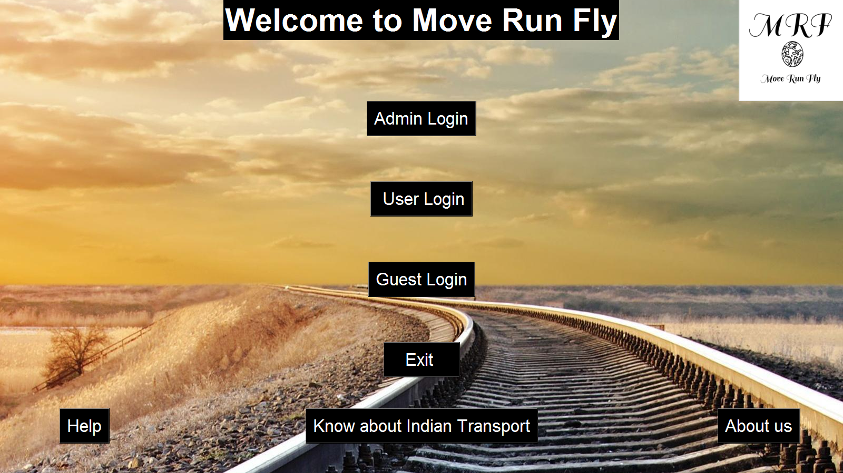

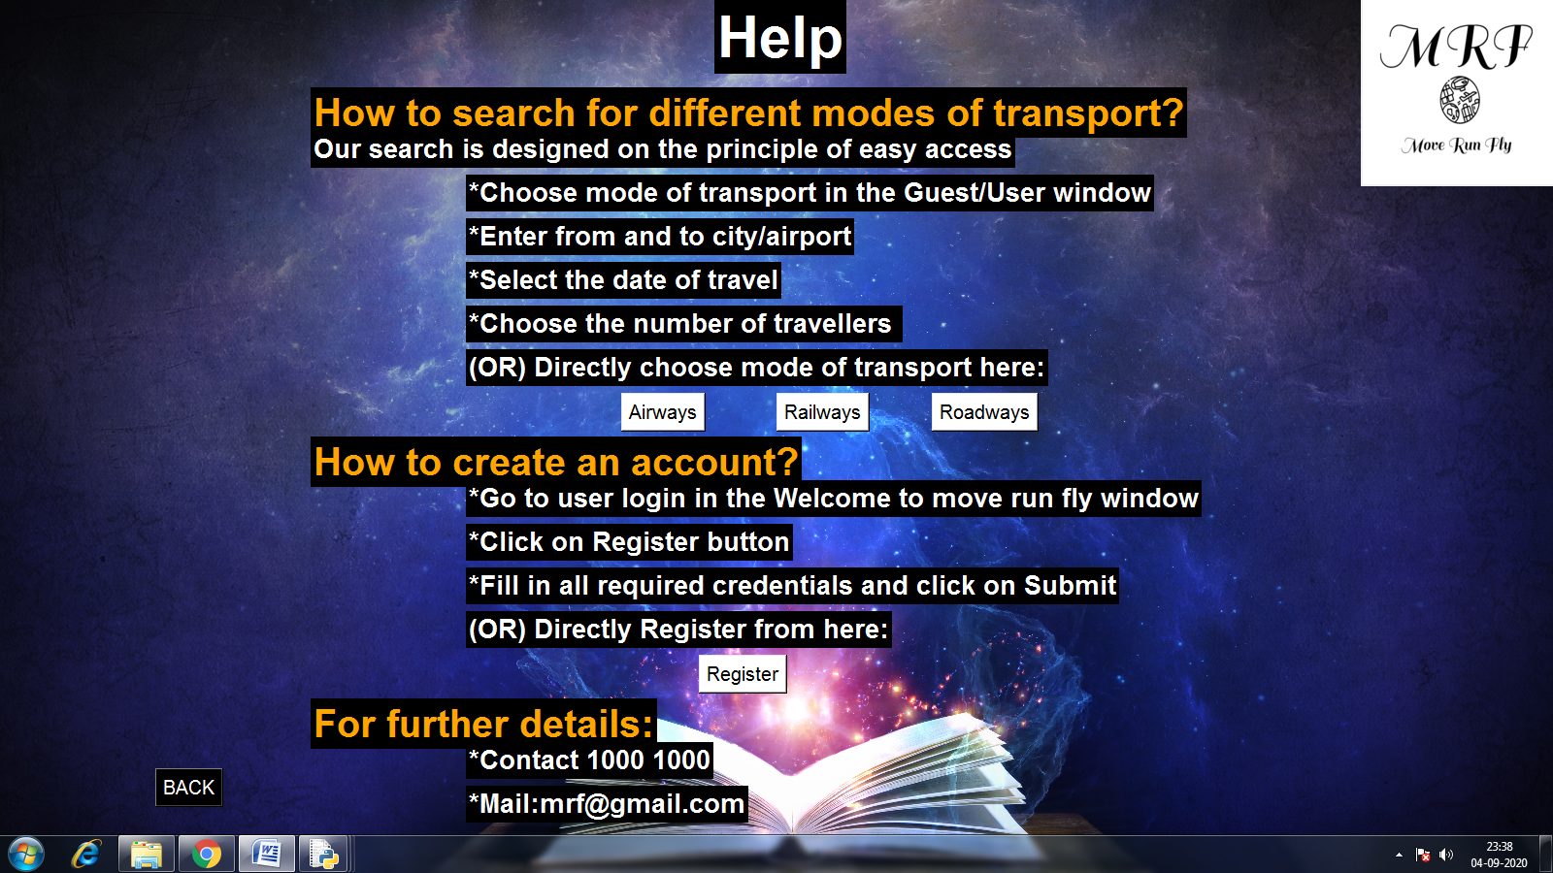

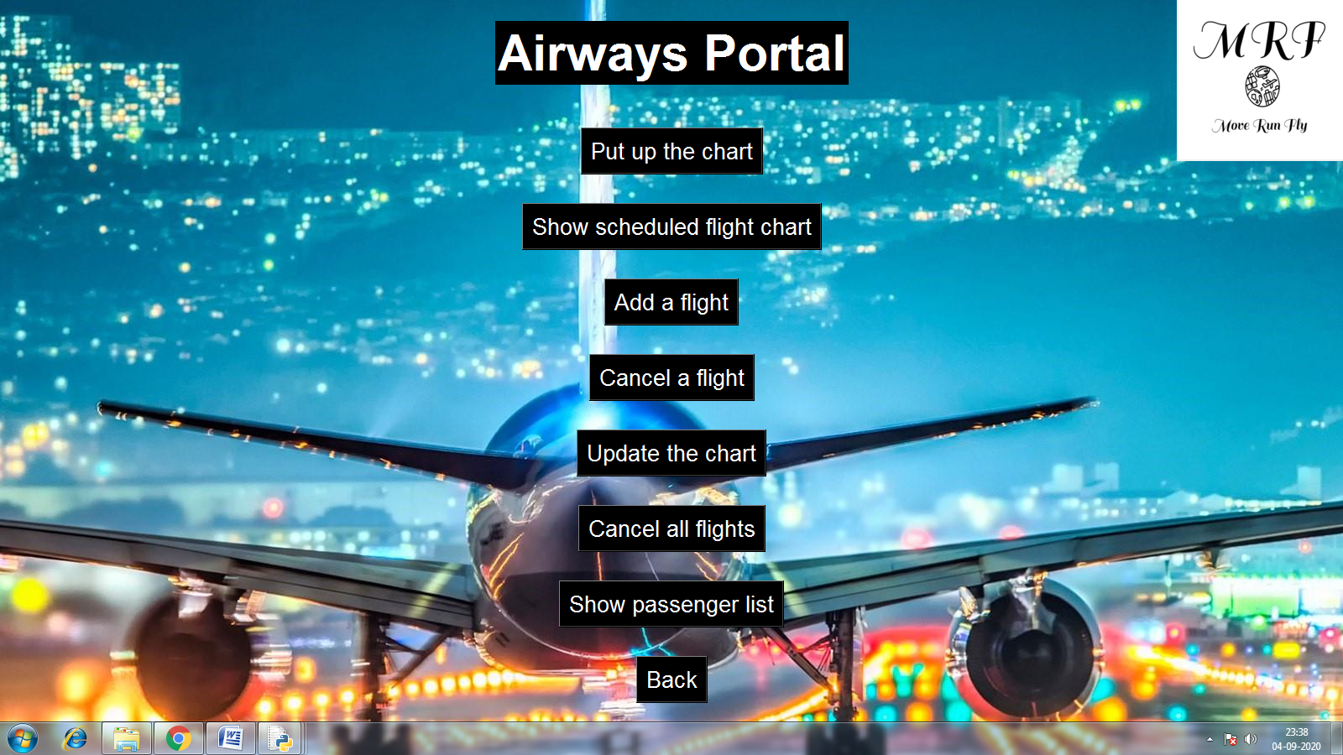

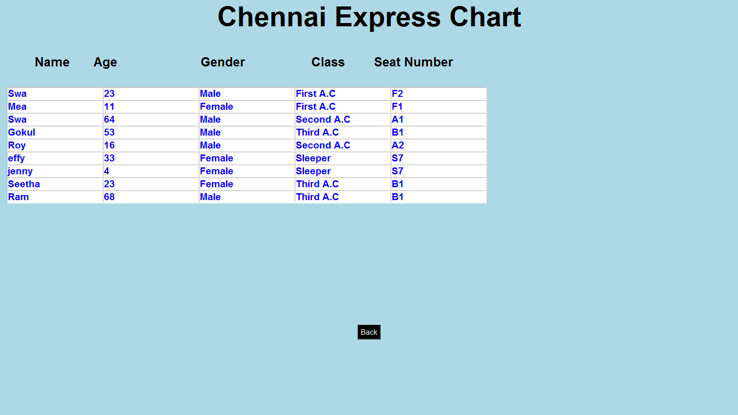

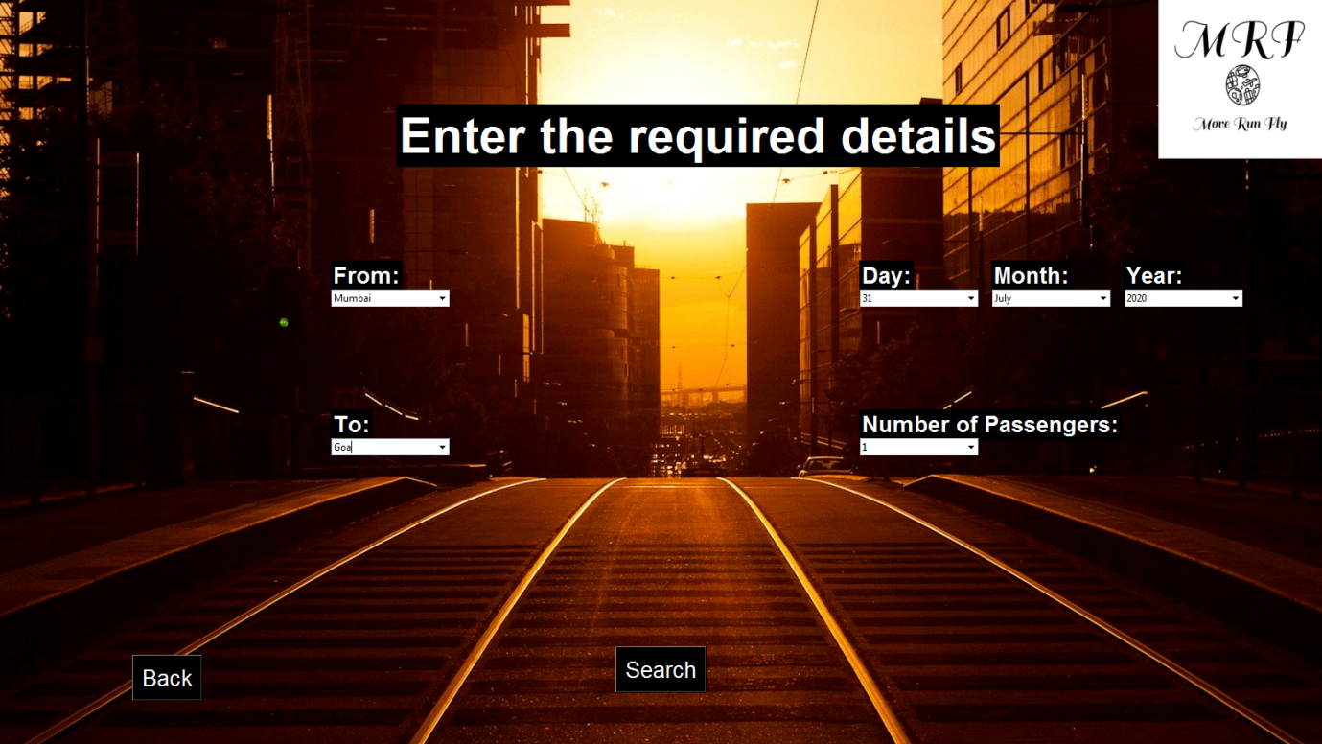

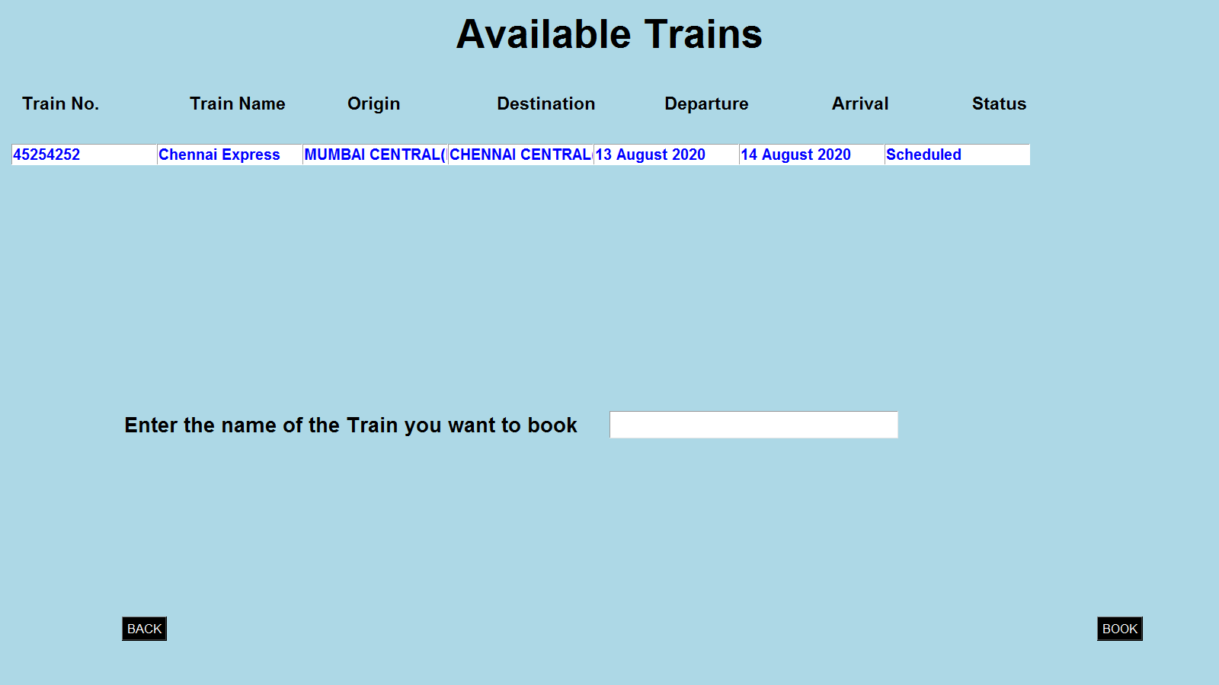

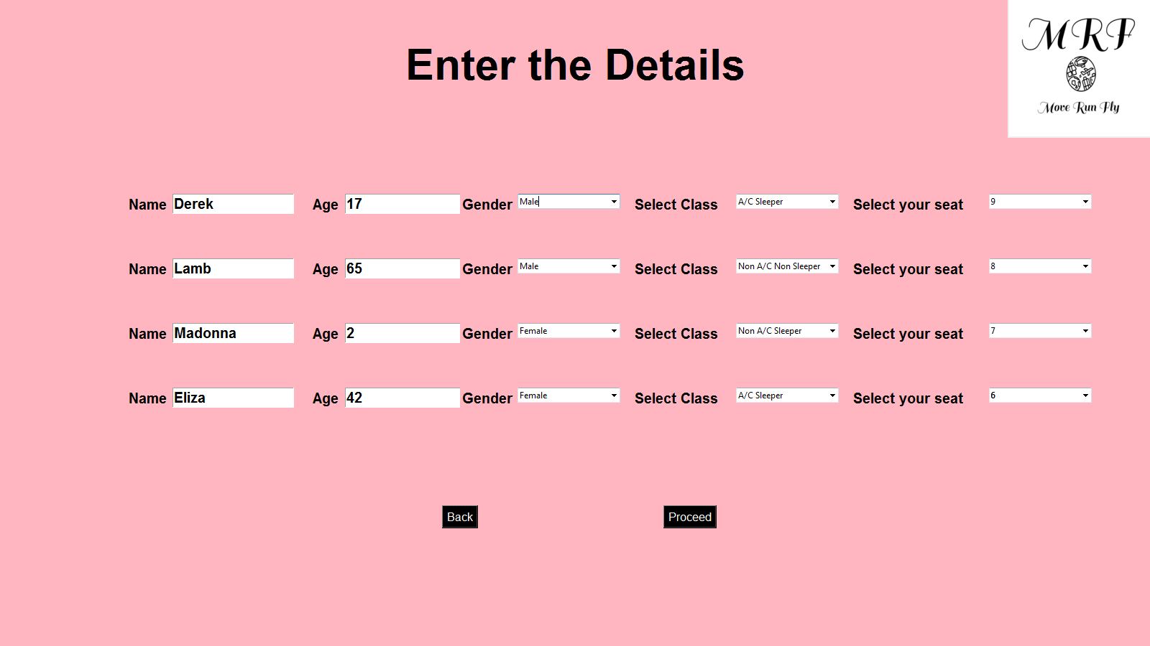

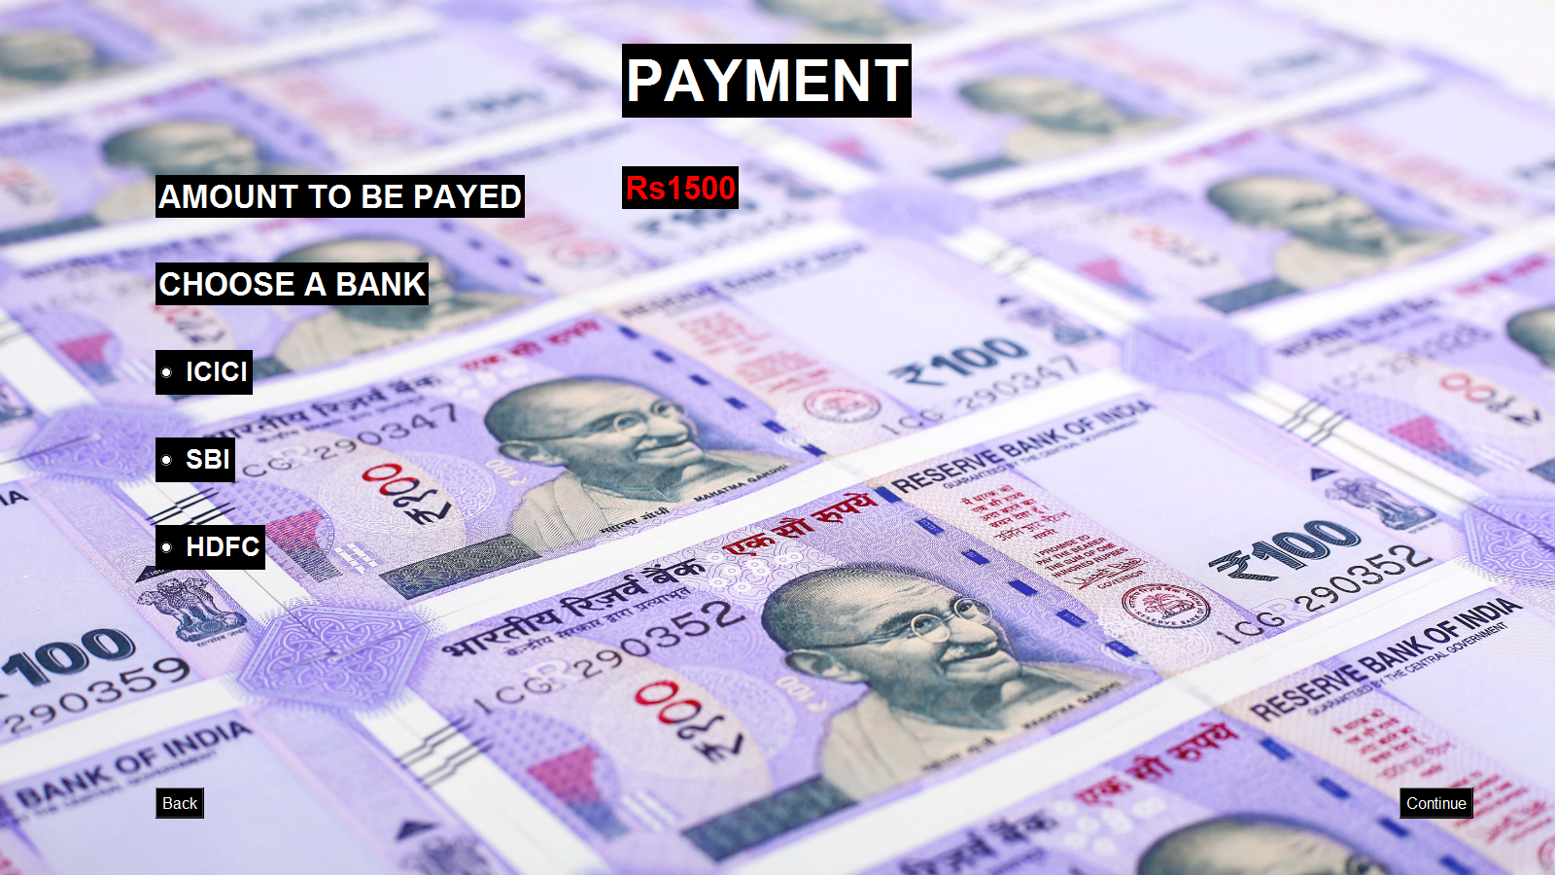

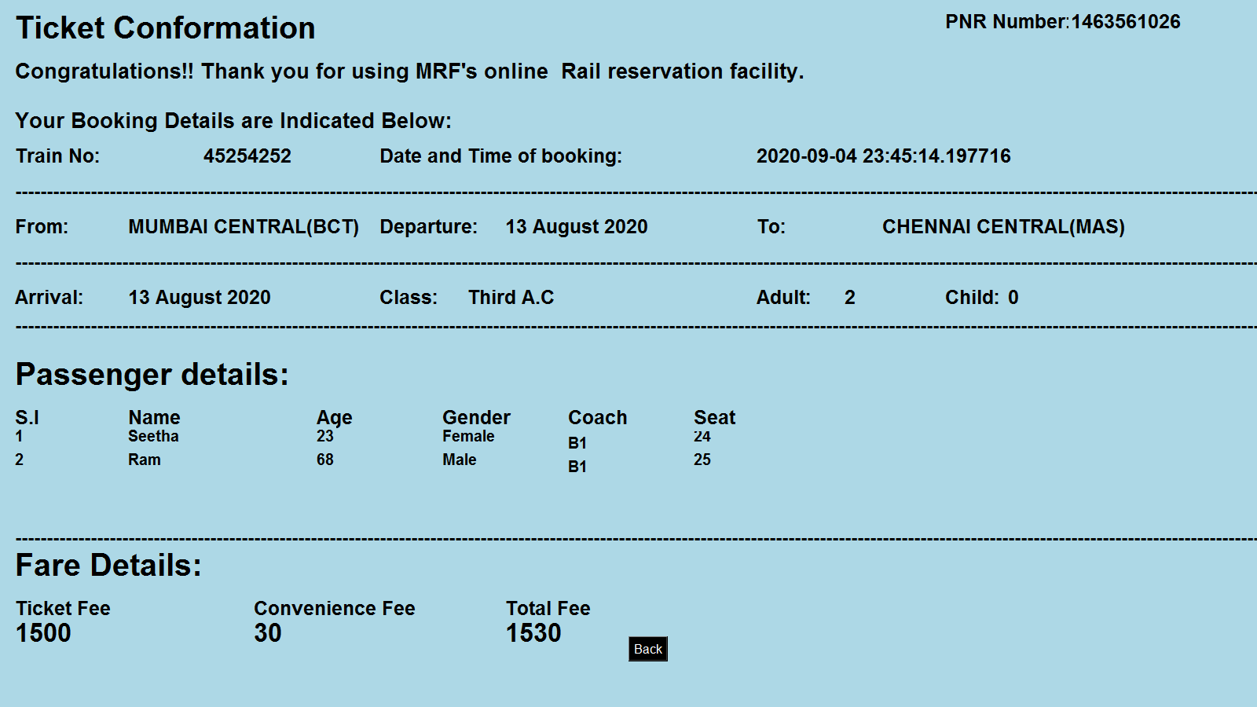

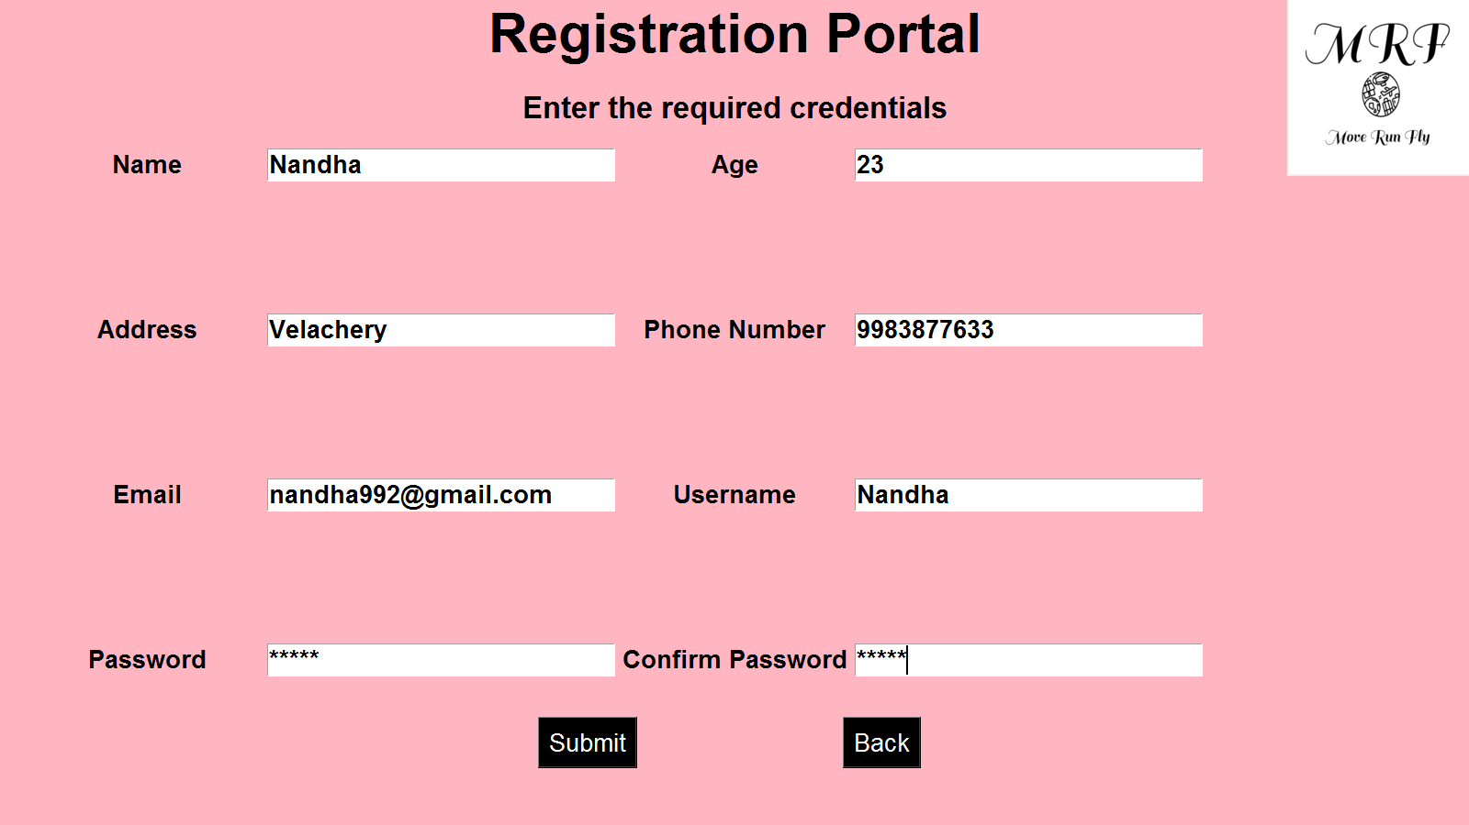

CONCLUSION

As mentioned in the beginning, our project’s aim is to make booking is simple and easy as our project allows users to book between three different modes of transport from a single space allowing the user to choose what suits them the best.

There is obviously scope for improvement in our project as new options can be added as well as further developments can be made in the existing elements of the project. For example, waterways can be added into our project to make our project a one stop destination for booking. All modes of transport can be brought into a single login so that the user need not have to login separately for each mode of transoprt, which makes it easier for the user to compare between the different modes of transport. We are happy to conclude that this project has had a great impact on our problem solving skills and has helped us in developing our programming knowledge.

BIBLIOGRAPHY

* <https://www.youtube.com/watch?v=VMP1oQOxfM0>
* <https://realpython.com/python-gui-tkinter/>
* [https://stackoverflow.com](https://stackoverflow.com/)
* [https://www.sololearn.com](https://www.sololearn.com/)